GOALS, OUTCOMES, AND OBJECTIVES

The standards of both institutional and programmatic accrediting and quality assurance agencies are peppered with terminology like ‘mission,’ ‘goals,’ ‘outcomes,’ and ‘objectives.’ But what precisely do these terms mean? For the purpose of developing and implementing a comprehensive and effective outcomes assessment plan for advancing academic quality in business education, the differences between these terms need to be clarified.

The Assessment Pyramid below illustrates the general hierarchical relationships among mission, goals, outcomes, and objectives:

The Assessment Pyramid

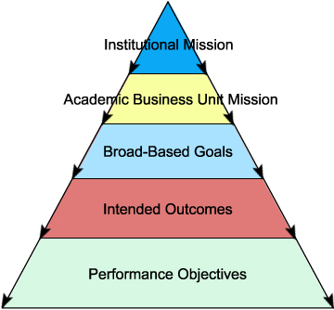

The Assessment Pyramid represents the flow from the institutional mission at the apex of the pyramid, which provides purpose and direction for the institution as a whole, followed by the mission of the academic business unit (and other academic units of the institution), and then down to the broad-based goals of the business unit, followed by intended outcomes, and then finally down to performance objectives associated with the intended outcomes at the base of the pyramid.

The widening and downward flow from the institutional mission in this hierarchical structure indicates that:

- The mission of the academic business unit flows from the institutional mission and should be consistent with and contribute to the institutional mission.

- The broad-based goals flow from the mission of the academic business unit with multiple goals associated with the business unit’s mission and each goal relating to some aspect of the mission.

- Intended outcomes flow from the broad-based goals with multiple intended outcomes associated with each goal.

- Performance objectives flow from the intended outcomes with multiple objectives associated with each intended outcome.

Consequently, evidence of accomplishment of desired results at a given level in the pyramid hierarchy would then constitute evidence of accomplishment of the desired results in the level above it.

