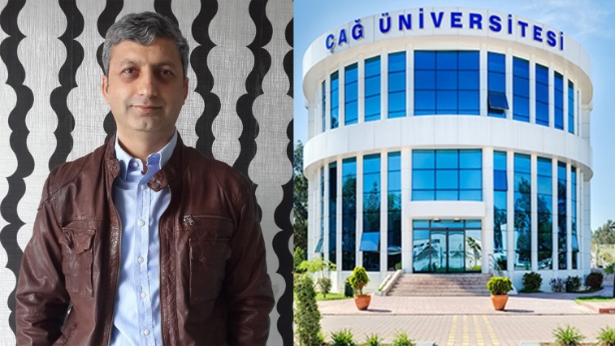
Çağ University Academic Staff Member Prof. Dr. İlhan Öztürk has been ranked within top 1% among 50,000 researchers by RePEc (Research Paper in Economics).
According to RePEc statistics for February 2018 and last 12 months, Prof. Dr. İlhan Öztürk ranked within top 1% among 50,000 authors in World considering the impact factor of his papers in RePEc services over the past 12 months. It is worth mentioning that Prof. Dr. İlhan Öztürk ranked 1th in the category of top 25 authors in the world by “Number of Abstract Views in RePEc Services over the past 12 months, Weighted by Number of Authors”. Prof. Dr. İlhan Öztürk has more than 155 international refereed publications until now. According to Google Scholar Citations, he received 6,824 citations to his papers and H-Index is 41.
Related Links:
http://logec.repec.org/scripts/authorstat.pf?topnum=25&sortby=ld&item=exsoft&country=tr&.submit=New+List&.cgifields=citems
https://ideas.repec.org/top/top.person.aabsviews.html#poz20
https://scholar.google.com.tr/citations?user=_LnB9a8AAAAJ&hl=tr
On the same ranking list, Cag University Faculty of Economics and Administrative Sciences ranked 7th among the all faculties in Turkish Universities.

Top 25% institutions in Turkey, all authors, all publication years
For Turkey, there are 763 authors affiliated with 205 institutions. All institutions in this region.
Rank | W.Rank | Institution | Score | Authors | Author shares
1 | [2] | İktisadi ve İdari Bilimler Fakültesi, Koç Üniversitesi  İstanbul, Turkey | 1.87 | 16 | 15.99
2 | [3] | İktisat Bölümü, Bilkent Üniversitesi  Ankara, Turkey | 2.69 | 23 | 21.96
3 | [1] | Türkiye Cumhuriyet Merkez Bankası  Ankara, Turkey | 3.26 | 110 | 105.69
4 | [4] | İktisadi ve İdari Bilimler Fakültesi, Orta Doğu Teknik Üniversitesi  Ankara, Turkey | 4.82 | 31 | 23.26
5 | [6] | İktisat Bölümü, Boğaziçi Üniversitesi  İstanbul, Turkey | 6.13 | 22 | 20.51
6 | [7] | Ekonomi Grubu, Sabancı Üniversitesi  İstanbul, Turkey | 6.34 | 11 | 11
7 | [5] | İktisadi ve İdari Bilimler Fakültesi, Çağ Üniversitesi  Mersin, Turkey | 9.22 | 1 | 1
8 | [9] | İktisadi ve İdari Bilimler Fakültesi, TOBB Ekonomi ve Teknoloji Üniversitesi  Ankara, Turkey | 12.82 | 12 | 9.37
9 | [8] | İktisat Bölümü, İstanbul Medeniyet Üniversitesi  İstanbul, Turkey | 13.96 | 7 | 6.45
10 | [10] | İktisadi ve İdari Bilimler Fakültesi, Kadir Has Üniversitesi  &#Istanbul, Turkey | 14.25 | 10 | 9.99
RePEc (Research Papers in Economics) is a joint product of hundreds of volunteers in 96 countries and has the fundamental aim of facilitating the dissemination of research in Economics and related sciences. The center of the project is a decentralized bibliographic database of working papers, journal articles, books, books chapters and software components, all maintained by volunteers. The collected data is then used in various academic services. Until now, over 1,600 archives from 96 countries have contributed about 1.4 million research pieces from 2,800 journals and 3,800 working paper series.

