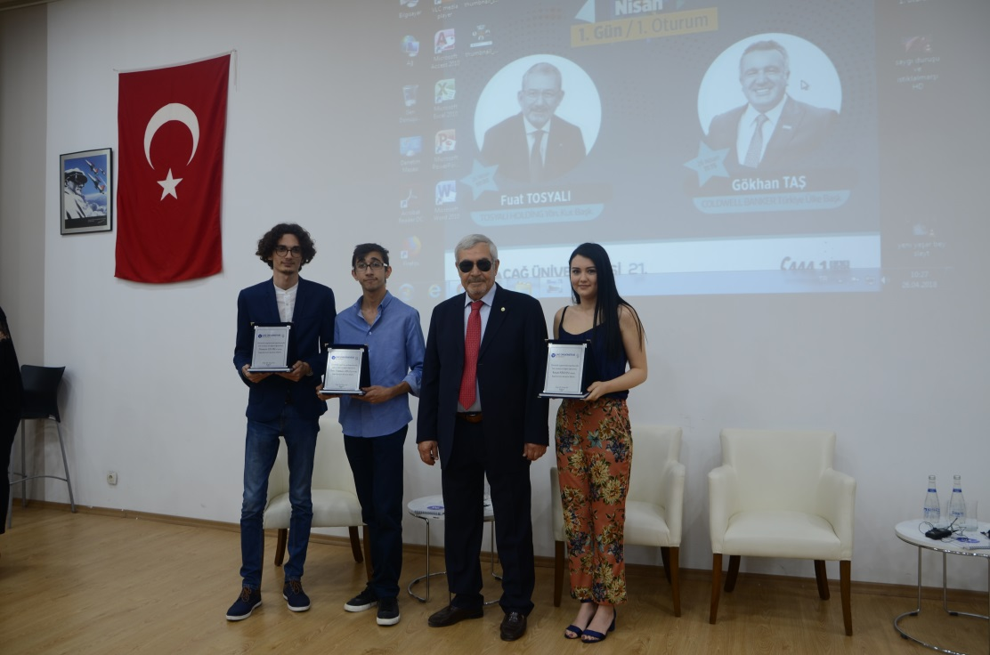

Eureopean Scholarship for our International Relations Student
Nurettin Gevri, 4th year student studying at International Relations Department, is awarded a scholarship for master’s degree in Hungary as part of the Stipendium Hungaricum full degree master’s studies scholarship agreement carried out by the Hungarian Government and Directorate General of European Union and Foreign Affairs of Turkish Ministry of Education. We wish him the best of luck.

An Award to CAG ESN from Erasmus International
Our Erasmus student Network Club was awarded by Erasmus International with their highly praised project on Social Erasmus and Exchange Ability. Burcak Arıkan, running her studies under the consultancy of Gul Kulak, the coordinator of International Office, stated “We are happy to receive the best project award in such an event where 48 universities competed with their projects. And we are also extremely honored to be the only university receiving this award successively in the recent years. We will be working on our studies in this context.”

Invitation to Our Student Dogukan Uslu
4th year International Relations Department student, Doğukan Uslu, one of the five students from Turkey, is invited to “SUSI- Students Leadership” program held by the Dialogues Institute and supported by the United States Department of State. Being one of the five students chosen from Turkey, Uslu is invited to workshops which will be held in Atlanta, New York, and Washington D.C. for five weeks.

