FACULTY OF ECONOMICS AND ADMINISTRATIVE
SCIENCES ADVISORY BOARD

MISSION AND OBJECTIVES
Mission :
Mission of the Advisory Board of the Faculty of Economics and Administrative Sciences is to communicate with internal and external partners with regard to educational activities carried out by the departments of our faculty.
Objectives :
- To start diploma programs, which would meet the needs and expectations of the modern and competitive business world,
- To update the existing programs,
- To develop the competence of the students in terms of self-expression and self-confidence,
- To promote social & environmental consciousness,
Puts forward new ideas for consideration by the Dean’s Office.

MEMBERS OF THE ADVISORY BOARD AND SOURCE OF INFORMATION
Teaching Staff | Source of Information | Activities
Assoc.Prof. Dr. Eda Yaşa ÖZELTÜRKAY  (Chairman) | Çukurova Human Resources  KOSGEB Mersin  Çağ University Career Center  Alumni & Students | 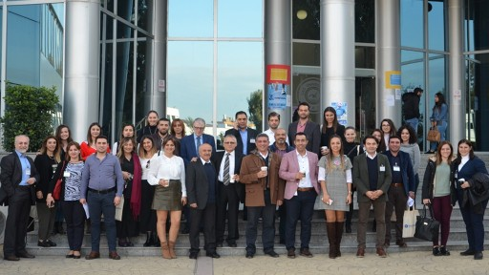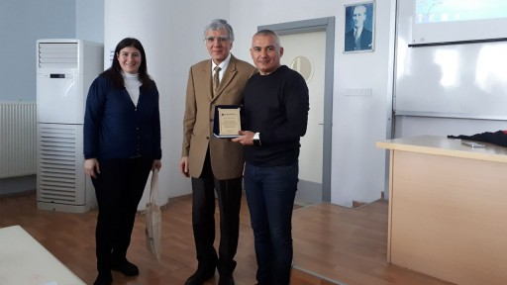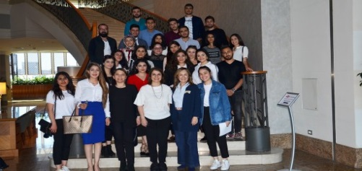
Assist.Prof.Dr.Murat Gülmez | International Academic Institutions | 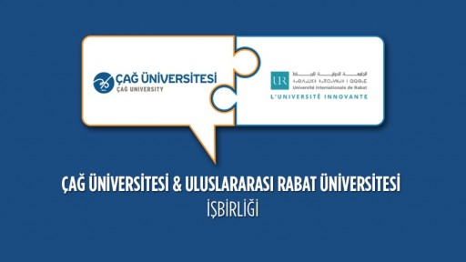
Assist.Prof.Dr.Korel Çepni | Representatives of the Business World | 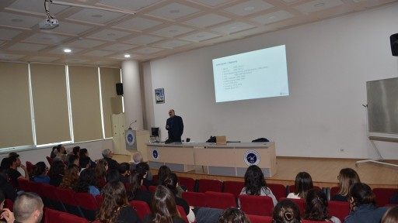
Assist.Prof.Dr.Gökhan Sökmen | Representatives of the Finance Sector | 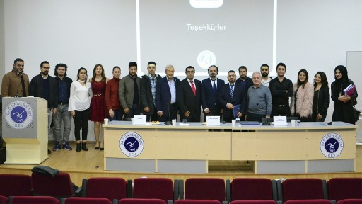
Assist.Prof.Dr.Sevgi Balkan Şahin | Non-Governmental Organizations
Assist.Prof.Dr.İbrahim İnan | Representatives of the Logistics Sector | 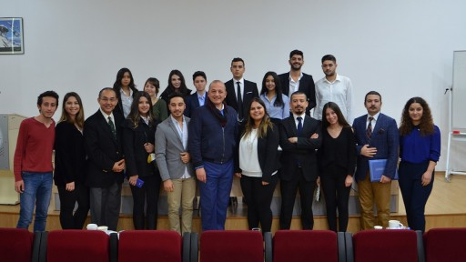
Assist.Prof.Dr.Musa İnal | Representatives of the Medical Sector | 