Mathematics for Business: Lecture Notes -3

Dr. Cansu Unver Erbas|cnsunvr@gmail.com

## 2.2 Equations (continuous)

Looking back over each part of the previous example, notice that there is a common strategy. In each case, the aim is to convert the given equation into one of the form:



which is the sort of equation that we can easily solve. If the original equation contains brackets then remove them by multiplying out. If the equation involves fractions then remove them by cross-multiplying.

**Practice 1**. Solve each of the following equations. Leave your answer as a fraction, if necessary.

a) b) c)

d) e) f)

g) h) i)

## 2.3 Inequalities

Remember the number line in Figure 1.1 that was cover in our first lecture.

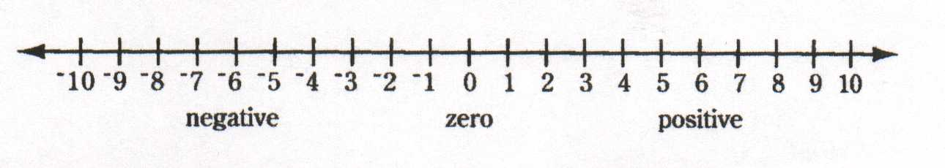

A number line can be used to decide whether or not one number is greater or less than another number. We say that a number is greater than a number if lies to the right of the on the line and write this as:



Likewise, we say that is less than if  lies to the left of  and write this as :



From the diagram we see that:

    

or equivalently;

    

There are occasions when we would like the letter and to stand for mathematical expressions rather than actual numbers. In this situations we sometimes use the symbols  and  to mean “less than or equal to” and “greater than or equal to” respectively.

We have already seen that we can manipulate equations in any way we like, provided that we do the same thing to both sides. An obvious question to ask is whether this rule extends to inequalities. To investigate this, consider the following:

**Example 1**: Starting with the true statement:

, decide which of the following is valid operations when performed on both sides are:

1. add 3
2. add -6
3. multiply by 3
4. multiply by -2

**Solution 1**:

1.  true
2.  true
3.  true
4.  false

This indicates that the rule needs modifying before we can extend it to inequalities and that we need to be careful when manipulating such things.

Practice Problem 1: Starting with the true statement:

, decide which of the following is valid operation when performed on both sides is:

1. add 6
2. multiply by 2
3. subtract 3
4. add -3
5. divide by 3
6. multiply by -4
7. multiply by -1
8. divide by -3
9. add -10

These examples show that the usual rule does apply to inequalities with the important proviso that:

If both sides are multiplied or divided by a negative number than the sense of the inequality is reversed.

**Example 2**: Simplify the inequality 

**Solution 2**: 

 (subtract 5x from both sides)

 (put all of the constant terms on the right-hand side by subtracting 1 from both sides)

 (divide both sides by -2, notice that the sense has been reversed at this stage because we have divided by a negative number)

**Practice 2**: Simplify the inequalities:

a) b) c)

d) e) f)

**Practice 3**: Please provide a definition each of the following:

1. Algebraic fraction
2. Denominator
3. Equation
4. Equivalent fractions
5. Factor
6. Identity
7. Number line
8. Numerator

**Practice 4**: Exercise 1.2 from Question-1 to Question-11.

# 3. Graphs of Linear Equations

Consider the two straight lines shown in Figure 4.1. The horizontal line is referred to as the **x-axis**, and the vertical line is referred to as the **y-axis**. The point where these lines intersect is known as the **origin** and is denoted by the letter O. These lines enable us to identify uniquely any point, P, in terms of its **coordinates** (*x*,*y*). The first number, *x*, denotes the horizontal distance along the x-axis and the second number, *y*, denotes the vertical distance along y-axis. The arrows on the axes indicate the positive direction in each case.

y

y

x

**O** x

Figure 4. 1

**Example 1**: Plot the points A(2,3), B(-1,4), C(-3,-1), D(0,2) and E(3,0)

**Solution 1**:

The point **A** with coordinates (2, 3) is obtained by starting at the origin, moving 2 units to the right on the x-axis, and then moving 3 units vertically upwards (y-axis).

The point **B**, coordinates (-1,4) is located 1 unit to the left of **O** (because the x coordinates is negative) and 4 units up.

The point **C**, coordinates (-3, -1) is located 3 units to the left of **O**, 1 unit down.

The point **D**, coordinates (3,-2) is located 3 units to the rights of **O** and 2 units down.

The point **E**, coordinates (3,0) is located 3 units to the right of **O**.

These points are plotted in Figure 4.2

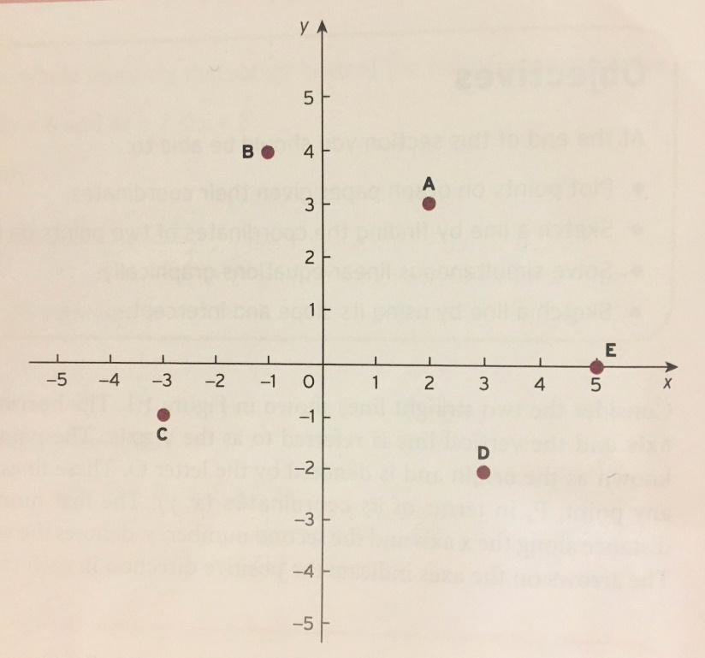

Figure 4 2

**Practice 1**: Plot the following point on the white board.

A (-1,4), B(-3,0), C(2,0), D(-2,-2), E(1,-3)

We would like to be able to sketch curves represented by equations and to deduce information from such a picture. We restrict our attention to those equations whose graphs are straight lines which pass through any directions on x-or y-axis.

The general equation of a straight line takes the form of:



Such an equation is called a **linear equation**. The numbers and are referred as **coefficients**. We can check whether any points P(x,y) pass through such straight line().

**Example 2**: Decide which of the following points lie on the line:

A(0,-3), B(2,2), C(-10,-28), and D(4,8)

**Solution 2**:

* 5(0)-2(-3)=0-(-6)=6
* 5(2)-2(2)=10-4=6
* 5(-10)-2(-28)=-50-(-56)=6

x 5(4)-2(8)=20-16=4≠6

**Practice 2**: Check that points (-1,2), (-4,4), (5,-2), (2,0) all lie on the line 

In general, to sketch a line from its mathematical equation, it is sufficient to calculate the coordinates of any two distinct points lying on it. The simplest and the best way of sketching a line is to find the slope and the intercept on the x-and y-axis.

In general, a linear equation can be rearranged into the special form:

.

In this special form of the equation, the coefficients and have particular significance.

In fact, is called the **intercept** on the y-axis. In other words, that is the value of when  is taken to be zero.

In the same way it is easy to see that , the coefficient of x, determines the **slope** of the line, and it is calculated as : .

Once we find out the intercept and the slope, we would then have sufficient points that pass through the line.

**Example 3**: Sketch the line 

**Solution 3**:

to find the intersect on x-axis, find the value of x when y is taken to be zero

x-4(0)=4 so, x=4 this is the point **(4,0)**

to find the intersect on y-axis, find the value of y when x is taken to be zero

0-4y=4 so, y=-1 this is the point **(0, -1)**

(4,0) 

(0,-1)

**Practice 3**: Sketch the graphs of followings:

1. 
2. 
3. 
4. 
5. 
6. 
7. 
8. 

**Practice 4** : Exercise 1.3, questions 1, 2, 3, 4 and 6