INTRODUCTION TO STATA AND DATA DESCRIPTIVE STATISTICS

Open Stata from the start button on your PC.

Stata is a very popular, interactive statistical package with user friendly drop-down menus as well as programming tools for graphics, statistics and data analysis. To begin with we will use the commands available in the drop-down menu: these cover most if not all your needs for this module and they are obviously much easier to use. Stata will record these commands in the display window, so you can copy-paste them into a do-file if you want. Do-files are a special type of file where you can store commands and whole sets of code that you use often so that you can access and re-run them every time you need without having to re-do things all over again. We will learn about do-files later in these labs.

Stata Interface
Main menu and menu tool bar

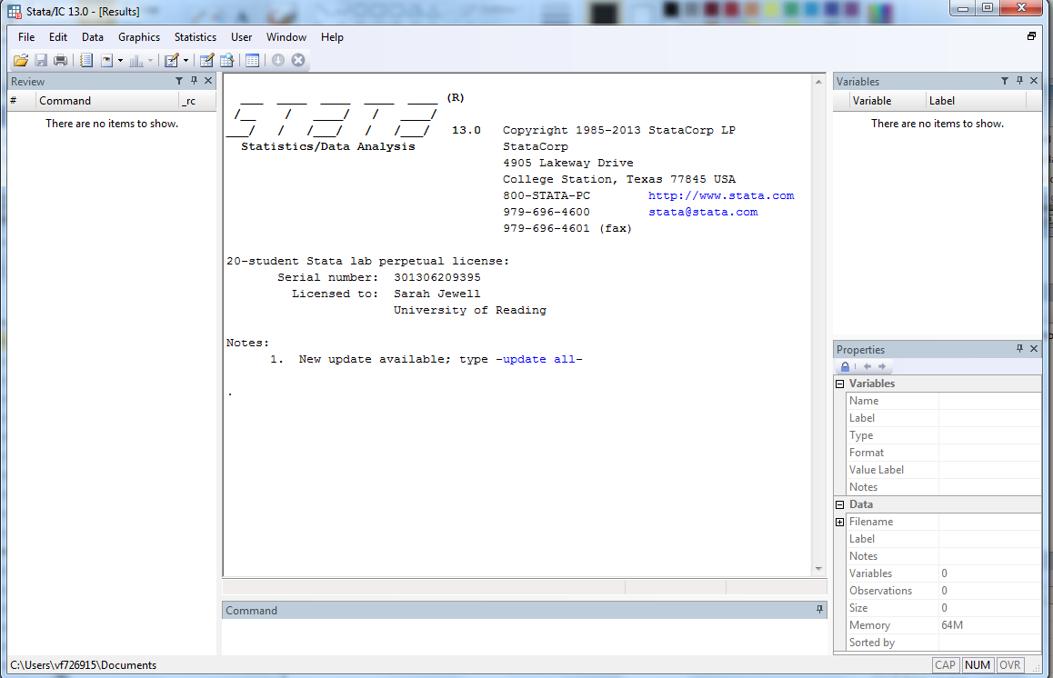
Output and display window
Command window
Variable
properties
Variables window
Command Box
Data information

Stata comprises of several windows and boxes:

Output and display window – displays executed commands and the resulting output;
Command box – you can type commands here and press return to execute them;
Command window – lists the commands you executed during the session;
Variables window – contains the names and labels (if they exist) of the variables in your dataset;
Variable properties – if you click on a variable in the variables window – information for that variable such as name, labels, format, will appear in the variables properties window;
Data Information – this window contains information about the dataset;
Main Menu and Tool Bar: The data, graphics and statistics drop down menus provide a user-friendly way of performing your data analysis. Most things can be done by using drop-down menus, while other, more complicated commands have to be written directly in the command box (or in a do-file).
The Help menu enables you to open the Stata help files if you know the command or search for help files based on key words. You should be able to access the help PDF Documentation from the help menu, which is extremely useful.

LET’S START YOUR SESSION

- Create a log file

A log file keeps track of what you have done, by recording all commands and output.
(Unlike a do-file, a log file is just history: it does not allow you to re-run commands directly from it. We will learn do-files soon).
To begin a new log file:
- Click on the log file button on the tool bar or go into File => log => begin;
- Give it a name (eg myclasslog) in the “File name” box and save it with the .log extension. This will allow you to open the log file outside of Stata.
- Click save.

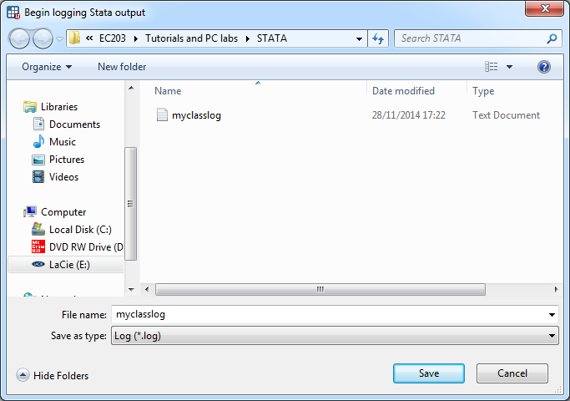

d. At the end of the session you can save and close the log file by clicking
File => log => close or by clicking on the log file button and choosing “close” in the box that appears:

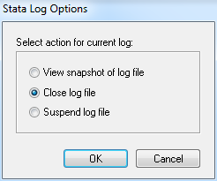

The other options allow you to:

- View a snapshot of the log-file (open in log file viewer window);
- Suspend the log file - for ex if you want to run some commands but not record them; you can then resume the log file by clicking on the log file button and selecting the “Resume suspended log” option.

2. Import data

a. Data in Stata format - Stata files are recorded as .dta. To load them you can use the open command on the tool bar or from the file menu. Or you can double click on them from your storage folder – that will automatically open STATA and load the data.
b. Excel files- this is what we are using today. Go into File => import => excel files, then browse to locate the file electricity.xls and select it.
In the following window click on “Import first row as variable names”.

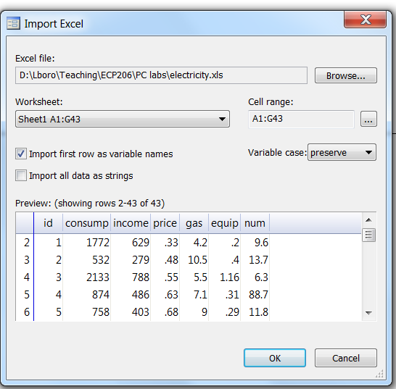
This option tells Stata to treat the first row in Excel as variable names, so you can see what the variables are. You should now be able to see that you have loaded data in the variables window on the main screen.

You can view your data in spreadsheet form in the data editor:
- You can use the icons from the tool bar menu: will open the data in edit form or will open the data in browse form. The edit option allows you to make changes to the data, whilst the browse form is read only.
- Or you can click Data => data editor from the tool bar. Again choose edit or browse.

This dataset was used in a paper by Houthakker to analyse the determinants of the demand for electricity on a cross section of 42 English towns in 1937/38.
The variables are:
Id: this is simply the observation identifier that numbers consecutively the 42 towns. We do not use it in the models but it can be useful for some graphs or to sort the data.
Consumption: yearly average consumption of electricity per consumer, measured in kWh; this is the dependent variable in the models that we will estimate;
Income: yearly average income of domestic consumers, measured in £;
Price: average yearly running electricity charge, measured in pence per kWh;
Gas: marginal price of gas; this is measured as an annual average price per therm, again in pence.
Equip: average holding of heavy electric equipment by domestic consumers measured in kW;
Num: total number of consumers.

Since the above information is not reported let’s do so by creating labels for our variables:
From the toolbar select Data => Variables Manager; the window below will open:

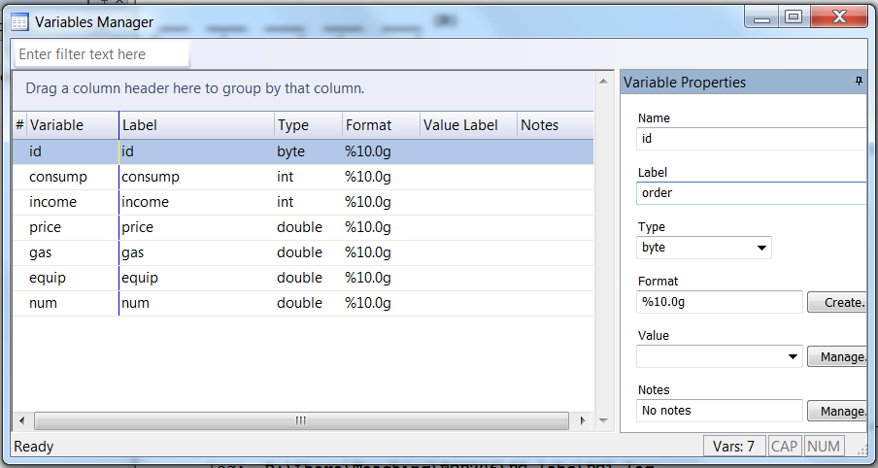

The name of the variable already appears as we imported it from Excel. We can now type its definition into the label box and click Apply; this information will now be visible from the main screen, and is useful for you to remember what the variables are.

3. Exploring Data and Descriptive Statistics
The first thing you always do with a new data set is to have a general look at the data, to see its main characteristics.
From the toolbar on the main screen go in:
Statistics => Summaries tables and tests => summary descriptive statistics => summary statistics.
This opens the following window, where you can select what variables to look at and whether to get the main basic or more detailed statistics. Select all variables except from id and click OK
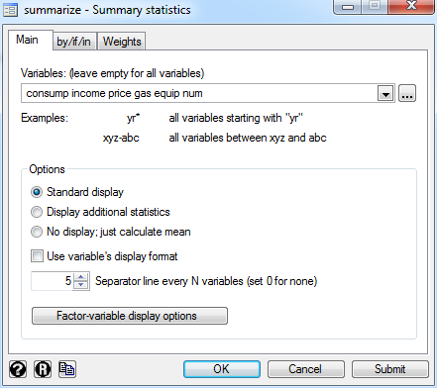

With the default standard display we get:

Variable Obs Mean Std. Dev. Min Max

income 42 592.7143 292.8343 279 1422
price 42 .5414286 .0953446 .33 .75
gas 42 7.747619 1.571117 4.2 11
equip 42 .6916667 .5343102 .03 2.52
consump 42 1271.214 642.5234 431 3183
num 42 16.5881 18.63596 1.3 88.7

which means…

We now try the following:
- Display “additional statistics” and see what you get; try for example for consumption only and see what you get.
- Correlate function: to see the correlations between the various variables in the model

consump income price gas equip num

consump 1.0000
income 0.7668 1.0000
price -0.2739 0.1270 1.0000
gas -0.0132 0.1438 0.3211 1.0000
equip -0.0383 -0.3131 -0.0484 -0.0377 1.0000
num -0.2445 -0.3621 -0.0091 -0.1478 0.1297 1.0000

4. Creating graphs
We can also plot some graphs to see what our data looks like and how the variables relate to one another. Graphs are displayed in the graphic windows, which will automatically open when you create a graph. Graphs will not be added to any log files and every time you create a new graph it overwrites the previous one so you should save any graph you need to keep through the save graph command. There are a lot of options you can specify with your graphs, which allow you to format labels, axes, legends and titles. There are too many options to go into detail here so it is recommended you refer to the help files or simply try playing around with the options you find. You can also use the graph editor to make formatting changes, obtained by right clicking on the graph itself.

Let’s create a scatterplot of the relationship between consumption and income.
Go under Graphics => two-way graph => create => scatter. Choose consumption for Y and for example income for X and click accept and then OK.

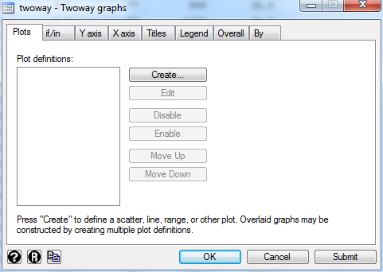

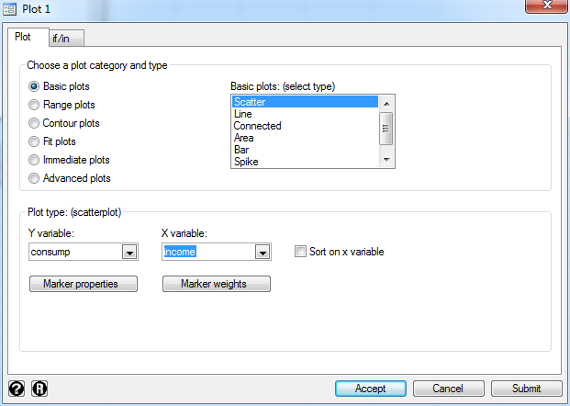

You can access various options by right clicking on the active graph to start the graph editor. Try using this to change title, axes labels etc

- Do the same using Price as the X variable. To proceed you will have to “disable” the old graph first and create a new one next:

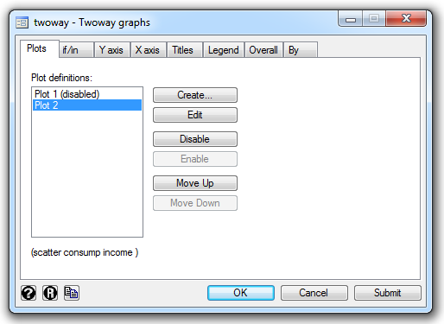

- Do a histogram now, selecting it from the graphics toolbar. If I do not give Stata any detailed commands the histogram for consumption looks like this:
I can alternatively choose to have more bins, eg 10; this will give me a more detailed picture of the distribution of the variable.

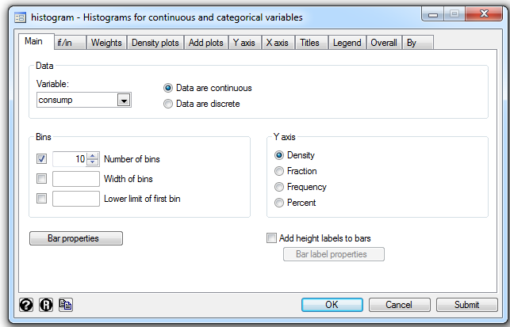

An even better representation of the distribution of the variable is given by
Graphics=> smoothing and densities => kernel density estimation
The result looks rather cooler…

5. End your session
To finish our session and exit we have to save the work we have done.
a. Close the log file: select File => log => close or click on the log file button and choose “close” in the box that appears.
b. When you try to exit Stata the following box appears, to ask you what to do about your data set:
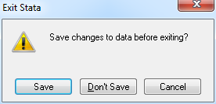

Select Save and then give the file a name (eg electricity) in the window that appears. This will automatically save your data as a Stata dataset, with extension .dta; you can open it as a dataset directly next time you log in.

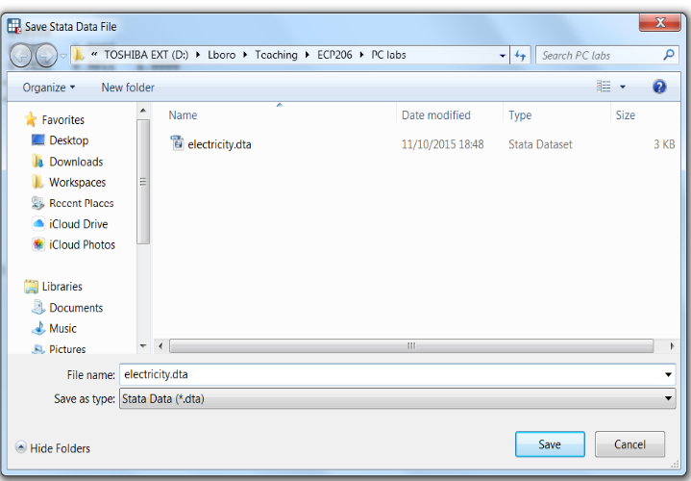

H.S. Houthakker (1951) “Some calculations on electricity consumption in Great Britain”, Journal of the Royal Statistical Society series A, vol 114, n. 3 pp- 359-371.

