Reading: How Social Services Help

Social services help families stay safe and happy.
What is a Social Services Department?
A Social Services Department is a group of people who help the community. Their job is to make sure everyone is safe and healthy. They work in a building in your town or city. They are there to support people who need extra help.

Who Do They Help?
Social services help many different people in our town:
- Families and Children: They help parents take good care of their kids.
- Seniors: They help older people stay safe and healthy in their homes.
- People with Disabilities: They help people who have a hard time moving or learning get the tools they need.
- People Without Homes: They help people find a warm place to sleep.

Working Together
Social workers do not work alone! They collaborate, or work together, with other helpers. They talk to doctors to help sick people. They work with teachers to help students. They also work with police officers and fire fighters to keep neighborhoods safe. When everyone works as a team, the community stays strong.
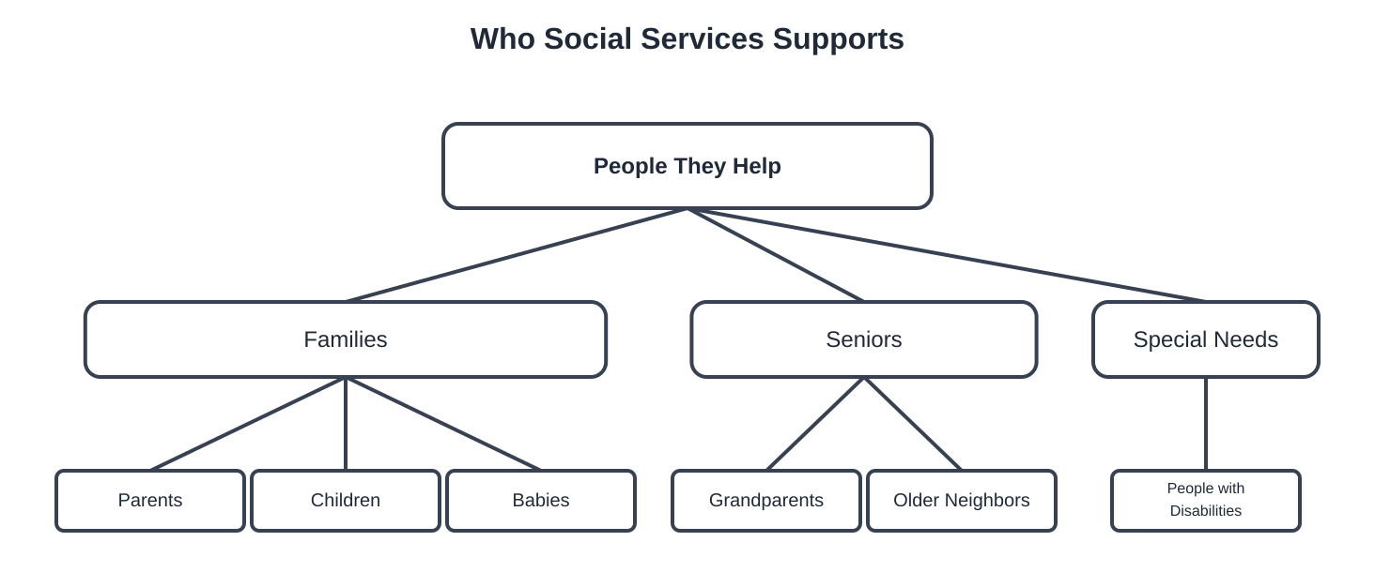
How You Can Help
You can be a community helper too! Even though you are young, you can do big things to help your neighbors.
- Be Kind: Saying hello or drawing a picture for a neighbor can make their day happy.
- Donate: You can give toys you don't play with or clothes that are too small to people who need them.
- Small Actions: Picking up litter or helping a friend shows you care about your town.
When we all do small, kind things, our whole community becomes a better place for everyone!

Community Impact
Social services have a big impact on our community. When one person gets help, the whole neighborhood becomes stronger. These services help people feel happy and safe. When we take care of each other, our community is a better place for everyone to live!

Vocabulary Match
Directions: Draw a line to match each word from the reading to its simple definition. Use the words in the box to help you.
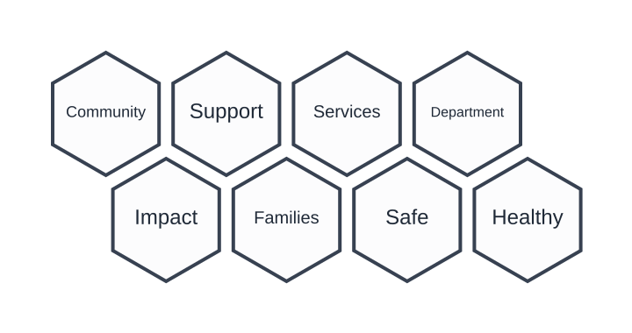
Key Vocabulary Words
Word | Simple Definition
2. Community | A. A group of people who live in the same area or town.
3. Support | B. To give extra help to someone who needs it.
4. Services | C. Helpful work or systems provided to people.
5. Department | D. A specific group or office that does a certain job.
6. Impact | E. A change or result that happens because of an action.
7. Families | F. Groups of people who are related and live together.
8. Safe | G. Away from danger or harm.

Practice: Choose one word from the list above and write a simple sentence using it.
In my community, ...

Comprehension Check
Part 1: True or False
Read each sentence. Circle True if it is correct or False if it is wrong based on the reading.
1. A Social Services Department is a group of people who help the community. | True / False
2. The department only helps people find a place to play sports. | True / False
3. Social services help families get healthy food to eat. | True / False
4. When one family gets help, the whole neighborhood becomes stronger. | True / False
5. Social services make the community a worse place to live. | True / False

Part 2: Wh- Questions
Write a simple sentence to answer each question.
1. Who does the Social Services Department help?
The department helps...
2. What are two things the department provides to families?
3. Where do the people in the Social Services Department work?

Answer Key (For Teacher Use)
True or False: 1. True, 2. False, 3. True, 4. True, 5. False
Wh- Questions:
- They help the community and families who need extra help.
- They provide food support, housing support, or help keeping children safe.
- They work in a building in your town or city.

Community Impact Reflection
Part 1: Draw a Picture
In the box below, draw a picture of a social worker helping someone in your community. Think about how they help families find food, a safe home, or stay healthy.

Part 2: Write About It
Write two simple sentences about how a social worker's help changes the community. Use the word bank to help you!
Word Bank: help | kind | safe | together | community | stronger

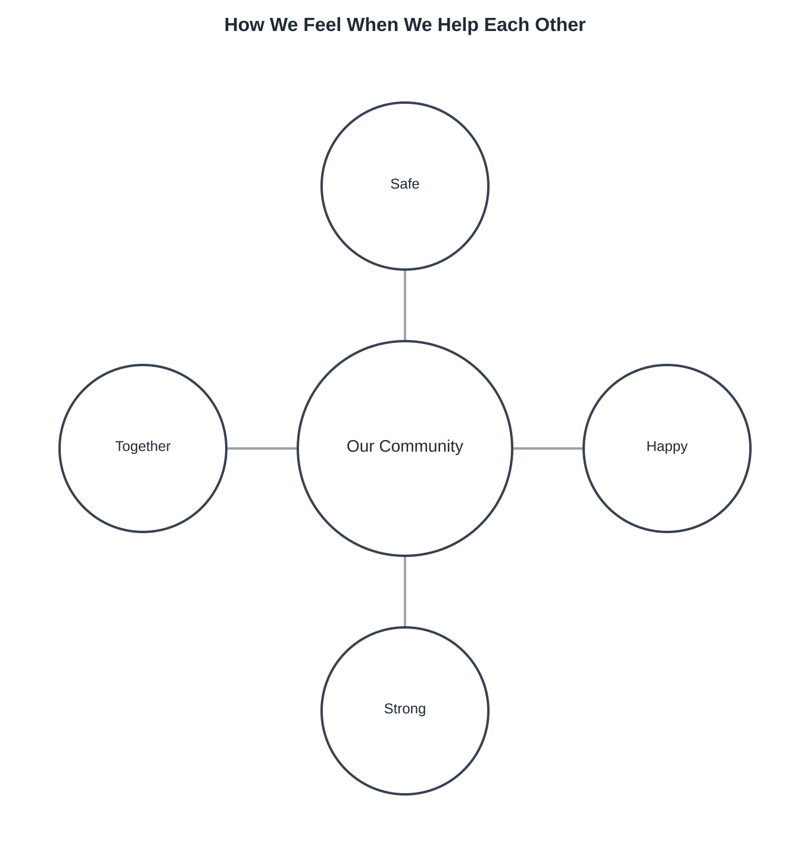
Social services help make our community a better place for everyone.

