Name

Date

**Economics-3** Score

1. Zero price elasticity of demand means

whatever the change in price, there is absolutely no change in demand for a small change in price, there is a small change in demand



**A**



**B**



**C**

for a small change in price, there is a large change in demand none of these answers



**D**

1. The price elasticity of demand is defined as

the percentage change in the quantity demanded divided by the percentage change in income the percentage change in income divided by the percentage change in the quantity demanded



**A**



**B**



**C**

the percentage change in price of a good divided by the percentage change in the quantity demanded of that good

none of these answers



**D**

1. In general, a flatter demand curve is more likely to be; price elastic



**A**



**B**

unit price elastic price inelastic



**C**



**D**

none of these answers

1. Which of the following would cause a demand curve for a good to be price inelastic? The good is a luxury



**A**



**B**

There are a great number of substitutes for the good The good is a necessity



**C**



**D**

None of these answers

1. If an increase in the price of a good has no impact on the total revenue on the market, demand must be

price inelastic unit price elastic price elastic



**A**



**B**



**C**



**D**

all of these answers

1. Assume that the average quantity of tea consumed per head in the UK falls 3% per year when the price of coffee falls 10% per 100g jar. What is then the cross-price elasticity of demand between tea and coffee?

-3.33



**A**

+0.3



**B**

-0.3



**C**

3.33



**D**

1. If supply is price inelastic, the value of the price elasticity of supply must be infinite



**A**



**B**

zero

less than 1



**C**

greater than 1



**D**

1. Accounting profit is equal to total revenue minus implicit costs



**A**

marginal costs



**B**

the sum of implicit and explicit costs explicit costs



**C**



**D**

1. Diminishing marginal product is the property whereby

the marginal product of an input declines as the quantity of the input increases the marginal product of an input increases as the quantity of the input increases the average product of an input declines as the quantity of the input increases the average product of an input increases as the quantity of the input increases



**A**



**B**



**C**



**D**

1. If a production function exhibits diminishing marginal product, its slope is linear (a straight line)



**A**



**B**

becomes steeper as the quantity of the input increases none of these answers



**C**



**D**

becomes flatter as the quantity of the input increases

1. 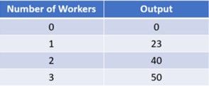

Refer to the figure on the left. The marginal product of labour as production moves from employing one worker to employing two workers is:

0



**A**

17



**B**

23



**C**

40



**D**

1. 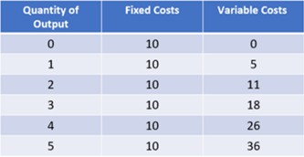

Refer to the figure on the left. The average fixed cost of producing four units is

2.50



**A**

2.60



**B**

9



**C**

10



**D**

1. 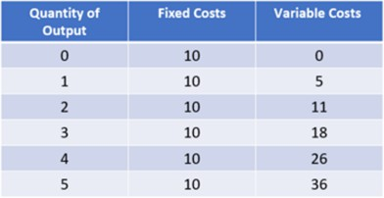

Refer to the figure on the left. The marginal cost of changing production from three units to four units is

5



**A**

6



**B**

7



**C**

8



**D**

1. When marginal costs are below average total costs average fixed costs are rising



**A**



**B**

average total costs are falling average total costs are rising average total costs are minimized



**C**



**D**

1. The efficient scale of production is the quantity of output that minimizes: average fixed cost



**A**

average variable cost average total cost marginal cost



**B**



**C**



**D**