ÇAĞ UNIVERSITY
FACULTY OF ECONOMIC AND ADMINISTRATIVE SCIENCES

ECONOMICS
COURSE NOTES-2016

ASST. PROF. CEMİL GÜNAY

CONTENTS
- Introduction: What is Economics?...………………………………………………………………… 3
- Production, Economic Growth and Distribution ………………………………………………11
- Market Mechanism: Demand and Supply ……………………………………………………… 21
- Market Mechanism: Market Equilibrium and Elasticity ………………………………… 35
- Firms (Producers)…………………………………………………………………………………………….45
- Output and Costs…………………………………………………………..………………………………..54
- Market Structures …………………………………………………………………..………………………67
- An Overview of Macroeconomics and National Income ………………………………….79
- Finance, Saving and Investment ………………………………………………………………………93
- Money and Money Market ………..………………………………………………………………….101

CHAPTER 1
INTRODUCTION: WHAT IS ECONOMICS?
In this introductory chapter, we start by giving a short story of the historical development of economic events in order to facilitate the understanding of the subject matter and scope of economics. Then, we try to answer the question of “what is economics”.
  - A SHORT STORY OF ECONOMIC EVENTS
Economics may be defined simply as the science which studies economy. But what constitutes economy? Economic events, as a component of social events are very complex and hence, it is not easy to fix a boundary for them. There is no unanimity among economists about the scope and the definition of economics. Nevertheless, an overview of the historical development of economic events would facilitate our understanding of economics.
People have to satisfy their natural needs, such as breeding, sheltering, wearing, etc., to survive. But, the satisfaction of natural needs is not enough; they have to satisfy also their cultural needs, which expand and get complicated as economic life develops. With the progress of living standards not only cultural needs expand and get sophisticated, but the process of satisfying natural needs also becomes more complex. Thus, economics is trying to explain facts and events that get more complicated as time goes on.
- Gathering and Hunting
At the prehistoric times people endeavored to satisfy their needs with the objects that existed in the natural environment. Our primitive ancestors could survive, probably, by gathering. They did not know producing and using tools. They were able to live by eating natural eatables and sheltering in caverns. At the gathering era, they probably spent most of the time to find daily food.
In time, they learned hunting. In the hunting stage, they could have been able to produce simple tools, such as arrow and bow, for hunting. Hunting, probably, made it possible, sometimes, to have more food than needed for daily consumption, and human learned to keep some of the food for the future.
- Agrarian Revolution, Specialization, Market and Trade
The domestication of wild animals and sowing and planting followed the hunting era. That development, which made people productive, was later called the agrarian revolution. People started to live sedentarily and, along with permanent settlement, the agricultural revolution brought surplus production; farmers could produce more than they needed to satisfy their own wants for survival. Agricultural surplus made the birth of many specialized occupations possible; such as soldiers, priests, and skilled artisans. Some people produced other goods and services while consuming the surplus food produced by farmers. This allocation of different jobs to different people is called specialization of labor.
Specialization must be accompanied by the division labor and trade. People who produce only one item must trade most of it in return for all of the other items they require. Naturally, trading became centered in particular gathering places. These places were called markets.
- Saving and Investment, Social Classes
Surplus production made it possible and necessary to think of the future, and people started to keep some of their produce for the future, hence saving and investment emerged. Keeping some animals to increase animal population, keeping some grains as seed, and producing tools were probably the first examples of saving and investment.
Surplus production, making possible of production of the means of production by saving and investment, had created the problem of who would own and use the extra products and the means of production: the ownership issue. With the emergence of ownership people divided into social classes, the haves and have-nots.
The ability to produce surplus product made also lending and borrowing possible and thus debtor-creditor relations arose. This development led to a new problem; what would be the difference between barrowed and returned amounts, namely, what would be the rate of interest.
- State
Sedentary life and stock building created the security problem and hence the need for making and implementation of common rules. It became a necessity to carry out these functions by a new institution that would be constructed and maintained by community. Thus a prototype of authority, namely, the state was born. A part of social product had to be allocated to maintain that authority. Which roles would the state play and how the sources necessary to maintain it would be raised, were the new questions. Hence, the taxation and public finance issues arose.
- Barter, Money
When the exchange of goods started, goods were changed for goods; namely, the barter system was applied. Barter was tiresome; for it to be realized each side must need the other side’s goods simultaneously. A double coincidence was necessary. Double coincidence was not, however, enough for trading. Deciding the rate of exchange between goods is a difficult problem by itself. People tried to overcome these difficulties by using some objects (abalones, animals etc.) as the means of exchange and the measure of value. Later in time, the precious metal bouillons and then metal coins were used as the means of exchange.
That development led the question of what would be the rate of exchange between different kinds of coins. Gold and silver coins were generally accepted as the means of exchange and the unit of value. Measurement of the values of other goods in terms of gold or silver facilitated the exchange of goods. If a farmer has wheat and wants a hummer, for example, he does not have to search for an individual who wants wheat. The farmer takes gold or silver coins in exchange for wheat and then finds another individual who wishes to trade a hammer and gives up the coins for the hammer.
In this way a new kind of unit of value and a means of exchange, very similar to today’s money, had been created. Every country had its own currency. In this system, the exchange rate of two countries’ currencies was determined according to which metal the coins were made of and the weights and pureness of the metals.
- Industrial Revolution, Workers, Unemployment, Distribution of Income
Market transactions in early economies involved mostly commodities that were provided directly by the maker. An individual specialized in making some commodity and traded it for all the other products that he or she required. Over the last several hundred years many technical developments have encouraged specialization in the method of production and made it efficient to organize agriculture and industry on a very large scale. Division of labor made it necessary to organize production in large and expensive production units.
For thousands of years, agriculture, handicraft and the exchange of goods (trade) had been the main economic activities. Increases in economic activities and progress in human knowledge and experience prepared a suitable environment for the birth of a new era in Western Europe, during the period between the fifteenth and eighteenth centuries. Mechanical energy was started to be used, in production in addition to organic energy; human developed machinery that works by mechanical energy. Production increased at an unseen speed with the usage of machinery.
Employment of machinery in production was named industrialization. During the one hundred years after 1750 the industrialization trend had accelerated, and the developments in that era were later called industrial revolution. Industrialization took place first in Great Britain, and then in France. USA, Germany, Italy and Japan followed them.
The use of machinery in agriculture made millions of people working in this sector dysfunctional. In time, agricultural lands had been collected in the hands of a small number of land lords. People who lost their lands and jobs migrated to the fast growing cities in which machines were used in production of manufactures. In cities, a new kind of production unit, using machines and employing many workers, namely the factory, had been established. Those developments created two new classes; the owners of the means of production (capitalists) and workers who sell their labor forces to the first. Individual laborers lost their status as independent producers and became merely members of the “labor force”. They became dependent for their income on their ability to sell their labor to factory owners. Since then, the owner of a factory or large farm has not personally made the commodities that the farm or factory sells. Rather, the owner has hired the labor of others to do so.
One of the important problems that resulted from this development was the division of the social product (income) among land owners, capitalists (industrialists and middle men) and workers.
Unemployment has become another significant social and economic concern. Since generally the number of workers looking for jobs was greater than the jobs supplied them in factories, many workers could not find jobs to live on. The number of unemployed people increased especially in crises during which economic activities declined.
- Development, Backwardness, International Economic System
Division of labor and specialization happen at different levels: in a production unit, in a locality, in a country, and in the world. Division of labor in a production unit is the specialization of tasks within the production process of a particular commodity. If there is a division of labor, each person does not perform all the tasks involved in making a unit of the commodity. Instead the labor involved is divided into a series of tasks, and each individual does repetitive tasks that represent a small fraction of those necessary to produce the entire commodity.
Local, national or international division of labor may be in the form of producing different parts and/or stages of a single product or producing different products.
Industrial development in some part of the world created a new division of labor among countries. In the countries which industrialized before others, industrial production increased rapidly. While these countries were getting richer, the income gap between the industrialized and other countries has widened. Hence a problem of backwardness arose. Industrialization of Western Europe had destructive effects on some backward countries, including the Ottoman Empire. In that new era, many countries had lost their political independence and became the colonies of the industrialized countries. Economic policies were no more only a domestic concern. As the industrialized countries dictated economic policies to them, they could not decide and implement their own policies, thereafter.
Those developments added new debate issues, of international character, to the economics’ agenda. The question of “while some countries could have successfully industrialized, why the others could not?” was an important discussion matter.
In the twentieth century the expansion and the intensification of industrialization created the risk of the depletion of natural resources and caused environmental pollution, leading to a dilemma: industrialization and development at all cost or a sustainable development.
On the other hand, with a widespread industrialization movement in the World, the economic relations among countries have increased and got complicated. Making international common rules and building an international economic system became a necessity. Thereby, the questions of how international rules could be made and implemented entered the agenda of economics, as well as policy.
As the monetary system based on precious metals had become insufficient in the face of increasing production and the diversification of economic activities, a new kind of money, namely the representative money, was born. In the representative money system, the relative values of national currencies are determined by a more complicated mechanism. The structure of the international monetary system, including determining the values of the national currencies, has been one of the most disputable economic problems.
- Conclusion
It is hoped that this short story of the development of the economic events would give students some clues about the subject matter of economics. As can be seen from this story, there is close relations among knowledge, technology and the social and economic events. The progress of knowledge and technology provided people with various alternatives among which they could make choices. Economics could have been developed by the birth of different alternatives. In this context it may be said that, economics is the science of choosing among alternatives. Where there is no alternative, there is no need for economics. Economics aims to clarify and explain the pattern of available possibilities.
Individuals and organizations have to make choices among alternatives.
Individuals make a choice among educational and professional alternatives. They seek ways of increasing their incomes, decide how to use their incomes, decide which goods and services to be consumed, decide how to use savings. In summary they try to live by choosing one of the alternatives they face at different areas of life.
At the level of organization, such as the business firm, the choice could be between investing in a new computer system or retaining and up-grading the existing equipment. In a health care charity, the choice might manifest itself as the option of spending donations to reduce the suffering of chronically sick people now or investing those limited funds for research into prevention and cure in the future.
At the national level, the choice could be between increasing government expenditure on motorways and expanding the number of National Health Service beds. Societies decide what to produce and how to divide social product among various social classes. They determine the percentage of the saving and consumption. They distribute total consumption among different goods and services. They decide how to allocate savings among different investment alternatives. They determine the share of national income spent by the state and who would pay the taxes, and how the state would allocate its expenditures. Moreover, countries decide about the exports and imports, they borrow from other countries and lend them.
  - WHAT IS ECONOMICS?
Having had a look at the story of the development of economic events, now, we are ready to ask the question of “what is economics?”
Economics is a branch of the social sciences that came into being in the second half of the eighteenth century. Hence, it is a relatively young academic discipline. Although economic thinking has a long tradition, the economic thought from the ancient Greeks to the scholastics may be summarized as normative, about ethics and justice rather than about causes and effects of the economic phenomena in question.
With the developments in economic thinking in the sixteenth and eighteenth centuries, the focus shifted from ethics and justice to production, growth and wealth and economics became an academic discipline in the eighteenth century. British philosopher Adam Smith’s famous book, An Inquiry into the Nature and Causes of the Wealth of Nations (published in 1776) was generally accepted as the first scientific work about economy, and Smith is known as the founder of the Classical School. The new science was called the classical political economy. The one hundred years following the publication of the Smith’s book is known as the classical period. Adam Smith considered political economy as a science of wealth, as implied in his book title. According to Smith the subject matter of the political economy is to inquire the factors behind the richness of societies: Why are some societies wealthier than others?
Following Smith’s definition, classical economists typically define classical political economy as the study of the production, distribution, exchange, and consumption of wealth. For example, British economist David Ricardo (1772-1823) wrote that the principal problem in political economy is the determination of the laws which regulate the division of social product, under the names of rent, profit, and wages, among three classes of the community; namely, the proprietor of the land, the owner of the stock or capital necessary for its cultivation, and the laborers.
Classical political economy, had a profound sense of the historical and the social, and consciously incorporated this both in its concepts and in its theory. All classical writers wrote at a time when political economy was the only identifiable social science. For most classical writers, political economy was seen as a united social science, rather than simply as the science of the economy.
This situation changed drastically with the emergence of the marginalist school in the 1870’s and the subsequent move from classical political economy to (neoclassical) economics. In its methods and technical apparatus, economics has become a-social and a-historical, in the sense of using universal categories without reference to time, place or context. The end result of this process was the separation of economics from other social sciences, especially economic history and sociology.
British economist Lionel Robbins (1898-1984) defined economics, in conformity to this approach, as the “science which studies human behavior as a relationship between ends and scarce means which have alternative uses.”
However, the attempts to keep the relationship between the economic and non-economic alive did not cease with neoclassical economics. The work of the members of alternative schools of thought, such as the Historical Schools and Institutionalism, was interdisciplinary in character and emphasized a multi-disciplinary approach.
For example, American institutional economist John R. Commons (1862-1945) defined economics as the “study of relationships among different property-owning groups (landowners, merchants, industrialists) and these groups and their workers.”
Some textbook writers take into consideration different aspects of economic phenomena in defining economics. For example, American economist Paul A. Samuelson (1915-2009) defines economy as “the study of how societies use scarce resources to produce valuable commodities and to distribute them among different people.”
After we have got a general idea about economics in this first chapter, we will discuss production, economic growth and distribution in the next one.

CHAPTER 2
PRODUCTION, ECONOMIC GROWTH AND DISTRIBUTION
Economics is concerned mainly with production and distribution problems of society. In the production process inputs are transformed into products that people consume. Average consumption per person of a society is one of the most important indicators of the level of development or standard of living. Since the society cannot consume more than it produces in the long run, the standard of living of a society is determined by its productive capacity.
The production capacity of any society is determined, first of all, by the existing quantities and qualities of the resources used in production.
  - FACTORS OF PRODUCTION
All societies face a production constraint. In order to explore and clarify the nature of the constraint and to show how it might be changed through time we must first examine the inputs of the production process. These inputs are called the factors of production. Both the quantity and the quality of such resources must be considered. Inputs, which are used to produce outputs, are usually divided into three broad categories; land, capital and labor.
Land: In economics land has a much wider meaning than in everyday speech. Land refers to natural resources, which include not simply farmland or the industrial site, but minerals underground, oil and gas, even fish stock in the sea.
Capital: The word capital has two different meanings in economics: financial capital and physical capital. Financial capital includes securities issued by governments and companies. Physical capital is the produced means of production and refers to such items as plant and equipment, factories, warehouses, or the infrastructure which includes, for example, roads, schools and hospitals. In this lecture we will use the term capital in meaning of physical capital; that is, capital as a factor of production.
Labor: Labor is the human resource, the people who use the land and capital to produce output. Labor can embody very different physical and mental talents, reflecting differences in innate abilities and large variations in the type and levels of education and training. The labor resources are often divided into broad categories; unskilled, semi-skilled, professional and managerial, depending on training levels and function. There are different types of labor, from the highly trained engineer, quantity surveyor, accountant to the manual laborer or machine operative.
Entrepreneurs are usually singled out from the factor of “labor”, for special emphasis. Particularly in the market economy, these are the people who organize and co-ordinate the other factors, take risks and innovate new ideas and make new investments in products, machinery and people. They are alert to gaps in the market for new products and processes and take advantage of new opportunities. Their ultimate goal is usually seen as one of self-interest. They have to base their decisions on limited information about the present and the future. They face uncertainty by going into uncharted fields where there is no previous experience. They are not always successful-but they provide a key driving force within the economy.
All of the factors of production are combined together to produce goods and services which give satisfaction to people.
  - PRODUCTION CAPACITY
The production capacity of a society is determined by the quantity and productivity of labor employed. Labor productivity is the relationship between the quantity of labor used in production and the quantity of output produced. It is measured by output per person per hour.
Labor productivity is determined by three factors: labor quality (skill), the quantity of capital per worker and the level of technology. Two additional factors for labor productivity are the social-economical conditions of the society and the living conditions of workers. They determine, in part, how the inputs will be brought together and hence the nature of the overall production constraint facing society. Living standards such as health, nutrition, environmental conditions affect labor productivity. Indeed there is an interrelationship between labor productivity and living conditions; any increase in labor productivity may raise living standards and any improvement in living conditions, in turn, may promote labor productivity.
Economic resources are limited. The limitedness of resources in comparison with our needs is called scarcity. Scarcity underlines the significance of the usage of resources effectively.
Effectiveness or efficiency in production is to produce the highest possible output using the existing resources. In other words, efficiency in production is to produce a given amount of output using the least amount of inputs.
The purpose of societies is not, however, to maximize the quantity of production at any cost. Some of the natural resources are not renewable; mineral reserves can be mined once only, they cannot be recreated. With the increasing production they are depleted and destructed. Maximization of the current production at any cost would be at the expense of the future production and, therefore, would reduce economic possibilities of future generations.
Because of scarcity the number and quantity of products that can be produced are limited. Since we cannot do all we like, we have to rank needs and make choices. Making a choice means picking up one of the options and forgoing the others. That means every choice has a price, a cost. This is called opportunity cost. Opportunity cost is the cost of one item (option) in terms of the best alternative foregone.
  - ECONOMIC GROWTH
Since the only way of increasing living standards of societies is to increase their productive capacities, the main purpose of economic policies is to seek the ways of increasing this capacity, and the function of economics is to explain how this can be done.
Economic growth is the increase in total production of a country. The increase in total production may be a result of an increase either in total labor employed or an increase in labor productivity, or both.
The quantity of labor is a function of total population; with an increase in population the quantity of labor will also increase. Today, most of the countries have not any problem in providing working people. The main problem regarding labor is to increase its productivity. If there is an increase in labor productivity, it will be possible to produce more output without any change in the quantity of labor.
As we stated above, increase in labor productivity would be possible by increase in capital per worker, and improvement in labor quality, the socio-economical structure of the society and living conditions of labor.
Labor quality improvement is provided mainly by education and training. Educated and trained people are much more productive. Changes in the society’s political and social structure can lead important changes in the ability to produce.
The total quantity of capital existing in any country at any time is called total capital stock. In modern societies although the increase in capital stock is an important factor augmenting productive capacities, technological advances are of primary importance. Technology may be defined as the way of producing. Technological development enhances productivity and results in more effective ways of production: decreases the quantity of inputs necessary to produce one unit of output.
As a result of technological development labor productivity increases faster than capital stock. In fact, many times, technological advances accompany increases in capital stock. Existing capital stock embodies a particular level of technical ‘know-how’. For example, in any country, some capital equipment may be new or ten, twenty, thirty years old. Parts of capital of different ages embody very different technologies; old or new. Since the new capital goods added to capital stock embody new technologies, the higher the rate investment the higher is the rate of renovation of capital, and therefore the higher is the rate of technological change.
Capital stock of the society is increased by investment. When the rate of increase in capital stock is higher than the increase in the total number of workers, capital per worker will rise. Societies provide funds necessary for investment from their savings. National saving is the quantity of product produced in a year but not consumed in the same year and used for investment. The higher the rate of saving the higher is the rate of investment and, therefore, the higher is the rate of increase in capital stock.
Technological development may be a result of formal research and development and/or by trial and error. Historically, technological developments before industrial revolution were mainly the result of individual trials and errors. As the industrialization deepening and production process getting more complicated, technological development has become more and more dependent on the formal research and development activities carried out by big business firms or public institutions, such as universities and scientific and technological research centers.
We said, at the beginning of this chapter, that economics is concerned mainly with production and distribution problems of society. The classification of these problems may be helpful in understanding the practical working of economies and the ways of solution.
  - A CLASSIFICATION OF ECONOMIC PROBLEMS
Modern economies involve thousands of complex production and consumption activities. While the complexity is important, many of the basic kind of decisions that must be made are not very different from those made in a primitive economy in which people work with few tools and barter with their neighbors. The great majority of the problems that studied in economics fall within five problem areas:
- What goods and services are being produced and in what quantities?
- By what methods are goods and services produced?
- How is the supply of goods allocated among the members of the society?
- Are the country’s sources being fully utilized?
- Is the economy’s productive capacity growing over time?
Now, we are going to discuss each briefly.
- What goods and services are being produced and in what quantities?
This question concerns the allocation of scarce resources among alternative uses. Any economy must have some mechanism for making decisions on the problem of resource allocation.
- By what methods are goods and services produced?
Generally, there is more than one technically possible way in which a commodity can be made. Agricultural commodities, for example, can be produced by taking a small quantity of land applying to it large quantities of fertilizer, labor, and machinery, or by using a large quantity of land applying only small quantities of fertilizer, labor, and machinery. Either method can be used to produce the same quantity of crop.
Which of the many alternative methods should be adopted? A criterion is the avoidance of inefficient methods. Production is said to be inefficient when it would be possible to reallocate resources and, as a result, produce more of at least one good without producing less of any other good.
- How is the supply of goods allocated among the members of the society?
Economics is interesting in what determines the distribution of a nation’s total income among such groups as landowners, laborers, and capitalists. It is interesting also in the consequences of government intervention designed to change the distribution of income by using devices such as progressive income taxes, minimum-wage laws, and programs of social insurance.
- Are the country’s sources being fully utilized?
Although there is scarcity and sources should be fully utilized, one of the most disturbing characteristics of market economies is that such waste occurs. Some of the workers cannot find jobs, the factories in which they could work may be closed or may not be working at the full capacity. Unemployment of resources is similar to an inefficient use of them in that both lead to production less than full employment.
- Is the economy’s productive capacity growing over time?
If the economy’s capacity to produce goods and services is growing, national income levels that are unattainable today become attainable tomorrow. Clearly, in an economy in which not enough can be produced to satisfy all wants, growth will be important because growth makes it possible to have more of all goods. Additionally, productive capacity grows rapidly in some countries and slowly in others, and in some countries it actually declines. Because of the differences in the growth rates of countries, living standards diverge more and more between the rich and poor countries.
  - WAYS OF SOLVING ECONOMIC PROBLEMS: ECONOMIC SYSTEMS
All economies face scarcity, and must decide how to allocate scarce goods. Whatever the historical setting, societies have to make choices. Different methods have been used for addressing the questions of production and distribution; what, how and for whom? Not all economies are or were organized on the same lines. It is usual to classify economies into different types, according to the predominant way in which they deal with the economic problem. Economies can be categorized as; traditional, market and planned (or command) economies.
In traditional pre-industrial societies, production and distribution decisions were based on procedures evolved through a long course of trial and error. The procedures were maintained rigidly by the sanctions of law, custom and belief. The bulk of the population was working on the land meeting most of their own needs, as typified by peasant agriculture. Markets did exist, but these were places where people came together to buy and sell a relatively restricted range of products; where goods and services were either swapped or exchanged for money. However, they were not the modern sophisticated markets of today. Relatively few societies’ resources were allocated by markets. Most people produced for their own needs, they did not supply their labor for money wages in labor markets. Parents were followed by children into the same occupation. The traditional solutions to the question of production and distribution resulted in relatively little development over time.
In modern economies market mechanism and planning are used to solve economic problems. Economies that use mainly market mechanism are called capitalist economies, and economies that use mainly planning are called socialist economies. The main differences between capitalist and socialist economies can be categorized as the differences in the ownership of resources, decision process, values, and incentive systems.
- Ownership of Resources
One characteristic of the capitalism is that the basic raw materials, the productive assets of the society, and the final goods are predominantly owned by individuals singly or in groups. In contrast, in a socialist economy the ownership of productive assets is public.
- Decision Process
In a market system decisions are made impersonally and in a decentralized way by the interaction of individuals in markets. In a command system, centralized decision makers decide what shall be done and issue commands to achieve the desired results.
- Whose Values
In the market and command systems different groups make the relevant decisions and it follows that different people’s judgments will determine these decisions.
In a capitalistic market economy, money “vote”. The demands of consumers for goods exert a major influence on the nature of goods produced. But since the purchasing power is not distributed evenly among people the rich consumers have much to say than the poor one and that firms have a great deal to say about what is and is not produced. In an unfettered market economy, the initial distribution of income and wealth influences the nature of economic decisions because it determines who has the money that exercises the effective demand.
In a command economy some group must decide what is to be produced and who is to get it. Whoever makes the decisions might do so on the basis of majority preferences, with each person having one vote, regardless of his or her share of the income. Alternatively, decision makers might decide on the basis of their or a particular group’s preferences, or they might decide on the basis of “what they think is better for the people”.
The general point is that different systems are likely to reflect the values of different groups. Planned systems have ended to reflect the values the central authorities somewhat more strongly than have market systems.
- Incentive Systems
People respond to reward and punishment. There are different incentive varieties. Direct monetary rewards are in the form of wages or profits or bribes. Indirect monetary rewards may be in the form of special housing, vacations, or subsidized education. Nonmonetary incentives include praise, medals, certificates, and applause. Fines, prisons terms, and other penalties are used to motivate behavior in all societies.
Capitalist market economies put major reliance on monetary incentives. Monetary incentives to the individual in a socialistic society are not very different from those in a capitalistic economy. The big difference in incentive systems is in whether those responsible for production responds that is profitable to produce or whether they respond to what they are directed. In the first case, profits can provide their own reward in terms of bonuses, salaries, dividends, and perhaps the funds to permit growth and the accumulation of power. In the second case, it is necessary to provide incentives to managers and workers to achieve the assigned quotas.
The market economy uses the market mechanism to find solutions to questions of production and distribution. A large number of individuals and organizations act in response to price changes in the market. The market mechanism coordinates the factors of production, and prices provide market signals. In market economies, apparently uncoordinated activities of individuals and firms are reconciled by market mechanism. Self-interest and profit provide the incentives.
Although big differences in economic systems of countries are a fact of life, every real economy is “mixed” rather than pure. The mixture differs among countries and changes over time.
Ownership patterns are genuinely variable. No country is found at either extreme. It is true that some economies rely much more heavily on market decisions than do others. But in even capitalist economies the command principle has some sway: minimum wages, quotas on some agricultural outputs, and war time priorities are obvious examples. More subtle examples concern public expenditures and taxes that in effect transfer command of some resources from private individuals to public officials.
The planned or command economy does not rely on the workings of markets to solve the economic problem. It may have a central planning unit to decide on production and distribution targets. Economic effort is directed towards goals administratively chosen by the State. Major decisions about what and how to produce, and for whom, are made administratively.
In the planned economies plans and targets, quotas and directives are important aspects of the decision-making system and there is substantial command at work. But markets are used too. There have been no completely communistic or socialistic societies. In socialist economies, generally, the factories are state-owned and farms are collectivized, but there are sectors where some significant private ownership exists: agriculture, retail trade, and hosing. However, even a command economy is not a purely socialist economy it is sufficiently near the public-ownership end of the spectrum to distinguish it from a capitalist economy.
Many countries fall between two ends on the spectrum and their position changes over time. Some European countries, for example, nationalized key industries after the Second World War: railroads, steel, coal, gas, electricity, atomic power, postal services, telephones, telegraphs, airlines, and some trucking. Most of these sectors were re-privatized since 1980s.
Today, countries’ economies are based mainly on private ownership of resources and the workings of markets; large proportions of their resources allocated by markets although they use the market in different degrees.
However, in practice, many vital elements of planning exist in market economies, with allocation decisions being made by governments and within business firms. Governments affect production and distribution decisions through a variety of means; by taxation and expenditure or by regulation of the competitive process. Governments play a vital part in the economic system through social security or welfare payments, by taxation on income or expenditure, the provision of goods and services such as defense or the judiciary. Indeed, governments in any economy have an important role to play in setting “the rules of the game”; the laws and regulatory framework of an economic system. At the same time, the giant corporation, the huge bureaucratic firm often straddling many national boundaries, depends on its internal planning mechanism.
HOMEWORK 2
- What are the factors of production? Explain each one briefly.
- What determines the productive capacity of a society?
- Define labor productivity and explain how it is determined.
- Define the following concepts: scarcity, efficiency, opportunity cost and technology.
- Define economic growth and explain by which factors it is determined.
- What is capital stock and how it is increased? Explain the role of savings.
- How does technological development occur?
- What are the five problem areas of economies?
- What are the main differences between capitalist and socialist economies? Explain.
- Explain why every real economy is mixed?

CHAPTER 3
MARKET MECHANISM: DEMAND AND SUPPLY
INTRODUCTION
We already stated that economics is about the choices people make to cope with scarcity and how those choices respond to incentives. Prices act as incentives. We are going to see how people respond to prices and how prices get determined by demand and supply.
The demand and supply model helps us answer basic economic questions: what, how and for whom goods and services are produced?
  - MARKETS AND PRICES
A market is any arrangement that enables buyers and sellers to get information and to do business with each other. A market has two sides: buyers and sellers.
There is a market for each good and service. There are also markets for money and financial securities. Some markets are physical places where buyers and sellers meet. Examples of this type of market are the stock exchange and the wholesale fish, meat, and produce markets. Some markets are groups of people spread around the world who never meet and know little about each other but are connected through the internet or by telephone and fax.
Markets vary in the intensity of competition that buyers and sellers face. In this lesson, we study a competitive market. The competitive market has many buyers and many sellers, the share of each buyer or seller in total quantity sold is very small; so, no single buyer or seller can influence the price.
Producers offer items for sale only if the price is high enough to cover their opportunity cost. And consumers respond to changing opportunity cost by seeking cheaper alternatives to expensive items. We are going to see how people respond to prices and the forces that determine price. We start with demand.
  - DEMAND
When we talk about the demand, we mean effective demand. Effective demand is the desire to buy backed by the ability to pay. Effective demand has two essential conditions: the ability to pay (the purchasing power) and the willingness to purchase. If you demand something, then you want it, can afford it, and plan to buy it. Wants are the unlimited desires or wishes that people have for goods and services. Because of scarcity many of our wants will never be satisfied. Demand reflects a decision about which wants to satisfy. The quantity demanded of a good or service is the amount that consumers plan to buy during a time period at a particular price. The quantity demanded is not necessarily the same as the quantity actually bought. Sometimes the quantity demanded exceeds the amount of goods available; so, the quantity bought is less than the quantity demanded. The quantity demanded is measured as an amount per unit of time. If you buy one cup of coffee a day, for example, the quantity of coffee that you demand can be expressed as a cup per day, 7 cups per week, or 365 cups per year. Many factors influence buying plans, and one of them is the price. We look first at the relationship between the quantity demanded of a good and its price. To study this relationship, we keep all other influences on buying plans the same and we ask: How, other things remaining the same, does the quantity demanded of a good change as its price changes?
The law of demand provides the answer.
- The Law of Demand
The law of demand states: Other things remaining the same, the higher the price of a good, the smaller is the quantity demanded; and the lower the price of a good, the greater is the quantity demanded. A higher price reduces the quantity demanded for two reasons: substitution effect and income effect.
- Substitution Effect
When the price of a good increases other things remaining the same, its opportunity cost rises. Although each good is unique, it has substitutes. Substitute goods are other goods that can be used in place of a good. As the opportunity cost of a good rises, the incentive to economize on its use and switch to a substitute becomes stronger.
- Income Effect
When a price increases, other things remaining the same, the price rises relative to income. Faced with a higher price and an unchanged income, people cannot afford to buy all the things they previously bought. They must decrease the quantities demanded of at least a good. Normally, the good whose price has increased will be one of the goods that people buy less of.
To see the substitution effect and the income effect at work, think about the effects of a change in the price of an energy bar. Several different goods are substitutes for an energy bar. For example, energy drink could be consumed for an energy bar.
Suppose that the price of an energy bar initially is $3 and then falls to $1.50. People now substitute energy bar for energy drinks: this is the substitution effect. And with a budget that now has some slack from the lower price of an energy bar people buy even more energy bars: this is the income effect. The quantity of energy bars demanded increases for these two reasons.
Now suppose that the price of an energy bar initially is $3 and then doubles to $6. People now buy fewer energy bars and more energy drinks: this is the substitution effect. And faced with a tighter budget, people buy even fewer energy bars: this is the income effect. The quantity of energy bars demanded decreases for these two reasons.
- Demand Curve and Demand Schedule
There is an important distinction between demand and quantity demanded. The term demand refers to the entire relationship between the price of a good and the quantity demanded of that good. Demand is illustrated by a demand curve or a demand schedule. The term quantity demanded refers to a point on a demand curve: it is the quantity demanded at a particular price. The table in Figure 3.1 is the demand schedule for energy bars.
A demand schedule lists the quantities demanded at each price when all other influences on consumers’ planned purchases remain the same. For example if the price of a bar is 50 cent, the quantity demanded is 22 million a week. If the price is $2.50, the quantity demanded is five million a week. The other rows of the table shows the quantities demanded at prices of $1.00, $1.50, and $2.00.
Figure 3.1 shows the demand curve for energy bars. A demand curve describes the relationship between the quantity demanded of a good and its price, ceteris paribus. We graph the demand schedule as a demand curve with the quantity demanded on the x-axis and the price on the y-axis. The points on the demand curve labeled A through E correspond to the rows of the demand schedule. For example, point A on the graph shows a quantity demanded of 22 million energy bars a week at a price of 50 cent a bar. At a price of $1.50 a bar, 10 million bars a week are demanded.
FIGURE 3.1: The Demand Schedule and Demand Curve
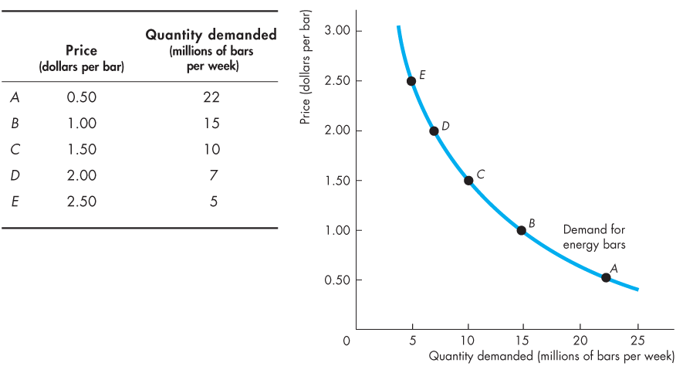
The demand curve shows the relationship between quantity demanded and price, other things remaining the same.

The Demand Schedule for Energy Bars

The demand curve slopes downward: As the price falls, the quantity demanded increases. The demand curve can be read in two ways. For a given price, the demand curve tells us the quantity that people plan to buy. For example, at a price of $1.50 a bar, people plan to buy 10 million bars a week. For a given quantity, the demand curve tells us the maximum price that consumers are willing and able to pay for the last bar available. For example, the maximum price that consumers will pay for the 15 millionth bar is $1.00.
- A Change in Demand
When any factor (other than the price of the good) that influences buying plans changes, there is a change in demand. Figure 3.2 illustrates an increase in demand.
When demand increases the demand curve shifts rightward and the quantity demanded at each price is greater. For example, at $2.50 a bar, the quantity demanded on the original (blue) demand curve is 5 million energy bars a week. On the new (red) demand curve, at $2.50 a bar, the quantity demanded is 15 million bars a week. Six main factors bring changes in demand. They are changes in the prices of related goods, expected future prices, income, expected future income and credit, population, and preferences.
FIGURE 3.2: An Increase in Demand
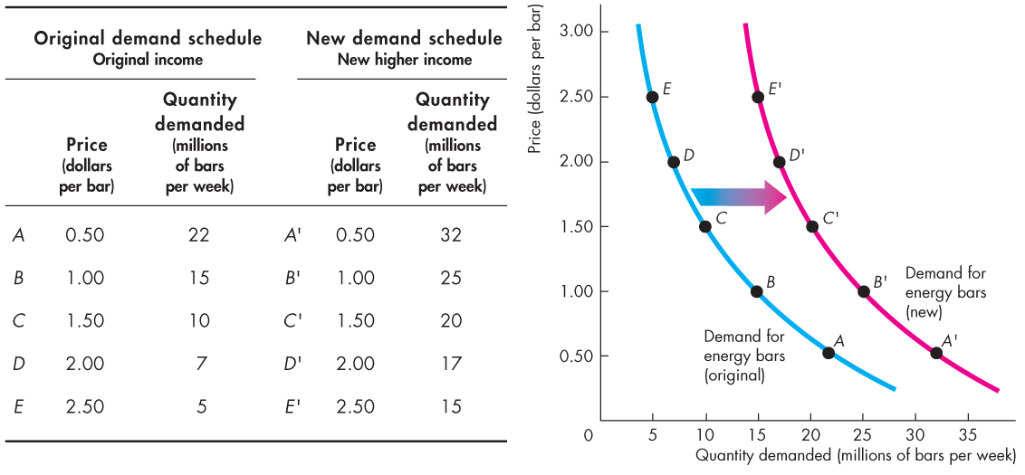
- Prices of Related Goods
The quantity of energy bars that consumers plan to buy depends in part on the prices of substitute for energy bars. A substitute is a good that can be used in place of another good. For example, a bus ride is a substitute for a train ride; a hamburger is a substitute for a hot dog; and an energy drink is a substitute for an energy bar.
If the price of a substitute for an energy bar rises, people buy less of the substitute and more energy bars. For example, if the price of an energy drink rises, people buy fewer energy drinks and more energy bars. The demand for energy bars increases. The quantity of energy bars that people plan to buy also depends on the prices of complements with energy bars. A complement is a good that is used in conjunction with another good. Tea and sugar are complements, and so are energy bars and exercise. If the price of an hour at the gym falls, people buy more gym time and more energy bars.
- Expected Future Prices
If the expected future price of a good rises and if the good can be stored, the opportunity cost of obtaining for the future use is lower today than it will be in the future. So, people retime their purchases; they substitute over time. They buy more of the good now before its price is expected to rise (and less afterward), so the demand for the good today increases.
For example, suppose that a frost damages the season’s orange crop. You expect the price of orange juice to rise, so you fill your freezer with enough frozen juice to get you through the next six months. Your current demand for frozen orange juice has increased, and your future demand has decreased. Similarly, if the expected future price of a good falls, the opportunity cost of buying the good today is high relative to what it is expected to be in the future. So again, people retime their purchases. They buy less of the good now before its price is expected to fall, so the demand for the good decreases today and increases in the future.
- Income
A change in consumers’ income changes the demand. When income increases, consumers buy more of most goods; and when income decreases, consumers buy less of most goods.
For example, at a price $1.50 a bar, 10 million energy bars a week are demanded at the original income (row C of the table in Figure 3.2) and 20 million bars a week are demanded at the new higher income (row C’). A rise in income increases the demand for energy bars. The demand curve shifts rightward, as shown by the shift arrow and the resulting red curve. Although an increase in income leads an increase in the demand for most goods, it does not lead to an increase in the demand for all goods. A normal good is one for which demand increases as income increases. An inferior good is one for which demand decreases as income increases.
- Expected future Income and Credit
When expected future income increases or credit becomes easier to get, demand for the good might increase now. For example, a sale person gets the news that she would receive a big bonus at the end of the year, so she goes into debt and buy a new car right now, rather than wait until she receive the bonus.
- Population
Demand also depends on the size and the age structure of the population. The larger the population the greater is the demand for all goods and services; the smaller the population, the smaller is the demand for all goods and services. Also, the larger the proportion of the population in a given age group, the greater is the demand for the goods and services used by that age group.
- Preferences
Demand depends on preferences. Preferences determine the value that people place on each good and service. Preferences depend on such things as the weather, information, and fashion.
- A Change in the Quantity demanded versus a Change in Demand
When the price of a good changes this brings a change in the quantity demanded; when influences other than the price of the good change they bring a change in demand. A change in the quantity demanded means a movement along the demand curve; a change in demand means a shift of the demand curve. A point in the demand curve shows the quantity demanded at a given price, so a movement along the demand curve shows a change in the quantity demanded. The entire demand curve shows demand and a shift of the demand curve shows a change in demand.
Figure 3.3 illustrates this distinction. A change in the quantity demanded, shown by the blue arrows on the demand curve D₀. A fall in the price of a good raises the quantity demanded of it. A rise in the price of a good lowers the quantity demanded of it. A change in demand shifts the demand curve. A decrease in demand shifts the demand curve leftward (from D₀ to D₂). An increase in demand shifts the demand curve rightward (from D₀ to D₁).
FIGURE 3.3: A Change in the Quantity Demanded Versus a Change in Demand
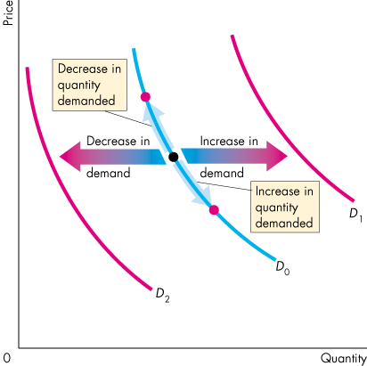
If the price of the good remains constant but some other influence on buying plans changes, there is a change in demand for that good. For example, if more people work out at the gym, consumers buy more energy bars at each price. In Figure 3.3, there is a change in demand and the demand curve shifts when any influence on buying plans, other than the price of the good, changes.
Demand increases and the demand curve shift rightward (to the red demand curve D₁) if the price of a substitute rises, the price of a complement falls, the expected future price of the good rises, income increases (for a normal good), expected future income or credit increases, the population increases.
Demand decreases as the demand curve shifts leftward (to the red demand curve D₂) if the price of a substitute falls, the price of a complement rises, the expected future price of the good falls, income decreases (for a normal good), expected future income or credit decreases, the population decreases.
For an inferior good, the effects of the changes in income are in the opposite direction to those described above.
  - SUPPLY
If a firm supplies a good or service, the firm has the resources and technology to produce it, can profit producing it, and plans to produce and sell it.
A supply is more than just have the resources and the technology to produce something. Resources and technology are the constraints that limit what is possible. Many useful things can be produced, but they are not produced unless it is profitable to do so. Supply reflects a decision about which technologically feasible items to produce. The quantity supplied of a good or service is the amount that producers’ plan to sell during a given time period at a particular price. The quantity supplied is not necessarily the same amount as the quantity actually sold. Sometimes the quantity supplied is greater than the quantity demanded, so the quantity sold is less than the quantity supplied. Like the quantity demanded, the quantity supplied is measured as an amount per unit of time. For example, suppose that a firm produces 1,000 cars a day. The quantity of car supplied by the firm can be expressed as 1,000 a day, 7,000 a week, or 365,000 a year. Without the time dimension, we cannot tell whether a particular quantity is large or small.
Many factors influence selling plans, and again one of them is the price of the good. We look first at the relationship between the quantity supplied of a good and its price. Just as we did when we studied demand, to isolate the relationship between the quantity supplied of a good and its price, we keep all other influences on selling plans the same and ask: How does the quantity supplied of a good change as its price changes, ceteris paribus?
The law of supply provides the answer.
- The Law of Supply
The law of supply states: Other things remaining the same, the higher the price of a good, the greater is the quantity supplied; and the lower the price of good, the smaller is the quantity supplied.
Suppliers can be induced to supply different quantities depending on the level of price. Some prices are so low that no seller would plan to offer goods for sale, because they could not cover costs and make a profit. Indeed, as prices rise, suppliers will supply a higher quantity because the increase in price will be enough to cover the increased costs of producing additional units of output and will add to profits. The higher price brings forth an increase in the quantity supplied.
- Supply Curve and Supply Schedule
We illustrate the law of supply with a supply curve and a supply schedule. The supply curve is a graph of a supply schedule. Figure 3.4 shows the supply schedule and the supply curve of energy bars. A supply schedule shows the quantity supplied at each price when all other influences on producers’ planned sales remain the same. For example, if the price of an energy bar is 50 cent, the quantity supplied is zero (row A of the table). If the price of energy bar is $1.00, the quantity supplied is 6 million energy bars a week, in row B. The other rows of the table show the quantities supplied at prices of $1.50, $2.00, and $2.50. To make a supply curve, we graph the quantity supplied on the x-axis and the price on the y-axis. The points on the supply curve labeled A through E correspond to the rows of the supply schedule.
For example, point A on the graph shows a quantity supplied of zero at a price of 50 cent an energy bar. Point E shows a quantity of 15 million bars at $2.50 an energy bar. There is a positive relationship between the price of the good and the quantity supplied of that good. So, the supply curve slopes upward: As the price of a good rises, the quantity supplied increases. For example, at a price of $1.00, 6 million bars a week are supplied; at a higher price of $2.50, 15 million bars a week are supplied.
FIGURE 3.4: The Supply Curve
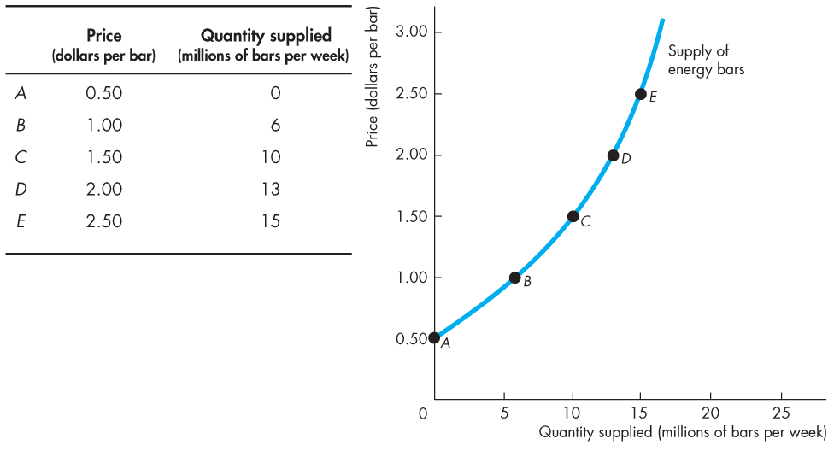
The supply schedule for energy bars

A supply curve can be read in two ways. For a given price, it tells us the quantity that producers plan to sell at that price. For example, at a price of $1.50 a bar, they are planning to sell 10 million bars a week. For a given quantity, it tells us the price corresponding to this quantity.
There is a critical distinction between supply and quantity supplied. The term supply refers to the entire relationship between the price of a good and the quantity supplied of it. Supply is illustrated by the supply curve or the supply schedule. The term quantity supplied refers to a point on the supply curve: the quantity supplied at a particular price.
The supply curve can be interpreted as a minimum-supply price curve. For a given quantity the supply curve tells us the minimum price at which producers are willing to sell one more bar.
In Figure 3.4, if 15 million bars are produced each week, the lowest price at which someone is willing to sell 15 millionth bar is $2.50. But if 10 million bars are produced each week, the lowest price at which someone is willing to accept is $1.50. But as the quantity increases, the lowest price at which someone is willing to sell an additional unit rises along the supply curve.
- A Change in Supply
When any factor that influences selling plans, other than price of the good, changes, there is a change in supply. Six main factors bring changes in supply. They are changes in the prices of factors of production, the prices of related goods produced, expected future prices, the number of suppliers, technology, and the state of nature
- Prices of Factors of Production
To see the influence of the prices of the factors of production used to produce a good, think about the supply curve as a minimum-supply price curve. If the price of a factor of production rises, the lowest price that a producer is willing to accept for that good rises, so supply decreases. For example, a rise in the minimum wage decreases the supply of hamburgers.
- Prices of Related Goods Produced
The prices of the related goods that firm can produce influence supply. Related goods may be substitutes or complements. For example, energy bars and energy gel are substitutes in production. They are goods that can be produced by using the same resources. If the price of energy gel rises, ceteris paribus, firms switch production from bars to gel. The supply of energy bars decreases. Beef and cowhide are complements in production. They are goods that must be produced together. If the price of beef rises, ceteris paribus, the supply of cowhide increases.
- Expected Future Prices
If the expected future price of a good rises, the return from selling the good in the future increases and is higher than it is today. The supply decreases today and increases in the feature.
- The Number of Suppliers
In a perfectly competitive market, the larger the number of firms that produce a good, the greater is the supply of the good. As a new firm enters an industry, the supply in that industry increases. As firms leave an industry, the supply in that industry decreases.
- Technology
The term technology is used broadly to mean the ways that factors of production are used to produce a good. A technological change occurs when a new method is discovered that lowers the cost of producing a good. For example, new method used in the factories that produce computer chips have lowered the cost and increased the supply of chips.
- The State of Nature
The state of nature includes all the natural forces that influence production. In includes the state of the weather and, more broadly, the natural environment. Good weather can increase the supply of many agricultural products and bad weather can decrease their supply. Extreme natural events such as earthquakes, tornadoes, and hurricanes can also influence supply.
A change in any influence on selling plans other than the price of the good itself results in a new supply schedule and a shift in the supply curve. Figure 3.5 illustrate an increase in supply.
FIGURE 3.5: An Increase in Supply
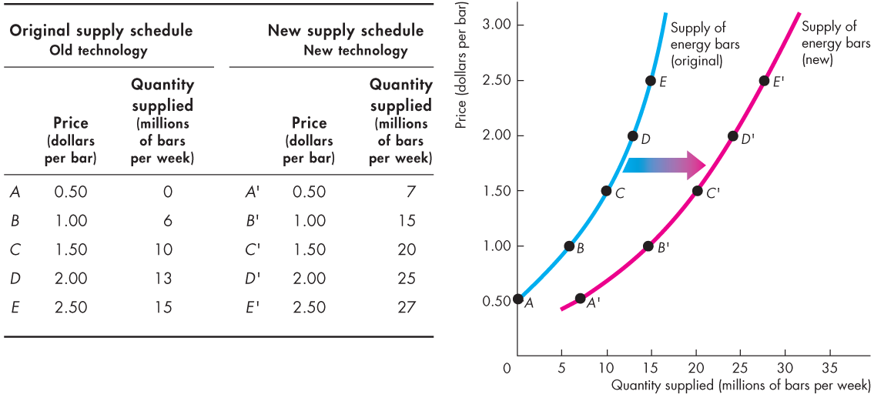
An advance in technology (for example, a new cost-saving technology) increases the supply of energy bars. At a price of $1.5 a bar, 10 million bars a week are supplied when producers use the old technology (row C) and 20 million energy bars a week are supplied when producers use the new technology (row C’). When supply increases, the supply curve shifts rightward and the quantity supplied at each price is larger.
In Figure 3.5, the old supply curve is the blue one and the new supply curve is the red one. For example, at $1.00 a bar, on the original (blue) supply curve, the quantity supplied is 6 million bars a week. On the new (red) supply curve, the quantity supplied is 15 million bars a week.
- A Change in the Quantity Supplied Versus a Change in Supply
Changes in the influences on selling plans bring either a change in the quantity supplied or a change in supply. Equivalently, they bring either a movement along the supply curve or a shift of the supply curve. A point on the supply curve shows the quantity supplied at a given price. A movement along the supply curve shows a change in the quantity supplied. The entire supply curve shows supply. When any influence on selling plans other than price changes, the supply curve shifts and there is a change in supply.
FIGURE 3.6: A Change in the Quantity Supplied Versus a Change in Supply
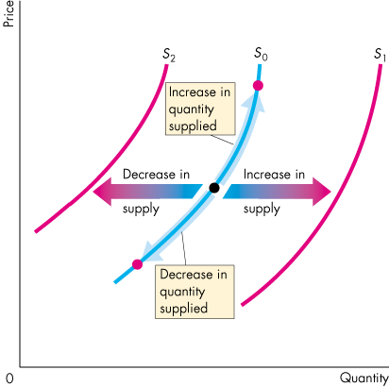
Figure 3.6 illustrates and summarizes these distinctions. If the price of the good changes, ceteris paribus, there is a change in the quantity supplied of the good. If the price of the good falls, the quantity supplied decreases and there is a movement down along the supply curve S₀. If the price of the good rises, the quantity supplied increases and there is a movement up along the supply curve S₀. If supply increases, the supply curve shifts rightward to S₁. If supply decreases, the supply curve shifts leftward to S₂.

HOMEWORK 3
- Define demand and quantity demanded and state the difference between them.
- Define supply and quantity supplied and state the difference between them.
- State the law of demand and the law of supply.
- What do the demand curve and the supply curve tell us?
- Explain the substitution and income effects of a price change on the quantity demanded.
- List the factors affecting demand (shifting the demand curve).
- List the factors affecting supply (shifting the demand curve).
- Suppose that the price of gasoline per litter has increased from 4.50 liras to 5.00 liras, ceteris paribus. Explain how the rise in the price of gasoline would affect
  - The demand for gasoline.
  - The quantity of gasoline demanded.
- Place the following goods and services into pairs of likely substitutes and pairs of likely complements. (You may use an item in more than one pair).The goods and services are: coal, oil, natural gas, wheat, corn, rye, pasta, pizza, sausage, laptop, iPod, cell phone, text message, email, phone call.
- When the price of corn increased by 20 percent while the price of cotton stayed constant, most of the farmers in Çukurova decreased cotton production and increased corn production.
- Does this fact illustrate the law of demand or the law of supply? Explain your answer.
- Why farmers did change their production plan?

CHAPTER 4
MARKET EQUILIBRIUM AND ELATICITY
4.1. MARKET EQUILIBRIUM
Now we will combine demand and supply and see how prices and quantities are determined. We have seen that when the price of a good rises, the quantity demanded decreases and the quantity supplied increases. We are now going to see how the price adjusts to coordinate buying plans and selling plans and achieve the equilibrium in the market. Equilibrium in market occurs when the price balances buying and selling plans. The equilibrium price is the price at which the quantity demanded equals the quantity supplied. The equilibrium quantity is the quantity bought and sold at the equilibrium price. A market moves toward its equilibrium, because price regulates buying and selling plans. Price adjusts when plans don’t match.
- Price as a Regulator
The price of a good regulates the quantities demanded and supplied. If the price is too high, the quantity supplied exceeds the quantity demanded. If the price is too low, the quantity demanded exceeds the quantity supplied. There is one price at which the quantity demanded equals the quantity supplied.
Figure 4.1 shows the market for energy bars. The table combines the demand schedule (from Figure 3.1) and the supply schedule (from Figure 3.4). If the price is 50 cent a bar, the quantity demanded is 22 million bars a week but no bars are supplied. There is a shortage of 22 million bars a week. The final column of the table shows this shortage. At a price of $1.00 a bar, there is still a shortage but only 9 million bars a week. The one price at which there is neither a shortage nor a surplus is $1.50 a bar. At that price, the quantity demanded equals the quantity supplied: 10 million bars a week. The equilibrium price is $1.50 a bar, and the equilibrium quantity is 10 million bars a week.
Figure 4.1 shows that the demand and the supply curves intersect at the equilibrium price of $1.50 a bar. At each price above $1.50 a bar there is a surplus of bars. For example, at $2.00 a bar, the surplus is 6 million bar a week, as shown by the blue arrow. At each price below $1.50 a bar there is a shortage of bars. When price is $1.00 a bar, the shortage is 9 million bars a week as shown by the red arrow.
FIGURE 4.1: Equilibrium tablodaki rakamlar
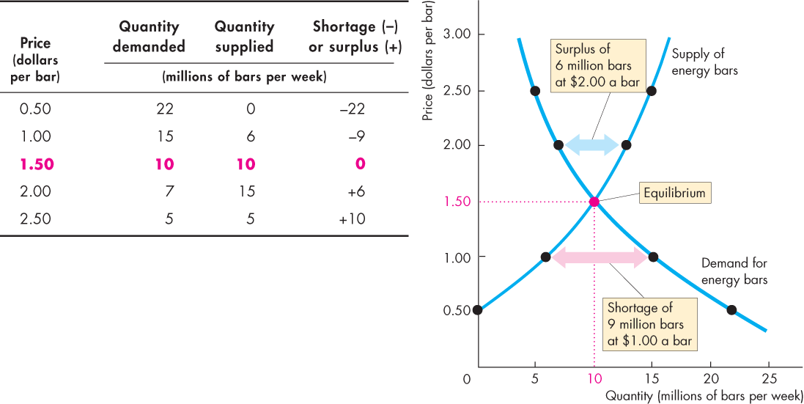
We have seen that if the price is below equilibrium, there is a shortage and that if the price is above equilibrium, there is a surplus. When there is either a surplus or a shortage the price changes and eliminates them.
A shortage Forces the Price Up: Suppose the price of an energy bar is $1. Consumers plan to buy 15 millions bars a week, and producers plan to sell 6 million bars a week. Consumers can’t force producers to sell more than they plan, so the quantity that is actually offered for sale is 6 million bars a week. In this situation, powerful forces operate to the price and move it toward to equilibrium price. Some producers, noticing lines of unsatisfied consumers, raise the price. Some producers increase their output. As producers push the price up, the price rises toward its equilibrium. The rising price reduces the shortage because it decreases the quantity demanded and increases the quantity supplied. When the price has increased to the point at which there is no longer a shortage, the forces moving the price stop operating and the price comes to rest at its equilibrium.
A Surplus Forces the Price Down: Suppose the price of a bar is $2. Producers plan to sell 13 million bars a week, and consumers plan to buy 7 million bars a week. Producers cannot force the consumers to buy more than they plan, so the quantity that is actually bought is 7 million bars a week. In this situation, powerful forces operate to lower the price and move it toward the equilibrium price. Some producers, unable to sell the quantities of energy bars they planned to sell, cut their prices. In addition, some producers scale back production. As producers cut the production, price falls toward its equilibrium. The falling price decreases the surplus because it increases the quantity demanded and decreases the quantity supplied. When the price has fallen to the point at which there is no longer a surplus, the forces moving the price stop operating and the price comes to rest at its equilibrium.
- Predicting Changes in Price and Quantity
The demand and supply model provides us a way of analyzing influences on prices and quantities bought and sold. According to the model, a change in price stems from a change in demand, a change in supply, or a change in both demand and supply.
- An Increase in Demand
If more people join health clubs, the demand for energy bars increases. The table in Figure 4.2 shows the original and new demand for energy bars as well as the supply schedule of energy bars. The increase in demand creates a shortage at the original price and to eliminate the shortage, the price must rise. Figure 4.2 shows what happens.
FIGURE 4.2: The Effects of a Change in Demand
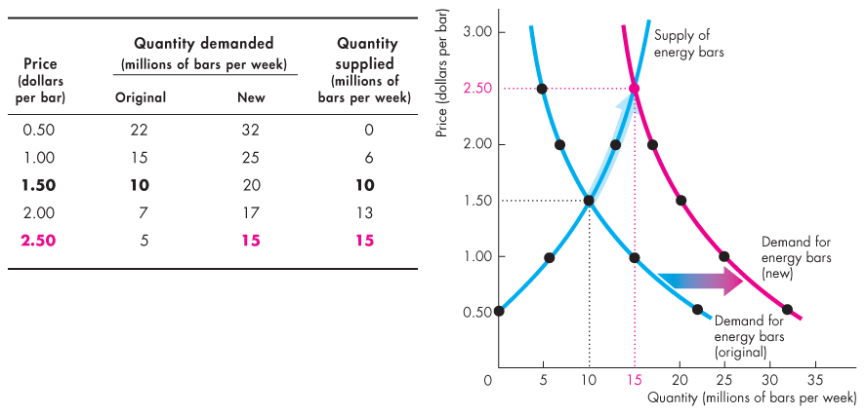
Initially, the demand for energy bars is the blue demand curve. The equilibrium price is $1.50 a bar, and the equilibrium quantity is 10 millions bars a week. When the demand for energy bars increases the demand curve shifts rightward and becomes the red curve. At $1.50 a bar, there is now a shortage of 10 million bars a week. The price of a bar rises to a new equilibrium of $2.50.
When the price rises to $2.50, the quantity supplied increases, as shown by the blue arrow on the supply curve, to the new equilibrium quantity of 15 million bars a week. Following an increase in demand, the quantity supplied increases but supply does not change. There is an increase in the quantity supplied but no change in supply: there is a movement along, but no shift of, the supply curve.
- A Decrease in Demand
We can reverse this change in demand. Start at a price of $2.50 a bar with 15 million energy bars a week being bought and sold, and then work out what happens if demand decreases to its original level. Such a decrease in demand might arise if people switch to energy gel (a substitute for energy bars). The decrease in demand shifts the demand curve leftward. The equilibrium price falls to $1.50 a bar, the quantity supplied decreases, and equilibrium quantity decreases to 10 million bars a week. We can now make our first two predictions, ceteris paribus: When demand increases, the price rises and the quantity increases. When demand decreases, the price falls and the quantity decreases.
- An Increase in Supply
When energy bar producers switch to a new cost-saving technology the supply of energy bars increases. Figure 4.3 illustrates the effect of an increase in supply. It shows the demand for energy bars and the original and new supply curves. The initial equilibrium price is $1.50 a bar, and the equilibrium quantity is 10 million bars a week.
When supply increases, the supply curve shifts rightward. The new quantity supplied at that price is 20 million bars a week, and there is a surplus. The equilibrium price falls to $1.00 a bar, and the quantity demanded increases to 15 million bars a week, highlighted in the figure. Only when the price is $1.00 a bar does the quantity supplied equal the quantity demanded. There is an increase in the quantity demanded but no change in demand: there is a movement along, but no shift of, the demand curve.

FIGURE 4.3: The Effects of a Change in Supply
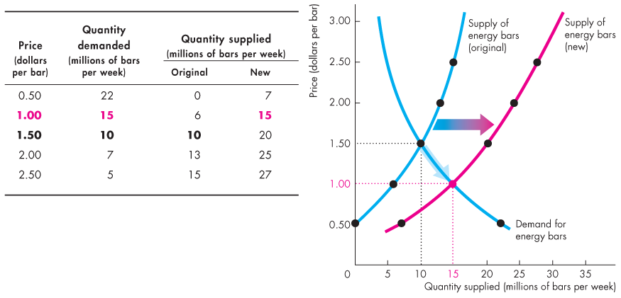
- All the Possible Changes in Demand and Supply
With what we have learned about the effects of a change in either demand or supply, we can predict what happens if both demand and supply change together.
  - ELASTICITY
We have seen that when the price of a good changes, the demand for and the supply of that good also change. We want to know how much the quantity supplied or demanded will rise or fall when the price of a good changes. Elasticity concept measures the sensitivity of the quantity to a change in price. Elasticity measures, generally, the sensitivity of one variable to another. Specifically, it is a number that tells us the percentage change that will occur in one variable in response to a 1-percent change in another variable.
    - PRICE ELASTICITY OF DEMAND
- Definition
The price elasticity of demand measures the sensitivity of quantity demanded to the price changes. It tells us the percentage change in the quantity demanded for a good following a 1-percent change in the price of that good. Denoting quantity and rice by Q and P, we write the price elasticity of demand, E_{P}, as
Price elasticity of demand (E_{P}) =$\frac{percentage change in the quantity demanded}{percentage change in the price of the good}$ $= \frac{\%∆Q}{\%∆P}$
The percentage change in a variable is just the absolute change in the variable divided by the original level of variable. Thus, we can also write the price elasticity of demand as follows:
E_{P} = $\frac{∆Q/Q}{∆P/P}=$ $\frac{∆Q}{∆P} \frac{P}{Q}$
For example, to calculate the price elasticity of demand for pizza, we need to know the quantity demanded of pizza at two different prices.
The price elasticity of demand is usually a negative number. When the price of a good rises, the quantity demanded usually falls: (∆Q/∆P) is negative. Since (P/Q) is always positive, E_{p} is also negative. We refer, generally, to the magnitude of the price elasticity; i.e., its absolute size. For example, if E_{p} = -2, we say that the elasticity is 2 in magnitude.
When the price elasticity is greater than 1 in magnitude, we say that the demand is price elastic because the percentage decline in quantity demanded is greater than the percentage increase in price. If the price elasticity is less than 1 in magnitude, demand is price inelastic. When the price elasticity is 1, demand is unit elastic. Goods and services have an elasticity of demand between zero and infinity.
Price elasticities for different goods are not the same. Moreover, the price elasticity of demand for a good is not the same at different price levels of the good. Price elasticity of demand is higher at high price levels and lower at low price levels. (∆Q/∆P) is the slope of the demand curve. For a given slope, (P/Q) will be higher at high price levels and lower at low price levels, because of the negative relationship between P and Q. Therefore, [(∆Q/∆P)/ (P/Q)] will be higher when P is high and lower when P is low.
Example: Suppose that when the price of a product rises from 8 to 10 liras, its quantity demanded fall from 6 units to 4. What is the price elasticity of demand for that good?
E_{P} = (ΔQ/ΔP)/(P/Q) = (Q₂-Q₁)(P₂-P₁)(P₁/Q₁)
=$\frac{4-6}{10-8} \frac{8}{6}=\frac{-2}{2}\frac{4}{3}= -\frac{4}{3}$ = -1.33
Since the absolute value of the elasticity coefficient is greater than one, demand for that good is price elastic. That means the percentage decrease in the quantity is higher than the percentage increase in price.
- The Factors That Influence the Elasticity of Demand
The elasticity of demand of a good depends on the closeness of substitutes, the proportion of the income spent on the good, and the time elapsed since the price change.
- Closeness of Substitutes
The closer the substitutes for a good or service the more elastic is the demand for it. Oil from which we make gasoline has no close substitutes. So the demand for oil is inelastic. Plastics are close substitutes for metals, so the demand for metals is elastic. In everyday language we call goods such as food and shelter necessities and goods such as exotic vacations luxuries. A necessity has poor substitutes and is crucial for our well-being. So, a necessity generally has an inelastic demand. A luxury usually has many substitutes, one of which is not buying it. So, luxury generally has an elastic demand.
- Proportion of Income Spent on the Good
The greater the proportion of income spent on a good, the more elastic is the demand for it. Think about your own elasticity of demand for chewing gum and housing, ceteris paribus. If the price of gum doubles, you consume almost as much as before. Your demand for gum is inelastic. If apartment rents double, you look for more students to share accommodation with you. Your demand for housing is much more elastic than your demand for gum, because housing takes a large proportion of your budget, and gum takes only a tiny proportion.
- Time Elapsed Since Price Change
The longer the time that has elapsed since a price change, the more elastic is demand. When the price of oil increased by 400 percent during 1970s, people barely changed the quantity of oil and gasoline they bought. But gradually, as more efficient auto and airplane engines were developed, the quantity bought decreased. The demand for oil became more elastic as more time elapsed following the huge price hike.
    - CROSS PRICE ELASTICITY OF DEMAND
We have already learned that changes in the prices of related goods affect the demand for a good. Cross elasticity of demand describes how the quantity demanded of a good changes when the price of a related good changes. The cross elasticity of demand is a measure of responsiveness of the demand for a good to a change in the price of a substitute or complement, ceteris paribus. We calculate the cross elasticity of demand using this formula
Cross elasticity of demand =$\frac{\% change in the quantity demanded}{\% change in the price of a substitute or complement}$
The cross elasticity of demand can be positive or negative. It is positive for a substitute: The demand for a good rises when the price of a substitute increases. A rise in the price of margarine, for example, makes butter cheaper relative to margarine and leads to an increase in the demand for butter. The cross elasticity of demand is negative for a complement: The demand for a good falls when the price of a complement increases. If the price of gasoline goes up, for example, the demand for cars falls.
If two items are close substitutes, such as two brands of spring water, the cross elasticity is large. If the items are close complements, such as cars and gasoline, the cross elasticity is large. If two items are somewhat unrelated to each other, such as newspapers and orange juice, the cross elasticity is small – perhaps even zero.
    - INCOME ELASTICITY OF DEMAND
The income elasticity of demand is a measure of responsiveness of the demand for a good or service to a change in income, ceteris paribus. The income elasticity of demand (E_{I}) is calculated by using the formula
E_{I} = $\frac{percentage change in the quantity demanded}{percentage change in income}$
Income elasticity of demand can be positive or negative and they fall into thee ranges:
  - Greater than 1 (normal goods, income elastic)
  - Positive and less than 1 (normal goods, income inelastic)
  - Negative (inferior gods)
When the demand of a good is income elastic, the percentage of income spent on that good rises as income increases. If the income elasticity of demand is positive but less than 1, demand is income inelastic. The percentage increase in the quantity demanded is positive but less than percentage increase in income. When the demand for a good is income inelastic, the percentage of income spent on that good falls as income increases.
If the income elasticity of demand is negative, the good is an inferior good. The quantity demanded of an inferior good and the amount spent on it decrease when income increases. Goods in this category include bread, potatoes, and rice. Low income consumers buy most of these goods.
    - ELASTICITY OF SUPPLY
The elasticity of supply measures the responsiveness of the quantity supplied to a change in the price of a good, ceteris paribus. It is calculated using the formula:
Elasticity of supply = $\frac{percentage change in the quantity supplied}{percentage change in price}$
The elasticity of supply is usually positive because a higher price gives producers an incentive to increase output. We can also refer to elasticity of supply with respect to such variables as interest rates, wage rates, and the prices of raw materials and other intermediate goods used to manufacture the product in question. For example, for most manufactured goods, the elasticity of supply with respect to the prices of raw materials is negative. An increase in the price of a raw material input means higher costs for the firm; therefore, the quantity supplied will fall, ceteris paribus. Goods and services have an elasticity of supply between zero and infinity. The elasticity of supply of a good depends on resource substitution possibilities and time frame for the supply decision
- Resource Substitution Possibilities
Some goods and services can be produced only by using unique or rare productive resources. These items have a low, perhaps even zero, elasticity of supply. Other goods and services can be produced by using commonly available resources that could be allocated to wide variety of alternative tasks. Such items have a high elasticity of supply. The supply of most goods and services lies between these two extremes.
- Time Frame for the Supply Decision
To study the influence of the amount of time elapsed since a price change we distinguish three time frames of supply: Momentary supply, short-run supply, and long-run supply
Momentary Supply: When the price of a good changes the immediate response of the quantity supplied is determined by the momentary supply of that good. Some goods, such as fruits and vegetables, have perfectly inelastic momentary supply. The quantities supplied depend on crop-planting decisions made earlier. In the case of oranges, for example, planting decisions have to be made many years in advance of the crop being available. Momentary supply is perfectly inelastic because, on a given day, no matter what the price of oranges, producers cannot change their output. They have picked, packed, and shipped their crop to market, and the quantity available for that day is fixed.
Short-Run Supply: In the short run, the response of the quantity supplied to a price change is determined by the short-run supply. In the short run, only some of the possible adjustments to production can be made. Most goods have an inelastic short-run supply. To increase output in the short run, firms must work their labor force overtime and perhaps hire additional workers. To decrease their output in the short run, firms either lay off workers or reduce their hours of work. With the passage of time, firms can make adjustments, perhaps training additional workers or buying additional tools and other equipment. For the orange grower, if the price of oranges falls, some pickers can be laid off and oranges left on the trees. Or if the price of oranges rises, the grower can use more fertilizer and improved irrigation to increase the yields of their existing trees. But an orange grower can’t change the number of trees producing oranges in the short run.
Long-Run Supply: In the long run, the quantity supplied responses to a price change after all the technologically possible ways of adjusting supply have been exploited. For most goods and services, long-run supply is elastic and perhaps perfectly elastic. For the orange grower, the long run is the time it takes new tree planting to grow to full maturity. In some cases, the long-run adjustment occurs only after a completely new production plant has been built and workers have been trained to operate it. Typically that process might take several years.
HOMEWORK 4
- What is the equilibrium price?
- What happens when the actual price is higher or lower than the equilibrium price?
- Define the price elasticity of demand and show how it is calculated.
- Explain the factors influencing the price elasticity of demand?
- What does the sign (positive versus negative) of the cross elasticity of demand tell about the relationship between two goods?
- What does the income elasticity of demand measure? What is the meaning of the sign (positive versus negative) of the income elasticity of demand?
- Which factors determine the elasticity of supply?
- Rain spoils the strawberry crop, the price increases from $4 to $6 a box, and the quantity demanded decrease from 1,000 to 600 boxes a week.
  - Calculate the price elasticity of demand.
  - Describe the demand for strawberries.
- The demand schedule for hotel room is
Price Quantity demanded
(per dollar per night) (millions of room per night)
200 100
250 80
400 50
500 40
800 25

  - What happens to total revenue when the price falls from $400 to $250 a night and from $250 to $200 a night?
  - Is the demand for hotel rooms elastic, inelastic, or unit elastic?
- If a 12 percent rise in the price of orange juice decreases the quantity of orange juice demanded by 22 percent and increases the quantity of apple juice demanded by 14 percent, calculate the
  - Price elasticity of demand for orange juice.
  - Cross elasticity of demand for apple juice with respect to the price of orange juice.

CHAPTER 5
FIRMS (PRODUCERS)
5.1. THE FIRM AND ITS ECONOMIC PROBLEM
Firms hire factors of production and organize those factors to produce and sell goods and services. Firms differ in size and in the scope of what they do, but they all perform the same basic economic functions. In this chapter we will explain firm’s behavior. To do so, we need to know its goal and the constraints it faces. We start with the goal.
- The Firm’s Goal
Although firms have many goals such as making a high-quality product, growth, and increasing market share, a firm’s main goal is to maximize profit. To understand what is the profit that a firm seeks to maximize, we will look at Campus Sweaters, Inc. Campus Sweaters is a small producer of knitted sweaters owned and operated by Cindy.
- Accounting Profit
In 2010, Campus Sweaters received $400,000 for the sweaters it sold. It paid out $80,000 for wool, $20,000 for utilities, $120,000 for wages, $5000 for the lease of a computer, $5000 in interest on a bank loan. These expenses total $230,000. So the firm had a cash surplus of $170,000 (= $400,000-$230,000).
To measure the profit of Campus Sweaters, Cindy’s accountant subtracted $20,000 for the depreciation of the buildings and knitting machines from the $170,000 cash surplus. Depreciation is the fall in the value of a firm’s capital. Cindy’s accountant calculated that Campus Sweaters made a profit of $150,000 in 2010 ($170,000-$20,000=$150,000).
- Economic Profit
Accounting profit and economic profit are not synonymous. Accounting profit equals total income minus expenses minus depreciation. Economic profit is the difference between total income and the opportunity cost of production.
- Opportunity Cost of Production
The opportunity cost of production is the value of the best alternative use of the resources that a firm uses in production. A firm’s opportunity cost of production is the value of real alternatives forgone. We express opportunity cost in money units so that we can compare and add up the value of the alternatives forgone. A firm’s opportunity cost of production is the sum of the cost of using resources. These resources are of three types: Bought in the market, owned by the firm and supplied by the firm’s owner
- Resources Bought in the Market
A firm incurs an opportunity cost when it buys resources in the market. The amount spent on these resources is an opportunity cost of production because they could have bought different resources to produce some other goods or services. For Campus Sweaters, the resources bought in the market are wool, utilities, labor, a leased computer, and a bank loan. The $230,000 spent on these items in 2010 could have been spent on something else, so it is an opportunity cost of producing sweaters.
- Resources Owned by the Firm
A firm incurs an opportunity cost when it uses its own capital. The cost of using capital owned by the firm is an opportunity cost of production because the firm could sell the capital that it owns and rent capital from another firm. When a firm uses its own capital, it implicitly rents it from itself. In this case, the firm’s opportunity cost of using the capital it owns is called the implicit rental rate of capital. The implicit rental rate of capital has two components: economic depreciation and forgone interest.
Economic depreciation: Accountants measure depreciation using formulas that are unrelated to the change in the market value of capital. But economic depreciation is the fall in the market value of the firm’s capital over a given period. Economic depreciation equals the market price of the capital at the beginning of the period minus the market price of the capital at the end of the period. Suppose that Campus sweaters could have sold its buildings and knitting machines on January 1, 2010, for $400,000 and that it can sell the same capital on December 31, 2010, for $375,000. The firm’s economic depreciation during 2010 is $25,000 ($400,000-$375,000 = $25,000). This forgone $25,000 is an opportunity cost of production.
Forgone Interest: The funds used to buy capital could have been used for some other purpose, and in their next best use, they would have earned interest. This forgone interest is an opportunity cost of production. Suppose that Campus Sweaters used $300,000 of its own funds to buy capital. If the firm invested its $300,000 in bonds instead of knitting factory and rented capital it needs to produce sweaters, it would have earned $15,000 a year in interest, assuming an interest rate of 5%. This forgone interest is an opportunity cost of production.
- Resources Supplied by the Firm’s Owner
A firm’s owner might supply both entrepreneurship and labor.
Entrepreneurship: The factor of production that organizes a firm and makes its decisions might be supplied by the firm’s owner or by a hired entrepreneur. The return to entrepreneurship is profit, and the profit that an entrepreneur earns on average is called normal profit. Normal profit is the cost of entrepreneurship and is an opportunity cost of production. If Cindy supplies entrepreneurial services by herself, and if the normal profit that she can earn on these services is $45,000 a year, this amount is an opportunity cost of production at Campus Sweaters.
Owner’s Labor Services: In addition to supplying entrepreneurship, the owner of a firm might supply labor but not take a wage. The opportunity cost of the owner’s labor is the wage income forgone by not taking the best alternative job. If Cindy supplies labor to Campus Sweaters, and if the wage she can earn on this labor at another firm is $55,000 a year, this amount of wage forgone is an opportunity cost of production at Campus Sweaters.
TABLE 5.1 Economic Accounting
Item Amount
Total Revenue $400,000
Costs of resources Bought in Market
Wool $80,000
Utilities 20,000
Wages 120,000
Computer lease 5,000
Bank interest 5,000 $230,000
Cost of Resources Owned by the Firm
Economic depreciation $25,000
Forgone interest 15,000 $40,000
Cost of Resources Supplied by Owner
Cindy’s normal profit $45,000
Cindy’s forgone wages 55,000 $100,000
Opportunity Cost of Production $370,000
Economic Profit $30,000

- Economic accounting: A Summary
Table 5.1 summarizes the economic accounting. Campus Sweaters’ total revenue is $400,000; its opportunity cost of production is $370,000; and its economic profit is $30,000. Cindy’s personal income is $130,000: the $30,000 of economic profit plus the $100,000 that she earns by supplying resources to Campus Sweaters ($45,000 normal profit plus $55,000 forgone wages).
  - DECISIONS OF THE FIRM
To achieve the objective of maximum economic profit, a firm must take five decisions:
  - What to produce and in what quantities
  - How to produce
  - How to organize and compensate its managers and workers
  - How to market and price its products
  - What to produce itself and buy from others
In all these decisions, a firm’s actions are limited by the constraints that it faces. Three features of a firm’s environment limit the maximum economic profit it can make. They are technology constraints, information constraints, and market constraints
- Technology Constraints
Technology is the method of producing a good or service. Technology includes the detailed designs of machines, the layout of the workplace and the organization of the firm. Technology advances over time. But at each point in time, to produce more output and gain more revenue, a firm must hire more resources and incur greater costs. The increase in profit that a firm can achieve is limited by the technology available. For example, the maximum number of cars per day that a car producer can produce by using its current plant and workforce is limited. To produce more cars per day, car producer must hire more resources. Hiring more resources increases its costs and limits the increase in profit that it can make by selling the additional cars.
- Information Constraints
We never posses all the information we would like to make decisions. We lack the information about both the future and the present. A firm is constrained by limited information about the quality and efforts of its workforce, the current and future buying plans of its customers, and the plans of its competitors. Workers might make too little effort, customers might switch to competing suppliers, and a competitor might enter the market and take some of the firm’s business. To address these problems, firms create incentives to boost workers’ efforts even when no one is monitoring them; conduct market research to lower uncertainty about customers’ buying plans, and spy on each other to anticipate competitive challenges. But these efforts don’t eliminate incomplete information and uncertainty, which limit the economic profit that a firm can make.
- Market Constraints (Demand Constraints)
The quantity each firm can sell and the price it can obtain are constrained by its customers’ willingness to pay and the prices and marketing efforts of other firms. Similarly, the resources that firm can buy and the prices it may pay for them are limited by the willingness of people to work for and invest in the firm. Firms spend billions of dollars a year for marketing and selling their products. Market constraints and the expenditures firms make to overcome them limit the profit a firm can make.
- Technological and Economic Efficiency
There are two concepts of production efficiency: technological efficiency and economic efficiency. Technological efficiency occurs when the firm produces a given output by using the least amount of input. Economic efficiency occurs when the firm produces a given output at the least cost. Let’s explore the two concepts of efficiency by studying an example.
Suppose that there are four alternative techniques for making TVs:
A) Robot production: One person monitors the entire computer-driven process.
B) Production line: Workers specialize in a small part of the job as the emerging TV passes them on a production line.
C) Hand-tool production: A single worker uses a few hand tools to make a TV.
D) Bench production: Workers specialize in a small part of the job but walk from bench to bench to perform their task.
Table 5.2 sets out the amount of labor and capital required by each of these four methods to make 10 TVs a day. Now the question is: Which of these alternative methods are technologically and economically efficient?
- Technological Efficiency
Technological efficiency occurs when the firm produces a given output by using the least amount of inputs. In the table, the method A uses the most capital and the least labor. Method C uses the most labor and the least capital. Method B and method D lie between the two extremes. Method B and method D use less capital and more labor than Method A and less labor and more capital than Method C. When we compare methods B and D we see that Method D requires 100 workers and 10 units of capital to produce 10 TVs. Those same 10 TVs can be produced by method B with 10 workers and the same 10 units of capital. Because method D uses the same amount of capital and more labor than method B, method D is not technologically efficient. The other three methods are technologically efficient. Method A uses more capital but less labor than method B and method C uses more labor but less capital than method B. Which of the methods are economically efficient?
TABLE 5.2 Four Ways of Making 10 TVs a Day
Quantities of inputs
Method Labor Capital
A Robot production 1 1,000
B Production line 10 10
C Hand-tool production 1,000 1
D Bench production 100 10
- Economic Efficiency
Economic efficiency occurs when the firm produces a given output at the least cost. Method D, which is technically inefficient, is also economically inefficient. It uses the same amount of capital as method B but 10 times as much labor, so it costs more. A technologically inefficient method is never economically efficient. One of the three technologically efficient methods is economically efficient. The other two are economically inefficient. But which method is economically efficient depends on factor prices.
In Table 5.3 there are three different sets of factor prices. The table shows how input prices affect economic efficiency of production methods. In Table 5.3(a), the wage rate is $75 per day and the rental rate of capital is $250 per day. Method B has the lowest cost and is the economically efficient method.
In Table 5.3(b), the wage rate is $150 a day and the rental rate of capital is $1 a day. Method A has the lowest cost and it is the economically efficient method. In this case, capital is so cheap relative to the labor that the method that uses the most capital is the economically efficient method.
In Table 5.3(c), the wage rate is $1 a day and the rental rate of capital is $1,000 a day. Method C has the lowest cost and is the economically efficient method. In this case, labor is so cheap relative to capital that, the method that uses the most labor is the economically efficient method.
TABLE 5.3 Costs of Different Ways of Making 10 TVs a Day
- Wage rate $75 per day; capital rental rate $250 per day
Method | Inputs |  | Labor cost  ($75 per day) | Capital cost  ($75 per day) | Total cost
 | Labor | Capital
A | 1 | 1,000 | $75 | $250,000 | $250,075
B | 10 | 10 | 750 | 2,500 | 3,250
C | 1,00 | 1 | 75,000 | 250 | 75,250
- Wage rate $150 per day; capital rental rate $1 per day (labor is expensive, capital is cheap)
Method | Inputs |  | Labor cost  ($75 per day) | Capital cost  ($75 per day) | Total cost
 | Labor | Capital
A | 1 | 1,000 | $150 | $1,000 | $1,150
B | 10 | 10 | 1,500 | 10 | 1,510
C | 1,00 | 1 | 150,000 | 1 | 150,001
- Wage rate $1 per day; capital rental rate $1,000,00 (labor is cheap, capital is expensive)
Method | Inputs |  | Labor cost  ($75 per day) | Capital cost  ($75 per day) | Total cost
 | Labor | Capital
A | 1 | 1,000 | $1 | $1,000,000 | $1,000,001
B | 10 | 10 | 10 | 10,000 | 10,010
C | 1,00 | 1 | 1,000 | 1,000 | 2,000

HOMEWORK 5
- What is a firm’s fundamental goal?
- Why do accountants and economists calculate a firm’s cost and profit in different ways?
- What are the items that make opportunity cost differ from the accountant’s measure of cost?
- Why is normal profit and opportunity cost?
- What are the constraints that a firm faces?
- Define technological efficiency and economic efficiency.
- Is a firm technologically efficient if it uses the latest technology?
- Why do some firms use large amounts of capital and small amounts of labor while others, operating in other places, use small amounts of capital and large amounts of labor?
- Joe, who has no skills, no job experience, and no alternative employment, runs a shoeshine stand at the airport. Operators of other shoeshine stands earn $10,000 a year. Joe pays rent to the airport of $2,000 a year and his total revenue from shining shoes is $15,000. Joe spends $1,000 on a chair, polish, and brushes, using his credit card to buy them. The interest on a credit card balance is 20 percent a year. At the end of the year, Joe was offered $500 for his business and all his equipment. Calculate Joe’s opportunity cost of production and his economic profit.
- Alternative ways of laundering 100 shirts are
Methods Labor Capital
A 1 10
B 5 8
C 20 4
D 50 1
- Which methods are technologically efficient?
- Which method is economically efficient if hourly wage rate and the implicit rental rate of capital are as follows:
- Wage rate $1, rental rate $100?
- Wage rate $5, rental rate $50?
- Wage rate $50, rental rate $5?

CHAPTER 6
OUTPUT AND COSTS
6.1. TIME IN PRODUCTION
Decisions of people who operate firms aimed at achieving maximum attainable profit. The biggest decision that an entrepreneur makes is in what industry to establish a firm. In our example, Cindy has already decided to set up Campus Sweaters. She has also decided the most effective method of organizing the firm.
Now, she will decide the quantity to produce, the factors of production to hire and the price to charge for sweaters. Since it is operating in a competitive market, price is determined by total supply and demand in the industry: Campus Sweaters cannot influence this price. Cindy must decide the quantity of output that will maximize her total profit at this price level.
Another decision that Cindy should make is about how to produce a given output. The actions that a firm can take to influence the relationship between output and cost depend on how soon the firm wants to act. A firm that plans to change its output rate tomorrow has fewer options than the one that plans to change its output rate six months or six years from now. To study the relationship between a firm’s output decision and its costs, we distinguish between two decision time frames: the short run and the long run
- The Short Run
The short run is a time frame in which the quantity of at least one factor of production is fixed. For most firms, capital, land, and entrepreneurship are fixed factors of production and the labor is the variable factor. We call the fixed factors of production the firm’s plant: In the short run a firm’s plant is fixed.
For Campus Sweaters, the fixed plant is its factory building and its knitting machines. To increase output in the short run, a firm must increase the quantity of a variable factor of production, usually labor. So to produce more output, Campus Sweaters must hire more labor. Short-run decisions are easily reversed. The firm can increase or decrease output in the short run by increasing or decreasing the amount of labor it hires.

- The Long Run
The long run is a time frame in which the quantities of all factors of production can be varied. To increase output in the long run, a firm can change its plant as well as the quantity of labor it hires. Campus Sweaters can decide whether to install more knitting machines, use a new type of machine, reorganize its management, or hire more labor. Long-run decisions are not easily reversed. Once a plant decision is made, the firm usually must live with it for some time. In the following sections we will study the production and cost structure of the firm in the short run.
  - SHORT-RUN TECHNOLOGY CONSTRAINT
To increase output in the short run, a firm must increase the quantity of labor employed. We describe the relationship between output and the quantity of labor employed by using three related concepts: total product, marginal product and average product.
- Product Schedules
Table 6.1 shows some data that describe Campus Sweaters’ total product, marginal product, and average product when capital is fixed. The numbers tell us how the quantity of sweaters produced increases as Campus Sweaters employs more workers. The numbers also tell us about the productivity of the labor that Campus Sweaters employs.
Focus first on the columns labeled “Labor” and “Total product”. Total product is the maximum output that a given quantity of labor can produce. The numbers in these columns show that as Campus Sweaters employs more labor, total product increases. For example, when 1 worker is employed, total product is 4 sweaters a day, and when 2 workers are employed, total product is 10 sweaters a day.
Each increase in employment increases total product. The marginal product of labor is the increase in total product that results from a one-unit increase in the quantity of labor employed, with all other inputs remaining the same. When Campus Sweaters increases employment from 2 to 3 workers, the marginal product of the third worker is 3 sweaters; total product increases from 10 to 13 sweaters (Table 6.1).
Average product tells how productive workers are on average. The average product of labor is equal to total product divided by the quantity of labor employed. For example, in Table 6.1, the average product of 3 workers is 4.33 sweaters per worker (=13/4). If we look closely at the numbers in the table, we can see some patterns. As the firm hires more labor, marginal product increases initially, and then begins to decrease.
For example, marginal product increases from 4 sweaters a day for the first worker to 6 sweaters a day for the second worker and then decreases to 3 sweaters a day for the third worker. Average product also increases at first and then decreases. We can see the relationship between the quantity of labor hired and these three product concepts more clearly by looking at the product curves.
TABLE 6.1: Total Product, Average Product, and Marginal Product
(short run, capital is fixed)
 | Labor  (workers per day) | Total product  (sweaters per day) | Marginal product  (sweaters per additional worker) | Average product  (sweaters per worker)
A | 0 | 0
B | 1 | 4 | 4 | 4.00
C | 2 | 10 | 6 | 5.00
D | 3 | 13 | 3 | 4.33
E | 4 | 15 | 2 | 3.75
F | 5 | 16 | 1

- Product Curves
The product curves are graphs of the relationships between the quantity of labor employed and total product, average product and marginal product. They show how total product, marginal product, and average product change as employment changes. They also show the relationships among total, average and marginal products.
- Total Product Curve
Figure 6.1 shows Campus Sweaters’ total product curve, TP. TP curve is a graph of the total product schedule. Points A through F correspond to rows A through F in Table 6.1. The total product curve shows how the quantity of sweaters produced changes as the quantity of labor employed changes. For example, 2 workers can produce 10 sweaters a day (point C). The total product curve separates the attainable output levels from those that are unattainable. All the points that lie above the curve are unattainable. Points that lie below the curve, in the orange area, are attainable, but they are inefficient: they use more labor than necessary to produce a given output. Only the points on the total product curve are technologically efficient.
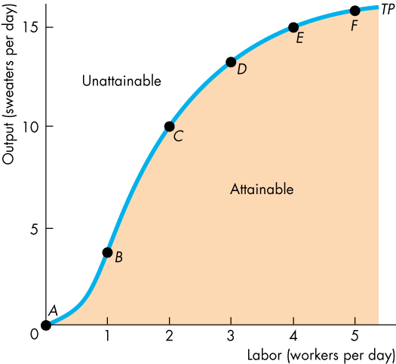
FIGURE 6.1: Total Product Curve
- Marginal Product Curve
Figure 6.2 shows Campus Sweaters marginal product of labor. Part (a) reproduces the total product curve from Figure 6.1 and part (b) shows the marginal product curve, MP. In part (a), the orange bars illustrate the marginal product of labor. The height of a bar measures marginal product. For example, when labor increases from 2 to 3 workers a day, marginal product is 3 sweaters. Marginal product is also measured by the slope of the total product curve. The slope of a curve is the change in the value of the variable measured on the y-axis (output) divided by the change in the variable measured on the x-axis (labor) as we move along the curve. The steeper is the slope of the total product curve (TP) in part (a), the larger is marginal product (MP) in part (b). A one unit increase in labor, from 2 to 3 workers, increases output from 10 to 13 sweaters, so the slope from point C to point D is 3 sweaters per additional worker. We plot that the marginal product at the midpoint between 2 and 3 workers. MP increases to a maximum (in this example when 1.5 workers a day are employed) and then declines. We call this decline diminishing marginal product. Almost every production process has two features: increasing marginal returns initially and diminishing marginal returns eventually.
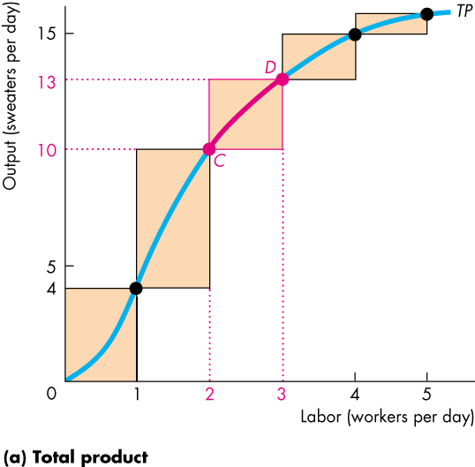
FIGURE 6.2: Total and Marginal Product Curves
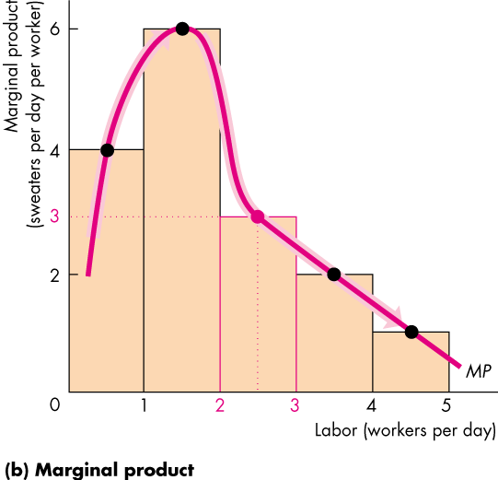
Increasing Marginal Returns: Increasing marginal returns occur when the marginal product of an additional worker exceeds the marginal product of the previous worker. Increasing marginal returns in the production process arise from increased specialization and division of labor.
For example, if Campus Sweaters employs one worker, that person must learn all the aspects of sweater production: running the knitting machines, fixing breakdowns, packing and mailing sweaters, buying and checking the type and color of the wool. All these tasks must be performed by that one person. If Campus Sweaters hires a second person, the two workers can specialize in different parts of the production process and can produce more than twice as much as one worker. The marginal product of the second worker is greater than the marginal product of the first worker. Marginal returns are increasing.
Diminishing Marginal Returns: Most production processes experience increasing marginal returns initially, but all production processes eventually reach a point of diminishing marginal returns. Diminishing marginal returns occur when the marginal product of an additional worker is less than the marginal product of the previous worker. Diminishing marginal returns arise from the fact that more and more workers are using the same capital and working in the same place. As more workers are added, the productivity of the additional workers falls.
For example, if Campus Sweaters hires a third worker output increases but not by as much as it did when it hired the second worker. In this case, after two workers are hired, all the gains from specialization and the division of labor have been exhausted. By hiring a third worker, the factory produces more sweaters, but the equipment is being operated closer to its limits. There are even times when the third worker has nothing to do because the machines are running without the need for the further attention. Hiring more and more workers continues to increase output but by successively smaller amounts: Marginal returns are diminishing. This phenomenon is called the law of diminishing returns. The law of diminishing returns states that
As a firm uses more of a variable factor of production with a given quantity of the fixed factor of production, the marginal product of the variable factor eventually diminishes.

FIGURE 6.3: The Relation between Average and Marginal Product Curves
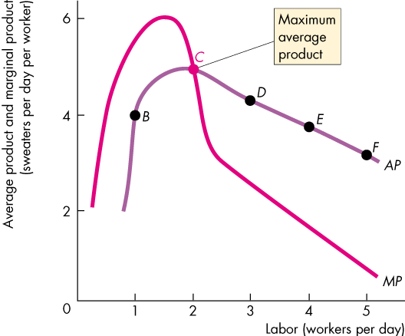

- Average Product Curve
Figure 6.3 illustrates Campus Sweaters average product of labor and shows the relationship between average product and marginal product. Points B through F on the average product curve AP correspond to the same rows in Table 6.1. Average product increases from 1 to 2 workers (its maximum value at point C) but then decreases as yet more workers are employed.
Average product is the largest when average product equals marginal product. That is, the MP curve cuts the AP curve at the point of maximum average product. For the number of workers at which MP exceeds AP, AP is increasing. For the number of workers at which MP is less than AP, AP is decreasing. Campus Sweaters’ product curves influence its costs, as we are now going to see.
  - SHORT-RUN COST
To produce more output in the short run, a firm must employ more labor, which means that it must increase its costs. We describe the relationship between output and cost by using three cost concepts: total cost, marginal cost, and average cost.

- Total Cost
A firm’s total cost (TC) is the cost of all the factors of production it uses. Total cost is the sum of the total fixed cost (TFC) and total variable cost (TVC).
TC = TFC + TVC
TFC is the cost of the firm’s fixed factors. For Campus Sweaters, TFC includes the cost of renting knitting machines. The quantities of fixed factors don’t change as output changes, so TFC is the same at all outputs. Total variable cost (TVC) is the cost of the firm’s variable factors. For Campus Sweaters, labor is the variable factor, so this component of cost is its wage bill. TVC changes as output changes.
FIGURE 6.4 Total Cost Curves
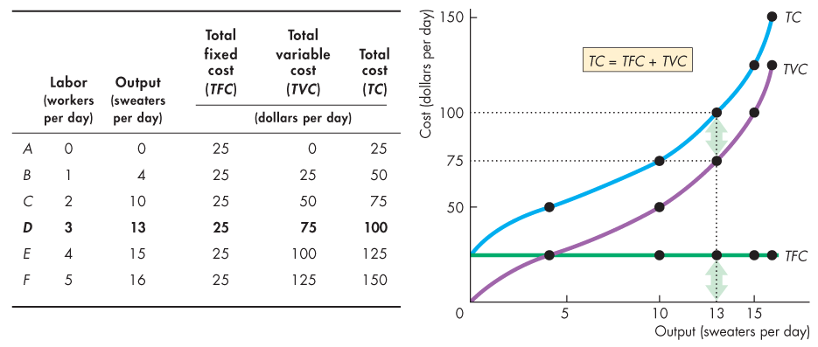
The table in Figure 6.4 shows total costs. Campus Sweaters rent a knitting machine for $25 a day, so TFC is $25. To produce sweaters, the firm hires labor, which cost $25 a day. TVC is the number of workers multiplied by $25. For example, to produce 13 sweaters a day (row D) the firm hires 3 workers and TVC is $75. TC = TFC + TVC, so to produce 13 sweaters a day, TC is $100 [= (3X$25) + $25].
Figure 6.4 shows Campus Sweaters total cost curves, which graph total costs against output. It illustrates how costs are changing with the changing output. The green TFC curve is horizontal because TFC ($25 a day) does not change when output changes. The purple TVC curve and the blue TC curve both slope upward because to increase output more labor must be employed. The rise in labor employment increases TVC. TFC equals the vertical distance between the TVC and TC curves.
- Marginal Cost
Figure 6.4 shows that TVC and TC increase at a decreasing rate at small outputs but eventually they increase at an increasing rate as output increases. To understand this pattern in the change in TC as output increases, we need to use the concept of marginal cost (MC). Marginal cost is the increase in total cost that results from a one-unit increase in the output. We calculate MC as the increase in total cost divided by the increase in output.
For example, in Figure 6.5, when output increases from 10 sweaters to 13 sweaters, total cost increases from $75 to $100. The change in output is 3 sweaters, and the change in total cost is $25. The MC of one of those 3 sweaters is $8.33 ($25/3) = $8.33). Figure 6.5 graphs the marginal cost data in the table as the red marginal cost curve, MC. This curve is U-shaped because when Campus Sweaters hires a second worker, MC decreases, but when it hires a third, a fourth, a fifth worker, MC successively increases. At small outputs, MC decreases as output increases because of greater specialization and the division of labor. But as output increases further, MC eventually increases because of the law of diminishing returns. The law of diminishing returns means that the output produced by each additional worker is successively smaller. To produce an additional unit of output, more workers are required, and the cost of producing the additional unit of output (marginal cost) must eventually increase.
- Average Cost
The average costs of production are Average fixed cost (AFC), Average variable cost (AVC), and Average total cost (ATC, AC). AFC is total fixed cost per unit of output. AVC is total variable cost per unit of output. ATC or AC is total cost per unit of output. Average total cost is the sum of the average variable cost and average fixed cost:
ATC = AFC + AVC
The table in Figure 6.5 shows the calculation of ATC. For example, in row C, output is 10 sweaters.
AFC = $25/10 = $2.50,
AVC = $50/10= $5.00,
ATC = $75/10=$7.50
Figure 6.5 shows the average cost curves. The green AFC curve slopes downward. As output increases, the same TFC is spread over a larger output. The blue ATC curve and the purple AVC curve are U-shaped. The vertical distance between the ATC and AVC cost curves is equal to AFC, as indicated by the two arrows. That distance shrinks as output increases because AFC declines with increasing output.
- The Relation Between Marginal Cost and Average Cost
The MC curve intersects the AVC curve and the ATC curve at their minimum points. When MC cost is less than AC, AC is decreasing, and when MC exceeds AC, AC is increasing. This relationship holds for both the ATC curve and the AVC curve. It is another example of the relationship we saw in Figure 6.3 for average product and marginal product.
- Why the ATC Curve is U-Shaped?
ATC is the sum of AFC and AVC cost, so the shape of the ATC curve combines the shapes of the AFC and AVC curves. The U shape of the ATC curve arises from the influence of two opposing forces: spreading total fixed cost over a larger output and eventually diminishing returns.
When output increases, the firm spread its TFC over a larger output and so its average fixed cost decreases: its AFC curve slopes downward. Diminishing returns means that as output increases, ever-larger amount of labor are needed to produce an additional unit of output. So as output increases, AVC decreases initially but eventually increases: The AVC curve is U shaped. The shape of the ATC curve combines these two effects. Initially, as output increases, both AFC and AVC decrease, so average total cost decreases. The ATC curve slopes downward. But as output increases further and diminishing returns set in, AVC starts to increase. With AFC decreasing more quickly than AVC is increasing, the ATC curve continues to slope downward. Eventually, AVC starts to increase more quickly than AFC decreases, so ATC cost curve starts to increase. The ATC curve slopes upward.

FIGURE 6.5 Marginal and Average Cost Curves
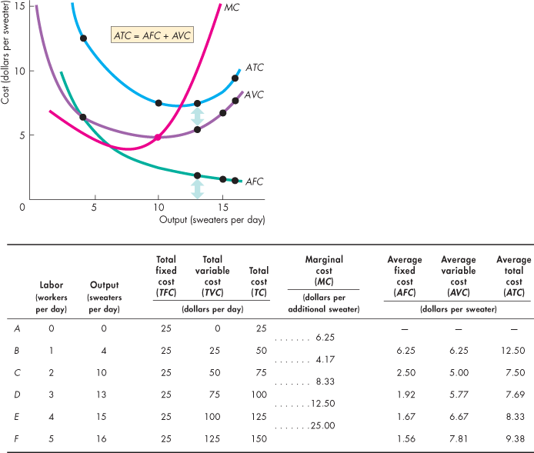
- Shifts in the Cost Curves
The position of firm’s short-run cost curves depend on two factors: technology and prices of factors of production.
- Technology
Technological development increases productivity and thus the marginal product and average product of labor increase. With a better technology, the same factors of production can produce more output, so the technological advance lowers the costs of production and shifts the cost curves downward. Often, a technological advance results in a firm using more capital (a fixed factor) and less labor (a variable factor). Thus, while a technological change decreases variable cost, it increases fixed costs. This change in the mix of fixed cost and variable cost means that ATC might increase at small outputs, but decreases at large outputs.
- Prices of Factors of Production
The second factor that influences the cost of production is the prices of factors. An increase in the price of a factor of production increases the firm’s costs and shifts its cost curves. How the curves shift depends on which factor price changes. An increase in one component of fixed cost shifts TFC, AFC and TC curves upward but leaves TVC, AVC, and MC curves unchanged. On the other hand, an increase in one component of variable cost shifts the TVC and AVC curves upward and shifts the MC curve upward but leaves the AFC and TFC curves unchanged.
FIGURE 6.6 Product Curves and Cost Curves
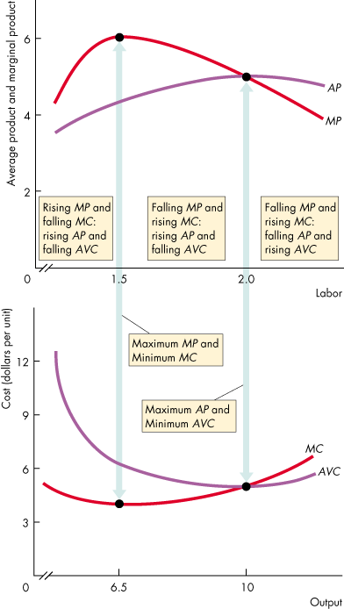
  - THE RELATION BETWEEN COST CURVES AND PRODUCT CURVES
The technology that a firm uses determines its costs. Figure 6.6 shows the links between the firm’s product and cost curves. The upper graph shows the average product curve, AP, and the marginal product curve MP. The lower graph shows the average variable cost curve, AVC, and the marginal cost curve, MC. As labor increases up to 1.50 workers a day (upper graph), output increases to 6.5 sweaters a day (lower graph). MP and AP rise and MC and AVC cost fall. At the point of maximum marginal product, MC is at a minimum. As labor increases from 1.50 workers to 2 workers a day, (upper graph) output increases from 6.5 sweaters to 10 sweaters a day (lower graph). MP falls and MC rises, but AP continues to rise and AVC cost continues to fall. At the point of maximum AP, AVC is at a minimum. As labor increases further, output increases. AP diminishes and AVC cost increases.
HOMEWORK 6
- What is the difference between the short run and the long run in production?
- Explain how the marginal product and average product of labor change as the labor employed increases (a) initially and (b) eventually.
- What is the law of diminishing returns? Why does marginal product eventually diminish?
- Explain the relationship between marginal product and average product.
- How is the relationship between short-run total cost, average cost and marginal cost?
- How does marginal cost change as output increases (a) initially and (b) eventually?
- What is the shape of the AFC curve and why does it have this shape?
- What is the shape of the AVC curve and why does it have this shape?
- Calculate A, B, C, D, and E in the following table.
TP | AFC | AVC | ATC | MC
10 | 120 | 100 | 220
20 | A | B | 150 | 80
30 | 40 | 90 | 130 | 9O
40 | 30 | C | D | 130
50 | 24 | 108 | 132 | E

CHAPTER 7
MARKET STRUCTURES
INTRODUCTION
We can categorize markets according to the degree of competition that they exhibit. The degree of competition in markets affects the determination of prices and quantities produced and, therefore, the allocation of resources. At the one end of the spectrum there are perfectly competitive markets. At the other extreme there are markets where monopoly prevails. In monopoly there is no competition. And between these two extremes there are imperfectly competitive markets: monopolistic competition and oligopoly. In this lesson, we will examine, first, the perfectly competitive markets and then summarize the main features of monopoly, monopolistic competition and oligopoly.
  - PERFECT COMPETITION
Perfect competition is a market in which
  - Many firms sell identical products to many buyers.
  - There are no restrictions on entry into the market.
  - Established firms have no advantages over the new ones.
  - Sellers and buyers are well informed about the market.
In a perfectly competitive market all firms produce a good that has unique characteristics, so consumers don’t care which firm’s good they buy. Firms in perfect competition are price takers. A price taker is a firm that cannot influence the market price because its production is an insignificant part of the total market.
In Figure 7.1(a), market demand and market supply determine the market price and quantity. Market price is $25 and quantity is 9 thousand sweaters. And Campus Sweaters takes this price as given (Figure 7.1(c)).
    - ECONOMIC PROFIT AND REVENUE
A firm’s goal is to maximize economic profit. Economic profit is equal to total revenue minus total cost. Total cost (TC) is the opportunity cost of production. TC includes normal profit. A firm’s total revenue (TR) equal the price of its output multiplied by the number of units of output sold (TR=PQ).
- Total Revenue(TR)
In the table in Figure 7.1, if Campus Sweaters sells 9 sweaters, its total revenue is $225 (=$25x9). Figure 7.1(b) shows the firm’s TR curve (TR). TR curve graphs the relationship between TR and the quantity sold. At point A on TR curve, the firm sells 9 sweaters and has a TR of $225. Because the price is constant MR is also constant ($25), the TR curve is an upward-sloping straight line.
FIGURE 8.1: Demand, Price, and Revenue in Perfect Competition
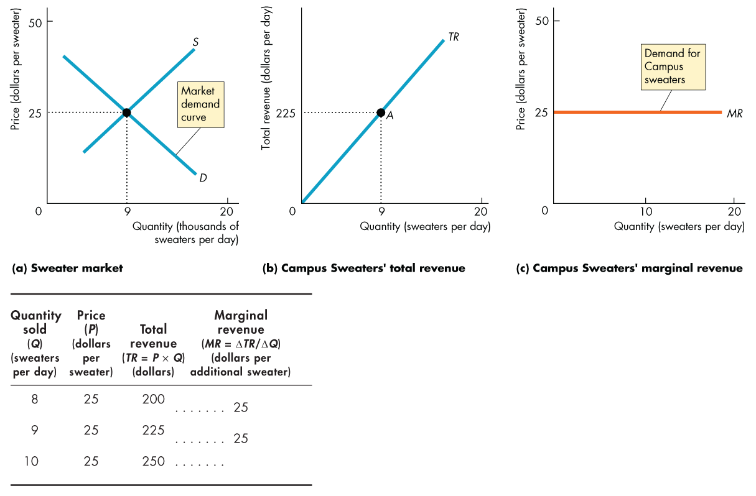
- Marginal Revenue(MR)
Marginal revenue (MR) is the change in TR that results from a one unit increase in the quantity sold. MR is calculated by dividing the change in TR by the change in the quantity sold. In our example the market price is $25 a sweater. Campus Sweaters is just one of many producers of sweaters, so it sells its sweaters for $25 each. Since sweaters market is a perfectly competitive market Campus Sweaters is a price taker. The change in TR that results from a one-unit increase in the quantity sold equals the market price: the firm’s MR equals the market price. In our example market price is $25, MR=$25. Figure 7.1 (c) shows the firm’s MR curve (MR) as the horizontal line at the market price.
- Demand for the Firm’s Product
A horizontal demand curve illustrates a perfectly elastic demand, so the demand for the firm’s product is perfectly elastic. A sweater from Campus Sweaters is a perfect substitute for a sweater from any other factory. The firm can sell any quantity it chooses at the market price. The demand curve is the firm’s MR curve. But the market demand for sweaters is not perfectly elastic: the demand curve is downward sloping. Its elasticity depends on the substitutability of sweaters for other goods and services.
    - FIRM’S DECISIONS
The goal of the firm is to maximize economic profit, given the constraints it faces. To achieve its goal, a firm must decide what quantity to produce and how to produce at minimum cost. Here, we assume that the cost structure is given and study the output decision.
- Firm’s Output Decision
A firm’s cost curves describe the relationship between its output and costs. And a firm’s revenue curves describe the relationship between its output and revenue. From the firm’s cost curves and revenue curves, we can find the output that maximizes the firm’s economic profit. Figure 7.2 shows how to do this for Campus Sweaters. The table lists the firm’s total revenue and total cost at different outputs. Part (a) of the figure shows the firm’s TR and TC curves. These curves are graphs of numbers in the first three columns of the table.
Economic profit equals (TR-TC). The fourth column of the table shows the economic profit made by Campus Sweaters. Part (b) of the figure graphs these numbers as its economic profit curve, EP. Campus Sweaters maximizes its economic profit by producing 9 sweaters a day: TR is $225, TC is $183, and the economic profit is $42 (=$225-$183). No other output rate achieves a larger profit. At outputs of less than 4 sweaters and more than 12 sweaters a day, the Campus Sweaters would incur an economic loss. At either 4 or 12 sweaters a day, economic profit is zero: the Campus Sweaters breaks even.

FIGURE 7.2: Total Revenue, Total Cost, and Economic Profit
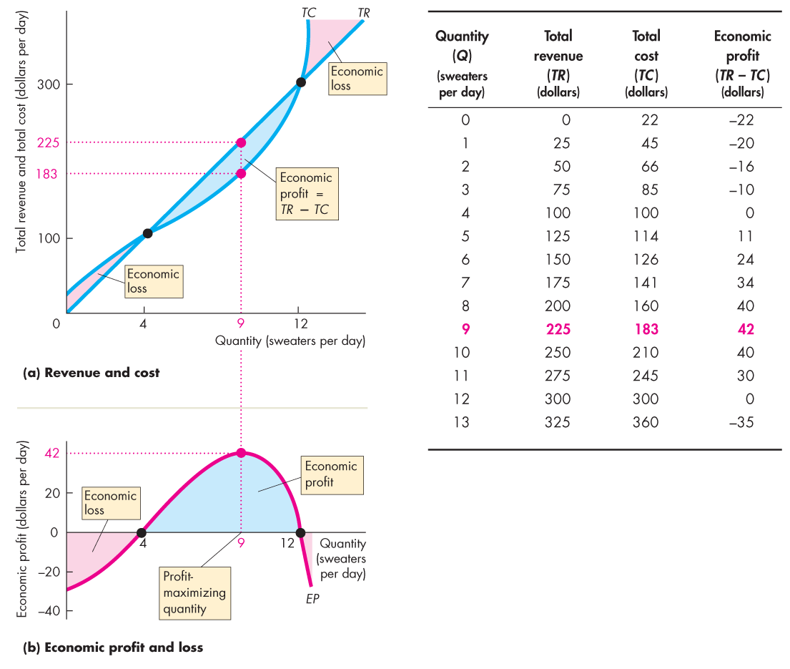
Part (a) graphs the total revenue and total cost curves and part (b) graphs economic profit.

- Marginal Analysis and Supply Decision
Another way to find the profit-maximizing output is to use marginal analysis, which compares MR with MC. As output increases, the firm’s MR is constant but its MC eventually increases. If MR exceeds MC (MR>MC), then the revenue from selling one more unit exceeds the cost of producing it and an increase in output increases economic profit. If MR is less than MC (MR<MC), then the revenue from selling one more unit is less than the cost of producing that unit and a decrease in output increases economic profit.
If MR equals MC (MR=MC), then the revenue from selling one more unit equals the cost incurred to produce that unit. When MR=MC economic profit is maximized and either an increase or a decrease in output decreases economic profit. Figure 7.3 illustrates these propositions. If Campus Sweaters increases its output from 8 sweaters to 9 sweaters a day, MR ($25) exceeds MC ($23), so by producing the 9th sweater economic profit increases by $2 from $40 to $42 a day. The blue area in the figure shows the increase in economic profit when the firm increases production from 8 to 9 sweaters per day.
FIGURE 7.3 Profit Maximizing Output
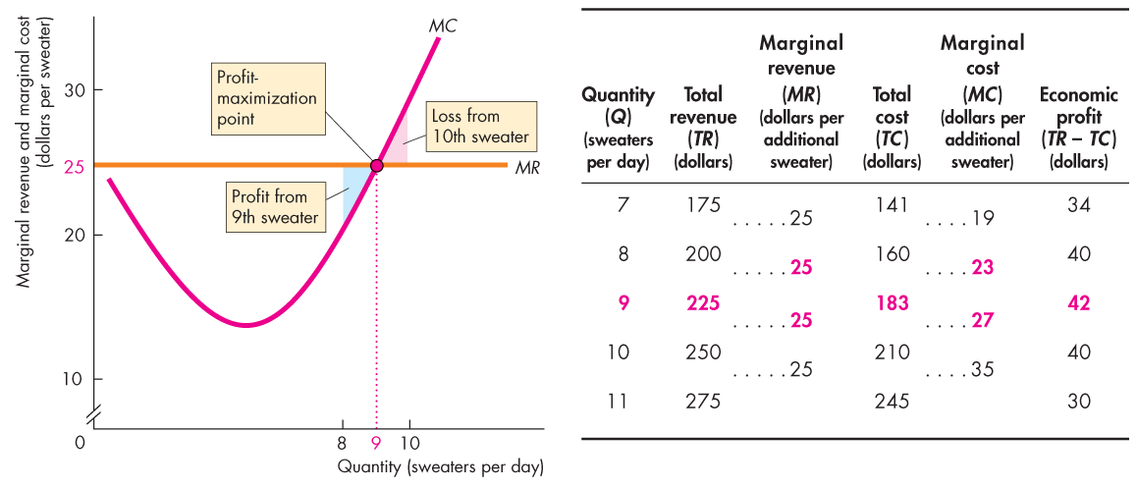
If Campus Sweaters increases its output from 9 sweaters to 10 sweaters a day, MR ($25) is less than MC ($27), so by producing 10th sweater, economic profit decreases. The last column of the table shows that economic profit decreases from $42 to $40 a day. The red area in the figure shows the economic loss that arises from increasing production from 9 to 10 sweaters a day. Campus Sweaters maximizes economic profit by producing 9 sweaters a day. At this quantity MR equals MC. A firm’s profit-maximizing output is its quantity supplied at the market price. The quantity supplied at a price of $25 is 9 sweaters a day. If the price were higher than $25 a sweater, the firm would increase production. If the price were lower than $25 a sweater, the firm would decrease production.
These profit-maximizing responses to different market prices are the function of the law of supply: Other thing remaining the same, the higher the market price of a good, the greater is the quantity supplied of that good.
    - SHORT RUN MARKET EQUILIBRIUM AND FIRM
Market demand and market supply determine the market price and market output. In the sort-run equilibrium, although the firm produces the profit-maximizing output, it does not necessarily end up making an economic profit. It might do so, but it might alternatively break even or incur an economic loss. Economic profit (or loss) per sweater is price (P) minus ATC. So, total economic profit (or loss) is (P-ATC) X Q.
- Three Possible Short-Run Outcomes
If price equals ATC, a firm breaks even: it makes normal profit. If price exceeds ATC, a firm makes an economic profit. If price is less than ATC, a firm incurs an economic loss. Figure 7.8 shows these three possible short-run profit outcomes for Campus Sweaters. These outcomes correspond to the three different levels of market demand. In Figure 7.8(a) the market price is $20 and firm produces 8 sweaters a day. ATC is $20 a sweater. Price equals ATC, so the firm breaks even (makes zero economic profit). In Figure 7.8(b) the market price is $25 a sweater and firm produces 9 sweaters a day. Here, price exceeds ATC: the firm makes an economic profit. Its economic profit is $42 a day:
Profit per sweater = $25.00-$20.33 = $4.67
Total profit = 9 x$4.67= $42.
The blue rectangle shows this economic profit. The height of that rectangle is profit per sweater ($4.67), and length is the quantity of sweaters produced, 9 a day. So, the area of the rectangle is economic profit of $42 a day.
In Figure 7.8(c) the market price is $17.00 a sweater and the price is less than ATC, so the firm incurs an economic loss. Price and MR are $17.00 a sweater, and the profit-maximizing (in this case loss-minimizing) output is 7 sweaters a day. Total revenue is $119 a day (7x$17). ATC is $20.14 a sweater, so the economic loss is $3.14 a sweater ($20.14-$17.00). This loss per sweater multiplied by the number of sweaters is $22. The red rectangle shows this economic loss. The height of that rectangle is economic loss per sweater, $3.14 and the length is the quantity of sweaters produced, 7 a day. So, the area of the rectangle is the firm’s economic loss of $22 a day. If the price dips below $17 a sweater, the firm shuts down and incurs an economic loss equal to the TFC.

FIGURE 7.8 Three Short-Run Outcomes for the Firm
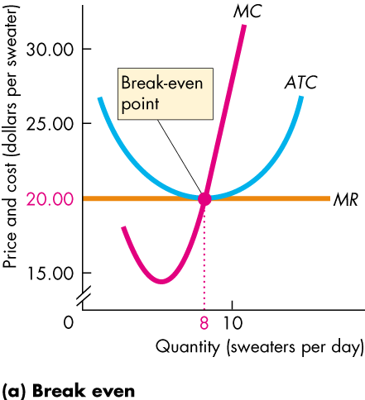
The price equals minimum average total cost. At the profit maximizing output, the firm breaks even and makes zero economic profit.
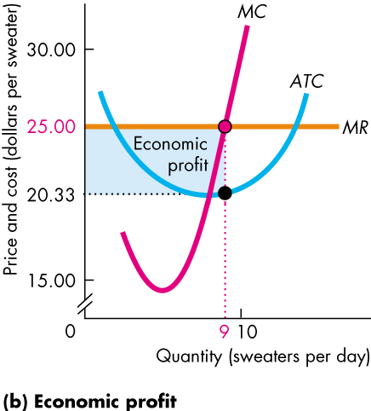
The market price is $25 a sweater. At the profit-maximizing output, the price exceeds average total cost and the firm makes an economic profit equal to the area of the blue rectangle.
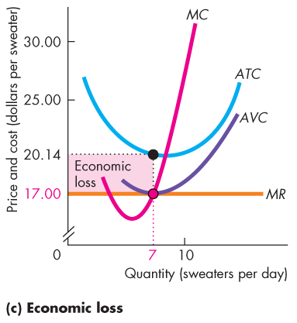
The market price is $17 a sweater. At the profit-maximizing output, the price is below minimum average total cost and the firm incurs an economic loss equal to the area of the red rectangle.
  - MONOPOLY
A monopoly is a market with a single firm that produces a good or service for which no close substitute exists and that is protected by a barrier that prevents other firms from selling that good or service. If a good has a close substitute, even though only one firm produces it, that firm effectively faces competition from the producers of the substitute.
- Barriers to Entry
A constraint that protects a firm from potential competitors is called a barrier to entry. The three types of barrier to entry are natural, ownership, and legal
A natural barrier to entry creates a natural monopoly. A natural monopoly is a market in which economies of scale enable one firm to supply the entire market at the lowest possible cost. The firms that deliver gas, water, and electricity to our homes are examples of natural monopoly. An ownership barrier to entry occurs if one firm owns a significant portion of a key resource. A legal barrier to entry creates a legal monopoly. A legal monopoly is a market in which competition and entry are restricted by the granting of a public franchise, government license, patent, or copyright.
A public franchise is an exclusive right granted to a firm to supply a good or service. A government license controls entry into particular occupations, professions, and industries, such as medicine, law, and dentistry. A patent is an exclusive right granted to the inventor of a product or service. A copyright is an exclusive right that granted to the author or composer of a literary, musical, dramatic, or artistic work. Patents and copyrights are valid for a limited time period.
- Monopoly Price-Setting Strategies
Monopoly sets its own price. In doing so, the monopoly faces a market constraint: To sell a larger quantity, the monopoly must set a lower price. There are two monopoly situations that create two pricing strategies: single price and price discrimination. A single-price monopoly is a firm that must sell each unit of its output for the same price to all its customers. When a firm practices price discrimination, it sells different units of a good or service for different prices. Many firm price discriminate. Microsoft sells its Windows and Office software at different prices to different buyers. Pizza producers offer a second pizza for a lower price than the first one. These are examples of price discrimination.
When the price is lowered to sell one more unit, two opposing forces affect total revenue. The lower price results in a revenue loss, and the increased quantity sold results in a revenue gain. Whether total revenue will increase or decrease when the price is lowered depends on the price elasticity of demand. When demand is elastic (elasticity is higher than 1) a price fall will increase total income since the percentage fall in the price brings a greater than percentage increase in the quantity demanded. The revenue gain from the increase in quantity sold outweighs the revenue loss from the lower price. In monopoly, demand is always elastic.
A monopoly never produces an output in the inelastic range of the market demand curve. A monopoly produces the profit-maximizing quantity and sells that quantity for the highest price it can get. For a profit-maximizing competitive firm, price equal marginal revenue, so price also equals marginal cost. For a monopoly, price exceeds marginal revenue, so price also exceeds marginal cost. Barriers to enter prevent new firms from entering the market, so a monopoly can make a positive economic profit and might continue to do so indefinitely. Compared to a perfectly competitive market, a single price monopoly produces a smaller output and charges a higher price.
Monopolies price discriminate when they can do so. To be able to price discriminate, a firm must be able to identify and separate different buyer types and sell a product that cannot be resold. Firms discriminate in two broad ways: among groups of buyers and among units of a good. People differ in the value they place on a good. Some of these differences are correlated with features such as age, employment status, and other easily distinguished characteristics. When such a correlation is present, firms can profit by price discriminating among the different groups of buyers. Buy one pizza and get a second one free (or for a low price) is an example of price discrimination among units. Monopoly can increase its total sales and profits by making price discrimination among groups and among units.
  - MONOPOLISTIC COMPETITION
Monopolistic competition is a market structure in which a large number of firms compete by making similar but slightly different products. Since a large number of firms compete in monopolistic competition and each supplies a small part of the total industry output, each firm has only a limited power to influence the price of its product. Making a product slightly different from the product of a competing firm is called product differentiation. A differentiated product is one that is a close substitute but not a perfect substitute for the products of other firms.
Product differentiation gives a firm an element of market power. The firm is the sole producer of the particular version of the good in question. Some people are willing to pay more for one variety of the product, so when its price rises, the quantity demanded of that variety decreases, but it does not (necessarily) decrease to zero.
For example, in the market for pizzas, hundreds of firms make their own version of the perfect pizza. Each of these firms is the sole producer of a particular brand.
Most real-world markets are competitive but not perfectly competitive, because firms in these markets have some power to set their prices, as monopolies do. In monopolistic competition firms compete on product quality, price, and marketing. Because of product differentiation, firms must market their products.
In monopolistic competition firms are free to enter and exit the industry. There are no barriers to prevent new firms from entering the industry in the long run. Consequently, a firm cannot make an economic profit in the long run. When existing firms make an economic profit, new firms enter the industry. This entry lowers prices and eventually eliminates economic profit. When firms incur economic losses, some firms leave the industry in the long run. This exit increases prices and eventually eliminates the economic loss. In the long-run equilibrium, firms in the industry make zero economic profit. There are two key differences between monopolistic competition and perfect competition:
- In monopolistic competition firms have excess capacity.
- Production is less and price is higher than perfect competition.
Buyers pay a higher price than in perfect competition.
  - OLIGOPOLY
Oligopoly, like monopolistic competition, lies between perfect competition and monopoly. It is a market structure in which a small number of firms compete. Oligopolies might produce almost identical products and compete only on price, or they might produce a differentiated product and compete on price, product quality, and marketing. The colas produced by Coke and Pepsi are examples of almost identical products while Boeing and Airbus aircraft are the examples of differentiated products. Natural or legal barriers to entry can create oligopoly.
Economies of scale and demand can create a natural oligopoly. Because barriers to entry and exist, oligopoly consists of a small number of firms, each of which has a large share of the market. Such firms are interdependent. With a small number of firms in a market, each firm’s actions influence the profits of all the other firms. Therefore, each firm has to consider probable reactions of its competitors before taking any action. When a small number of firms share a market, they can increase their profit by forming a cartel and acting like a monopoly. A cartel is a group of firms acting together – colluding – to limit output, raise price, and increase economic profit. Cartels are illegal, but they do operate in some markets.
HOMEWORK 7
    - How we can categorize markets according to their competitiveness?
    - What are the main properties of a perfectly competitive market?
    - Why is a firm in perfect competition a price taker?
    - Why does a firm in perfect competition produce the quantity at which marginal cost equals price?
    - A Pizza Kitchen is a price taker and its costs are
Output Total cost
(pizzas per hour) (dollars per hour)
    - 10
    - 23
    - 34
    - 44
    - 55
    - 69
Calculate the profit maximizing output and economic profit if the market price is $10 a pizza.
    - What are three types of barrier to entry creating monopoly?
    - Explain two price setting strategies of monopoly.
    - What are the distinguishing characteristics of monopolistic competition?
    - What are the differences between monopolistic competition and oligopoly?
    - Which type of market is preferable for consumers from a theoretical point of view?

CHAPTER 8
AN OVERVIEW OF MACROECONOMICS AND NATIONAL INCOME
INTRODUCTION
Through chapters 1-7 we have studied mainly microeconomic issues. In this chapter we will make an introduction to macroeconomics.
Microeconomics is concerned with economic issues at micro level. It is the study of how households and firms make decisions and they interact in a specific market; how do the prices of goods occur and change? Macroeconomics, on the other hand, is the study of economy as a whole. The goal of macroeconomics is to explain the economic changes that affect many households, firms, and markets at once. Macroeconomists address diverse questions: Why is average income is high in some countries while it is low in others? Why do prices rise rapidly in some periods of time while they are more stable in other periods? Why the production and employment expand in some years and contract in others? These diverse questions are all macroeconomic because they concern the workings of the entire economy.
Some examples will help us clarify the difference between microeconomics and macroeconomics. Microeconomics considers the behavior of steel prices versus energy prices, while macroeconomics studies the behavior of all producer and consumer prices. Microeconomics studies individual’s job preference, while macroeconomics examines what determines the overall unemployment rate. Microeconomics examines the individual items of foreign trade, why we export textiles and import computers. Macroeconomics examines the overall trends in our imports and exports.
There are interactions between microeconomics and macroeconomics. It is not possible to explain macroeconomic events without understanding individual behavior, but individual cannot behave independent of macroeconomic developments.
  - OBJECTIVES AND INSTRUMENTS IN MACROECONOMICS
Macroeconomics is a vital subject for many reasons. First of all, macroeconomic performance is central to the success or failure of nations. As we try to explain the rises and declines of nations, it quickly becomes clear that a very few key variables dominate the analysis. In judging a nation’s performance, we encounter national income, employment, inflation, and balance of payments. These are the central objectives or goals of macroeconomic analysis and policy.
Table 8.1 is a list of major objectives and instruments of macroeconomic policy. We will summarize each, thereby illustrating some key questions that confront macroeconomics.
- Objectives of macroeconomics
Four areas are central to good macroeconomic performance; those concerning output, employment, prices, and the foreign sector.
Table 8.1 Objectives and instruments of macroeconomics
OBJECTIVES | INSTRUMENTS
Output:  High level, both actual and  relative to potential  Rapid growth rate  Employment:  High level of employment  Low unemployment  Price-level stability  Foreign balance:  Export and import equilibrium  Exchange-rate stability | Fiscal policy:  Government expenditure  Taxation  Monetary policy:  Control of money supply affecting  interest rates  Incomes policies:  From voluntary wage-price  guidelines to mandatory controls.  Foreign economics:  Trade policies  Exchange-rate intervention

        - Output
The ultimate measure of economic success is a country’s ability to generate a high level and rapid growth in the output of goods and services. National income is the measure of output. Movements in national income are the best widely-available measure of the level and growth of output. Output growth rate is not constant: there are ups and downs movements in national income. Economies don’t grow in a smooth and even pattern. Several years of economic expansion are followed by recession, or even a crisis. Then national output falls and unemployment rises. The ups and downs of national income are called business cycles.
        - Employment and Unemployment
High employment, or low unemployment, is one of the main objectives of macroeconomic policies. There is unemployment mainly because of the difference between the existing jobs and the number of people seeking a job. People looking for a job but cannot be able to find it are called unemployed, and this phenomenon is called unemployment. Unemployment usually moves in tandem with output. As output falls, firms need fewer labor inputs, so new workers are not hired and current workers are laid off. Attaining high employment is more than a purely economic goal. Unemployment is a serious personal and social economic problem.
As an economic problem, it is a waste of valuable resources. When the unemployment rate goes up, the economy is in fact throwing away all the goods and services that the unemployed workers could have produced. The loss of a job brings a loss of income and lost production. Lost production means lower consumption and a lower investment in capital, which lower the living standard in both the present and future.
As a social problem, it is a source of enormous suffering. During periods of high unemployment, economic distress spills over to affect people’s emotions and family lives. The economic cost of unemployment is certainly large, but the social cost is enormous. No money figure can adequately convey the human and psychological toll of long periods of persistent involuntary unemployment. Unemployment is also a personal tragedy. Unemployment leads to a deterioration of both physical and psychological health.
        - Prices and Inflation
The third major macroeconomic objective is to ensure price stability. A persistently rising price level is called inflation; a persistently falling price level is called deflation. The price level is the average level of prices. Low, steady and anticipated inflation or deflation is not a problem, but unexpected burst of inflation or period of deflation brings big problems and costs. An unexpected inflation or deflation redistributes income and wealth, and affects efficiency and output negatively.
Workers and employers sign wage contracts that last for a year or more. An unexpected burst of inflation raises prices but doesn’t immediately raise the wages. Workers are worse off because their wages buy less than they bargained for and employers are better off because their profits rise.
People enter into loan contract that are fixed in money terms and that pay an interest rate agreed as a percentage of the money borrowed and lent. With an unexpected burst of inflation, the money that the borrower repays to the lender buys less than the money originally loaned. The borrower wins and the lender loses.
Inflation affects total output and efficiency. It impairs economic efficiency because it distorts price signals. In a high-inflation economy it is hard to distinguish between changes in relative prices and changes in the overall price level.
Unpredictable inflation or deflation turns the economy into a casino and diverts resources from productive activities to forecasting inflation. It can become more profitable to forecast the inflation rate or deflation rate correctly than to invent a new product. People can make themselves better off, not by specialization in the profession for which they have been trained but by spending more of their time dabbing as amateur economists and inflation forecasters and managing their investments. From a social perspective, the diversion of talent that results from unpredictable inflation is a waste of scarce resources. This waste is a cost of inflation.
        - Foreign Balance
Countries make foreign trade; export and import goods and services. One of the main purposes of macroeconomics is foreign trade balance and exchange rate stability.
- Instruments of macroeconomics
- Fiscal policy
Fiscal policy is related to total government expenditures, distribution of government expenditures, and sources of these expenditures: taxes and other sources. Government can affect aggregate demand (expenditures) by changing tax burden and its expenditure. At any time, if the government wants to increase total demand, it may increase its own expenditures and promote consumption and investment expenditures by lowering the tax rate. If the government wants to decrease total demand it implements just the opposite policies.
- Monetary policy
Monetary policy is the way of influencing economy by changing the quantity of money and interest rate. While expansionary monetary policy would lower the rate of interest and raise total demand, a contractionary monetary policy would raise the rate of interest and lower aggregate demand.
- Incomes policies
Incomes policies are related to changing wages and salaries by the government. The main concern may be either to control inflation and stabilize prices or to change the distribution of income between labor incomes and capital incomes.
- Foreign economics
Foreign economics is related to foreign trade and exchange rate policies. There is an interaction between the exchange rate and foreign trade balance. Exchange rate is the price of a national currency in terms of other national currencies. It is a significant factor determining the price of imported and exported goods. Therefore, exchange rate has a critical role in reaching both foreign trade balance and price stability.
Because the exchange rate is the price of a country’s money in terms of another country’s money, governments and central banks must have a policy toward the exchange rate. Three possible exchange rate policies are flexible exchange rate, fixed exchange rate and crawling peg. A flexible exchange rate is the exchange rate that is determined by demand and supply in the foreign exchange market with no direct intervention by the CB. Most countries operate flexible exchange rate. But even a flexible exchange rate is influenced by central bank actions. If the CB raises interest rate and other countries keep their interest rates unchanged, the demand for national currency increases, the supply of national currency decreases, and the exchange rate rises. Similarly, if the CB lowers the interest rate, the demand for national currency decreases, the supply increases, and the exchange rate falls.
In the fixed exchange rate system the exchange rate is determined by the government or the CB. A fixed exchange is achieved by the CB intervention in the foreign exchange market to block the unregulated forces of demand and supply. If the market forces push up the value of the national currency, the CB sells national currency and buys foreign currencies. If the market forces push down the value of the national currency, the CB sells foreign currencies and buys national currency.
A crawling peg is an exchange rate that follows a path determined by a decision of government or the CB. A crawling peg is achieved in a similar way to a fixed exchange rate by the CB intervention in the foreign exchange market. A crawling peg works like a fixed exchange rate except that the target value changes. The target might change at fixed intervals (daily, weekly, monthly) or at random intervals.
  - NATIONAL INCOME
    - BASIC CONCEPTS
National income is the total income of everyone in the economy. It is the basic concept in macroeconomics. When judging whether the economy is doing well or poorly, we look at the national income.
In this section we examine two basic concepts relating to national income: gross domestic product (GDP) and net domestic product (NDP).
- Gross Domestic Product (GDP)
Gross domestic product (GDP) is the market value of all final goods and services produced within a country in a given period of time. To simplify understanding of this definition, let’s consider each phrase in the definition with some care.
GDP is the market value. It adds together many different kinds of products into a single measure of the value of economic activity. To do this, it uses market prices. Market prices measure the amount people are paying for different goods and they reflect the value of those goods.
GDP includes all items produced in the economy and sold legally in the markets. It excludes items produced and sold illicitly, such as illegal drugs. It also excludes most items produced and consumed at home and, therefore, never enter the marketplace. Vegetables you buy at the grocery store are part of GDP; vegetables you grow in your garden and you consume at home are not.
GDP includes only the value of final goods. The reason is that the value of intermediate goods is already included in the prices of final goods. We cannot calculate the total output of the economy by simply adding up the output of all firms. Suppose, for example, that we took the value of all farmers’ sales of wheat and added to it all flour mill’s sales of flour, plus the sales of bakeries, plus the sales of bread by all retail stores. The resulting total would be much larger than the value of the final product (bread) produced by the economy. We would have counted the value of the wheat four times, of the flour three times, of the bread produced by the bakery twice, and of the services of the retail store once.
To avoid this problem of double counting, national income accountants use the important concept of the value added. Each firm’s value added is the value of its output minus the value of the inputs that it purchases from other firms. Thus a flour mill’s value added is the value of its output of flour minus the value of the grain it buys from the farmer and minus the values of any other inputs such as electricity and fuel oil that it buys from other firms.
The idea of value added suggests an important distinction between intermediate and final products. Intermediate products are all goods and services used as inputs into a further stage of production. Final products are the output of the economy after eliminating all double counting. In the previous example, grain, flour, electricity, and fuel oil were all intermediate products used at various stages in the process that led to the production of the final product, bread.
GDP measures the value of production within the geographic confines of a country. For example, Turkey’s GDP measures only the total values of goods and services produced in Turkey. When a Turkish citizen works temporarily in Germany, his production is part of Germany’s GDP. When a Turkish citizen has factory in Bulgaria, the production at his factory is not part of Turkey’s GDP. Thus, items are included in a nation’s GDP if they are produced domestically, regardless of the nationality of the producer.
GDP measures the value of production that takes place within a specific interval of time. Usually that interval is a year or a quarter (three months). GDP measures the economy’s flow of income and expenditure during that interval.
- Net Domestic Product (NDP)
A distinction between gross and net concepts of national income (or national product) would help us understand the relation between the capital stock and national income. Gross domestic income (or gross domestic product, GDP) is the sum of all values added in the economy; it is the sum of the values of all final goods produced for consumption or investment. Net domestic income (or net domestic product, NDP) is GDP minus the capital consumption allowance (depreciation). NDP is thus a measure of the net output of the economy after deducting from gross output an amount of necessary to maintain the existing stock of capital intact.
National income (NI) is the term generally used in literature and daily discussions for the market value of the total final goods and services produced within a country in a specific interval of time. We will use this term from now on.
    - CALCULATION OF NATIONAL INCOME (NI)
NI income measures two things at once; the total income of everyone in the economy and the total expenditure on the economy’s output of goods and services. Total income and total expenditure are really the same. For an economy as a whole, income must equal expenditure for goods produced in that economy. NI can be calculated, then, by adding up either expenditures or incomes of everyone.
- The Expenditure Approach
When we use the expenditure approach to measure the total value of output, we calculate the total expenditure needed to purchase the nation’s output.
Households, firms, government and foreigners purchase a part of the economy’s output. We can write total expenditures on total output of economy as following,
Y = C+I+G+(X-M)
Y stands for national income, C consumption expenditures, I investment, G government expenditure, X exports, M imports, and (X-M) net exports.
Consumption: Households spend most of their income to buy goods and services. The total amount of expenditures on goods and services of household gives us consumption (C).
Investment: We may define investment (I) as the production of goods not for the present consumption. Such goods are called investment goods. They are produced by firms and they may be bought either by firms or by households. Most investment is done by firms. Firms can invest either in capital goods, such as plant and equipment, or in inventories.
(a)Investment in inventories: Virtually all firms hold stocks of their inputs and their own outputs. Such stocks are called inventories. Inventories of inputs allow production to continue at the desired pace in spite of short-term fluctuations in the deliveries of inputs bought from other firms. Inventories of output allow firms to meet orders in spite of temporary, unexpected fluctuations in the rate of output or sales.
Inventories require an investment of the firm’s money since the firm has paid for them but has not yet sold them. An accumulation of inventories counts as current investment because it represents goods produced but not used for current consumption.
(b)Investment in capital goods: All production uses capital goods such as hand tools, machines, and factory buildings. The total amount of capital goods in the country is called capital stock. The act of creating capital goods is an act of investment.
Investments are financed by saving. Saving is income not spent on goods and services for current consumption. Both households and firms can save. Households save when they elect not to spend part of their current income on goods and services for consumption. Firms save both when they deduct from their gross revenues depreciation allowances which can be used to keep their capital stock intact and when they elect not to pay out to their owners some of the profits that they have earned. Undistributed profits are profits held back by firms for their own uses.
Gross and net investment: The total investment that occurs in the economy is called gross investment. Gross investment may be thought of as divided into two parts, replacement investment and net investment. The amount of replacement investment required to maintain the existing capital stock intact is called the capital consumption allowance or simply depreciation. Net investment is gross investment minus the capital consumption allowance. It is net investment that increases the economy’s total stock of capital, while the replacement investment keeps the existing stock intact by replacing what has been worn out or used up.
Government expenditure is given the symbol G includes government spending on goods and services.
Table 8.2 Calculation of Turkish GDP, the expenditure approach (millions of TL)
 | 2010 | Percentage  of GDP
Consumption Expenditures (C) | 787.270 | 71.3
Investment (private + government)(I) | 219.905 | 19.9
Government Consumption Expenditures (G) | 157.451 | 14.2
Net Exports (X-M) | -60.955 | -5.5
Gross Domestic Product (C+I+G+X-M) | 1.103.750 | 100
Net exports: The goods that are produced at home and sold abroad are called exports. The goods that are produced abroad and sold at home are called imports. Part of the expenditure on the domestic economy’s output comes from foreign firms, households, and governments and part of the expenditure of domestic firms, households, and governments goes to the NI of foreign countries. The value of the difference between exports and imports (X-M) is called net exports. A change in either X or M, not matched by a change in the other, will cause the NI to change in the same way as would a change in C, I, or G.
Table 8.2 shows a simplified set of national income accounts for the economy using the output-expenditure approach.
- The Factor-Income Approach
The second approach of measuring NI is referred to as the factor-income approach. In this approach, NI is calculated by adding factor-payments or factor-incomes.
There are four main components of factor incomes; rent, which is the payment to landowners for the land in production; wages, which are the payment to workers; and interest and profits, both of which are payments to capitalists. In order to obtain its capital goods a firm requires money. This is made available by those who lend money to the firm and by those who put up their own money in order to become the firm’s owners. Interest is earned by those who lend money to the firm, and profits are earned by those who own the firm.

Table 8.3: GDP of Turkey: The Income Approach (2006)
Item | Amount (billions of TL) | Percentage  of GDP
Compensation of employees (labor income) | 150,231 | 26
Operating surplus (rents, profits and interest) | 288,516 | 50
NI (at factor cost) | 439,747
Indirect taxes less subsidies | 100,607 | 18
NDP(at market prices) | 540,354
Depreciation | 35,967 | 6
GDP(at market prices) | 576,321

    - RELATED MEASURES OF NATIONAL INCOME
In this section we explain money values versus real values, per capita income, and purchasing power parity income.
- Money Values versus Real Values
The NI measures the total money value of final goods produced during a year. Thus it has a price and a quantity component. A particular change in the NI can be caused by many different combinations of price and quantity changes. A 10 percent rise in NI might, for example, have been caused by a 10 percent rise in prices, all quantities remaining unchanged; a 10 percent rise in output, all prices remaining unchanged; or smaller increases in both prices and quantities. For some purpose the money value of national income is just the measure required. Sometimes, however, we wish to know what is happening to quantity of output. To do this we need to separate changes in the NI that were caused by changes in market prices from changes that were caused by variations in the quantity of output. Changes in the quantity of output are defined as “real” changes to distinguish them from mere “money” changes.
Over any longer period of time, changes in the NI reflect both real quantity changes and money price changes. How much of these changes result from changes in the volume of goods and services and how much from a general rise in price?
To answer this question, the NI series has to be “deflated”. Deflation means adjusting money values for the change in the level of prices. Deflation is done by an index number developed for that purpose and called the national income deflator.
- Per Capita Income
For many purposes we want to measure of total output of a country; for example, if we wish to assess a country’ total economic power or to know total size of its market. For other purposes, however, we prefer per capita measures, which are obtained by dividing a total measure by the number of persons in some group.
GDP divided by the total population gives us a measure of how much GDP there is on average for each person in the economy. This is called per capita GDP. Per capita income is widely used in international comparisons. It is the most important indicator of the richness and the level of development of countries. Per capita income is also used to understand how fast of a countries average welfare increases in time. Those countries that could raise their per capita incomes faster than other countries could overcome the poverty and increased the average purchasing powers of their citizens.
Note, however, that per capita income is only an average indicator; it does not say anything about the distribution of income and wealth among individuals and social classes. Therefore, it is possible to see that in any country, while national income and per capita income are increasing, incomes of some people may fall.
- National Income at Purchasing Power Parity Prices
Every country calculates its national income in terms of its own national currency. Therefore, it is impossible to compare two countries’ national or per capita incomes without making some transformations. One way of making international comparisons is to calculate each country’s income in terms of a common currency, such as US dollar. In this way we can easily compare countries’ total and per capita incomes with each other. But, in calculating a country’s income in terms of another country’s currency raises some problems. In making such a calculation, a country’s national income estimated in terms of its own currency, for example in TL, is divided by the exchange rate between TL and US dollar. If current exchange rates are used in such calculations, obtained results may not be reliable.
In principle, the exchange rates should indicate the relative value of currencies. The value of a currency depends on its purchasing power. But, current exchange rate usually does not reflect the real relative purchasing power of currencies. For exchange rate to reflect the real relative value of currencies it must change according to the relative price changes in two countries. This does not generally happen. Hence current exchange rates do not usually reflect relative purchasing power of currencies; while the currencies of some countries may be overvalued the currencies of some other countries may be undervalued. As a result, national incomes in terms of common currency, say the dollar, may seem to be higher or lower than what it should be.
To overcome this defect of international comparisons, countries’ national incomes are calculated by using purchasing power parity. Purchasing power parity between two countries’ currencies is estimated by using the values of a representative basket of goods and services in terms of their national currencies. The relative value of the basket in each country is taken as the purchasing power parity. For example, in 2010, per capita income was $42.800 in the United States and TL15.051 in Turkey. The market exchange rate, was TL1.502 per $1U.S. Using market exchange rate we calculate per capita income in Turkey as $10,022 (=TL15,051/1.502). On these numbers, per capita income in the United States was 4.27 times that in Turkey ($42,800/$10,022 = 4.27). If we use purchasing power parity instead of market exchange rate, we calculate per capita income in Turkey in terms of U.S. prices. The prices of most of goods and services are higher in the U.S. than they are in Turkey. So, per capita income in Turkey is higher in terms of the U.S prices than it was in terms of Turkish prices. PPP was 0.97 in 2010 and per capita income in Turkey calculated using PPP was $15,571(=TL15,051/0.97).
If we compare per capita income using PPP we see that per capita income in the United States was 2.75 times that in Turkey, not 4.27 times.
$42,800/$15,571 = 2.75; $42,800/$10,022 = 4.27
Therefore, to obtain a more accurate figure for the Turkish national income in terms of US dollar we should divide the Turkish national income in terms of TL by 0.97. If every country’s national income in terms of common currency is calculated by this way, more reliable comparisons among countries would be possible.
HOMEWORK 8
- List the objectives and instruments of macroeconomics and explain monetary and fiscal policies.
- Define gross domestic product (GDP) and explain its meaning.
- What is the difference between GDP and net domestic product (NDP)?
- What is the difference between nominal and real GDP? How real GDP is calculated?
- Suppose that in a country in any year consumption (C) is 700 billion liras, government expenditure (G) is 150 billion liras, investment (I) is 200 billion liras and net exports (X-M) is -50 billion liras. Calculate GDP of that country in that year.
- Data related to a country is given as follows, all million liras: wage incomes is 800, capital incomes is 320, indirect taxes is 250 and depreciation is 180.
- Calculate GDP in that country.
- Which method of calculation you have used?
- How the per capita income calculated and for what we may use it? Does it give any idea about income distribution?
- What is investment? How we may categorize investments? What is the difference between gross and net investment?
- What is purchasing power parity and how does it contribute international comparisons of economic values?

CHAPTER 9
FINANCE, SAVING AND INVESTMENT
  - BASIC CONCEPTS
The financial institutions and markets play an important role in the economy. They provide the channels through which saving flows to finance the investment in new capital. And new capital makes the economy grow.
- Finance
In economics, we use the term finance to describe the activity of providing the funds that finance expenditures on capital (investment). The study of finance looks at how households and firms obtain and use financial resources and how they cope with the risks that arise in this activity.
- Physical Capital and Financial Capital
Economists distinguish between physical capital and financial capital. Physical capital is the tools, instruments, machines, buildings, and other items that have been produced in the past and that are used today to produce goods and services. Inventories of raw materials, semi-finished goods, and components are part of physical capital. When economists use the term capital, they mean physical capital. The funds that firms use to buy physical capital are called financial capital.
An increase in the quantity of physical capital increases the production capacity. We are going to see, in this lesson, how investment, saving, borrowing, and lending decisions influence the quantity of capital and make it grow, and as a consequence, make real GDP grow. We begin by describing the links between capital and investment and between wealth and saving.
- Capital and Investment
The quantity of capital changes because of investment and depreciation. Investment increases the quantity of capital and depreciation decreases it. The total amount spent on new capital is called gross investment. The change in the value of capital is called net investment. Net investment equals gross investment minus depreciation.
Figure 9.1 illustrates these terms. On January 1, 2010, Ace Bottling Inc. had machines worth $30,000. This is Ace’s initial capital. During 2010, the market value of Ace’s machines fell by 67 percent ($20,000). After this depreciation, Ace’s machines were valued at $10,000. During 2010, Ace spent $30,000 in new machines. This amount is Ace’s gross investment. By December 31, 2010, Ace Bottling had capital valued at $40,000, so its capital had increased by $10,000. This amount is Ace’s net investment. Ace’s net investment equals its gross investment of $30,000 minus depreciation of its initial capital of $20,000.
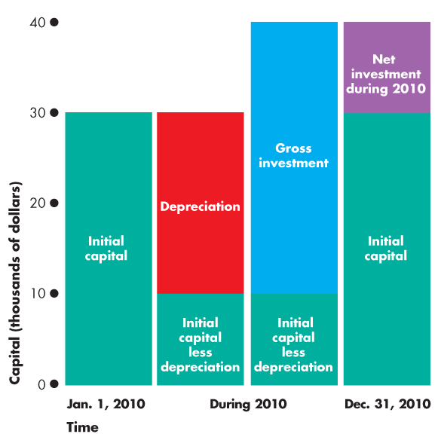
FIGURE 9.1: Capital and Investment
- Wealth and Saving
Wealth is the value of all the things that people own. What people own is related to what they earn, but it is not the same thing. People earn an income, which is the amount they receive during a given time period. Saving is the amount of income that is not paid in taxes or spent on consumption goods and services. Saving raises wealth. Wealth also increases when the market value of assets rises. The increase in wealth as a result of the increase in the market value of assets is called capital gains. Wealth decreases when the market value of assets falls and these decreases are called capital losses.
For example, at the end of the school year you have $250 in the bank and a coin collection worth $300, so your wealth is $550. During the summer you earn $5,000 and spend $1,000 on consumption goods and services so your saving is $4,000. Your bank account increases to $4,250 and your wealth becomes $4,550 (300+250+4,000). The $4,000 increases in wealth equals saving.
If coins rise in value and your coin collection is now worth of $500, you have a capital gain of $200, which is also added to your wealth. National wealth and national saving work like this personal example. The wealth of a nation at the end of a year equals it wealth at the start of the year plus its saving during a year. Saving equals income minus consumption expenditure. To make real GDP grow, saving and wealth must be transformed into investment and capital. This transformation takes place in the markets for financial capital and through the activities of financial institutions. We are now going to describe these markets and institutions.
  - FINANCIAL MARKETS
Saving is the source of the funds used to finance investment, and these funds are supplied and demanded in financial markets. There are three types of financial markets:
  - Loan markets
  - Bonds market
  - Stock market
- Loan Markets
Businesses often want short-term finance to buy inventories or to extend credit to their customers. Sometimes they get this finance in the form of a loan from a bank. Households often want to finance to purchase big ticket items, such as automobiles or household furnishing and appliances. They get this finance as bank loans. Households also get finance to buy new homes. Expenditure on new homes is counted as part of investment. All types of financing take place in loan markets.
- Bond Markets
When firms expand their business they may get some of the finance they need by selling bonds. Governments also raise finance by issuing bonds. A bond is a promise to make specified payments on specified dates. For example, an investor can buy a bond that promises to pay $5.00 every year until 2024 and then to make a final payment of $100 in 2025. The buyer of a bond from firms or governments makes a loan to them and is entitled to the payments promised by the bond. When a person buys a newly issued bond, he or she may hold the bond until the borrower has repaid the amount borrowed or sell it to someone else. Bonds issued by firms and governments are traded in the bond market. The term of a bond might be long (decades) or short (just a month or two). Firms often issue very short-term bonds as a way of getting paid for their sales before the buyer is able to pay.
For example, when a company sells $100 million of investment goods to another company, the seller wants to be paid when the items are shipped. But buyer does not want to pay until the investment goods are earning an income. In this situation, buyer might promise to pay seller $101 million three months in the future. A bank would be willing to buy this promise for (say) $100 million. The seller gets $100 million immediately and the bank gets $101 million in three months when the buyer honors its promise.
Similar promises that are issued by Treasuries are called treasury bills. Another type of bonds is a mortgage-backed security, which entitles its holder to the income from a package of mortgages. A mortgage is a legal contract that gives ownership of a home to the lender in the event that the borrower fails to meet the agreed payments of principle and interest. Mortgage lenders create mortgage-backed securities. They make mortgage loans to homebuyers and then create securities that they sell to obtain more funds to make more mortgage loans. The holder of a mortgage-backed security is entitled to receive payments that derive from the payments received by the mortgage lender from the home-buyer borrower.
- Stock Markets
When companies want finance to expand their business, they issue stock. A stock is a certificate of ownership and claim to the firm’s profit. If a company issued 1000 stocks and you bought one of them, you would own one thousandth of the company and be entitled to receive one thousandth of its profits. Unlike a stockholder, a bondholder does not own part of the firm that issued the bond. A stock market is a financial market in which shares of stocks of corporations are traded. Borsa İstanbul is an example of stock markets.
  - FINANCIAL INSTITUTIONS
A financial institution is a firm that operates on both sides of the markets for financial capital. The financial institution is a borrower in one market and a lender in another. Financial institutions also stand ready to trade so that households with funds to lend and firms or households seeking funds can always find someone on the other side of the market with whom to trade.
The key financial institutions are
  - Commercial banks
  - Government-sponsored mortgage lenders
  - Pension funds
  - Insurance companies
- Commercial Banks
Commercial banks are financial institutions that accept deposits, provide payment services, and make loans to firms and households. The bank that you use for your own banking services and that issues your credit card is a commercial bank. These institutions play a central role in the monetary system.
- Pension Funds
Pension funds are financial institutions that use the pension contributions of firms and workers to buy bonds and stocks.
- Insurance Companies
Insurance companies enable households and firms to cope with risks such as accident, theft, fire, ill-health, and a host of other misfortunes. They receive premiums from their customers and pay claims. Insurance companies use the funds they have received but not paid out as claims to buy bonds and stocks on which they earn interest income.
  - INTEREST RATES AND ASSETS PRICES
Stocks, bonds, short-term securities, and loans are collectively called financial assets. The interest rate on a financial asset is the interest received expressed as a percentage of the price of the asset. Because the interest rate is a percentage of the price of an asset, if the assets price increases, other things remaining the same, the interest rate falls. Conversely, if the asset price falls, other things remaining the same, the interest rate rises. To see this inverse relationship between asset price and the interest rate, let’s look at an example. We will consider a bond that promises to pay its holder $5 a year forever. The rate of return or the interest rate on this bond depends on the price of the bond. If you could buy this bond for $50, the interest rate would be 10 percent per year:
Interest rate = ($5/$50) X 100 = 10 percent.
But if the price of this bond increases to $200, its rate of return or interest rate would be only 2.5 percent per year. That is,
Interest rate = ($5/$200) X 100 = 2.5 percent.
This relationship means that the price of an asset and the interest rate on that asset are determined simultaneously: one implies the other. This relationship also means that if the interest rate on the asset rises the price of the asset falls, debts become harder to pay, and the net worth of the financial institution falls. Insolvency can arise from a previously unexpected large rise in the interest rate. In the next part of this lesson, we learn how interest rates and asset prices are determined in the financial markets.
  - THE LOANABLE FUNDS MARKET
We group all the financial markets that we described in the previous section into a single loanable funds market. The loanable funds market is the aggregate of all the individual financial markets.
- Funds that Finance Investment
Funds come from three sources:
  - Household saving
  - Government budget surplus
  - Borrowing from the rest of the world
Households’ income (Y) is spent on consumption (C), saved (S) or paid in net taxes (T). Net taxes are taxes paid to governments minus the cash transfers received from government (such as Social Security and unemployment benefits). So income is equal to the sum of consumption expenditure, saving and net taxes:
Y = C + S + T.
We know that Y also equals the sum of the items of aggregate expenditure: consumption expenditure(C), investment (I), government expenditure (G), and exports (X), minus imports, M. That is:
Y = C + I + G + X –M.
By using these two equations, you can see that
I + G + X = M + S + T
Subtract G and X from both sides of the last equation to obtain
I = S + (T-G) + (M-X).
This equation tells us that investment (I) is financed by
  - household saving (S),
  - the government budget surplus, (T-G),
  - and borrowing from the rest of the world, (M-X).
A government budget surplus (T>G) contributes funds to finance investment, but a government budget deficit (T<G) competes with investment for funds. If we exports less than we import, we borrow (M-X) from the rest of the world to finance some of our investment. If we export more than we import, we lend (X-M) to the rest of the world and part of the national saving finances investment in other countries. The sum of private saving (S), and government saving (T-G), is called national saving. National saving and foreign borrowing finance investment.
In 2011, total investment in Turkey was TL 313 billion. Government had a deficit of TL6 billion. This total of TL319 billion was financed by saving of TL198 billion and borrowing from the rest of the world of TL121 billion.
- The Real Interest Rate
The nominal interest rate is the number of currency that a borrower pays and lender receives in interest in a year expressed as a percentage of the number of currency borrowed and lent. For example, if the annual interest paid on a $500 loan is $25, the nominal interest rate is 5 percent per year:
($25/$500) X 100 = 5 percent.
The real interest rate is the nominal interest rate adjusted to remove the effects of inflation on the buying power of money. The real interest rate is approximately equal the nominal interest rate minus the inflation rate. You can see why if you suppose that you have put $500 in a savings account that earns 5 percent a year. At the end of a year, you have $525 in your savings account. Suppose that inflation rate is 2 percent per year.
Now, at the end of the year, it costs $510 to buy what $500 would have bought one year ago. Your money in the bank has really only increased by $15, from $510 to $525. That $15 is equivalent to a real interest rate of 3 percent a year on your original $500. So the real interest rate is the 5 percent nominal interest rate minus the 2 percent inflation rate.
The real interest rate is the opportunity cost of loanable funds. The real interest paid on borrowed funds is the opportunity cost of borrowing. And the real interest rate forgone when funds are used either to buy consumption goods and services or to invest in new capital goods is the opportunity cost of not saving or not lending those funds.
HOMEWORK 9
- Distinguish between physical capital and financial capital and give two examples of each.
- What is the distinction between gross investment and net investment?
- What are the three main types of markets for financial capital?
- Explain the relationship between the price of a financial asset and its interest rate.
- How do firms make investment decisions?
- What determines the demand for loanable funds and what makes it change?
- Michael is an internet service provider. On December 31, 2009, he bought an existing business with servers and a building worth $400,000. During his first year of operation, his business grew and he bought new servers for $500,000. The market value of some of his older servers fell by $100,000.
  - What was Michael’s gross investment, depreciation, and net investment during 2010?
  - What was the value of Michael’s capital at the end of 2010?

CHAPTER 10
MONEY AND MONEY MARKET
  - MONEY
Money is anything that serves as a commonly accepted medium of exchange or means of payment. Changes in the quantity of money have enormous effects on output, employment, and prices. The central bank can use its control over the supply of money to stimulate the economy when growth turns sluggish, or to brake the economy when prices start to race ahead. When money is well managed, output can grow smoothly with stable prices. But when there are problems in the monetary system, money can grow rapidly or shrink sharply, leading to inflation or depression.
Money serves four functions: it is a means of payment, a medium of exchange, a unit of account, and a store of value
- Means of payment
A means of payment is a method of settling a debt. When a payment has been made, there is no remaining obligation between the parties to a transaction. A medium of exchange is any object that is generally accepted in exchange for goods and services. Without a medium of exchange, goods and services must be exchanged directly for other goods and services. If a good is exchanged for another good we call such exchange barter. Barter requires double coincidence of wants. A double coincidence of wants is a situation that rarely occurs.
For example, if you want a hamburger, you might offer a CD in exchange for it. But you must find someone who is selling hamburgers and wants your CD. A medium of exchange overcomes the need for a double coincidence of wants. Money acts as a medium of exchange because people with something to sell will always accept money in exchange for it.
- Unit of Account
A unit of account is an agreed measure for stating the prices of goods and services. To get the most out of your budget, you have to figure out whether seeing one more movie is worth its opportunity cost. Opportunity cost is, for example, the number of ice-cream cones, sodas, or cups of coffee that you must give up. It is easy to make such calculations when all these goods have prices in terms of money. We can see how much simpler it is if all the prices are expressed in money.
- Store of Value
Money is a store of value in the sense that it can be held and exchanged later for goods and services. If money were not a store of value, it could not serve as a means of payment. Money is not the only store of value. A house, a car, and a work of art are other examples. The more stable the value of a commodity or token, the better it can act as a store of value and the more useful it is as money. No store of value has a completely stable value. The value of a house, a car, or a work of art fluctuates over time. The value of the commodities and tokens that are used as money also fluctuates over time. Inflation lowers the value of money and values of other commodities and tokens that are used as money. To make money as useful as possible as a store of value, a low inflation rate is needed.
  - MONEY IN TURKEY
In Turkey, money consists of currency in circulation and deposits at banks.
Currency in circulation is the notes and coins held by individuals and businesses. Notes are money because the government declares them so. Deposits of individuals and businesses at banks are also counted as money. Deposits are money because the owners of the deposits can use them to make payments.
The narrowest measure of money is M1. M1 consists of currency in circulation (held by public) and sight deposits both TRY and FX. M1 does not include currency held by banks. Sight deposits include all deposits in banks that can be withdrawn without prior notice. They are non-interest bearing. M2 consists of M1 plus time deposits. Time deposits include TRY deposits and FX deposits. They are interest-bearing. M3 is the broadest definition of money.
Money stock definitions used by the Central Bank of Turkey are:
M1 = Currency in circulation + Sight Deposits (TRY) + Sight Deposits (FX)
M2 = M1 + Time Deposits (TRY) + Time Deposits (FX)
M3 = M2 + REPOS + Money Market Funds + Debt Securities Issued
  - BANKING SYSTEM
The banking system consists of the central bank (CB) and commercial banks. The CB is at the top of the system and is responsible to carry out monetary policy. The CB can influence the economy by changing the amount of money using monetary policy tools.
- The Central Bank’s Policy Tools
The CB influences the quantity of money and interest rates by manipulating three tools: open market operations, loans to banks, and required reserve ratio
- Open Market Operations
An open market operation is the purchase of securities from commercial banks or sale of securities by the CB to commercial banks. When the CB buys securities, it pays for them with newly created money. When the CB sells securities, the CB is paid with money held by banks. By open market operations, the CB changes the quantity of money.
- Central Bank’s Loans to Banks
The CB is the lender of last resort. If a bank is short of money, it can borrow from the CB. The CB can provide money to the banking system by making loans to banks. The CB sets the interest rate on the last resort loans and this interest rate is called the discount rate. These loans increase bank reserves. The CB can change commercial banks’ demands for loan by changing the discount rate. If the CB lowers the discount rate banks may increase their loan from the CB and their reserves increase. If the CB increase the discount rate this may lead a decrease in loan demand of the banks from the CB and their reserves decrease.
- Required Reserve Ratio
Commercial banks hold a part of deposits as reserves and lend the other part to firms and households. The required reserve ratio is the minimum percentage of deposits that the CB wants commercial banks to hold as reserves. The CB can influence the total amount of banks loans to firms and households by changing the required reserve ratio and thus the excess reserves that can be used as loans.
- Commercial Banks
A commercial bank is a firm that receives deposits and makes loans. Commercial banks provide services such as check clearing, account management, credit cards, and internet banking. A commercial bank holds a part of the funds it receives from depositors and other funds that it borrows as reserves and puts the other part of funds into financial assets and loans.
Bank’s reserves are notes and coins in the bank’s vault or in a deposit account in the central bank (CB). These funds are used to meet depositors’ currency withdrawals and to make payments to other banks. Loans are funds committed for a period of time to firms to finance investment and to households to finance the purchase of goods and services.
Commercial banks provide four benefits: they create liquidity, pool risk, lower the cost of borrowing and lower the cost of monitoring borrowers
Commercial banks create liquidity by borrowing short and lending long. They take deposits and stand ready to repay them on short notice or on demand and make loan commitments that run for terms of many years.
A loan might not be repaid. This is a default. If you lend to one person who defaults, you lose the entire amount loaned. If you lend to people through a bank and one person defaults, you lose almost nothing. Commercial banks pool risk.
Commercial banks monitor borrowers and encourage good decisions that prevent defaults. It would be very costly for individuals that lent money to a firm monitoring that firm directly. Commercial banks can perform this task at a much lower cost.
  - HOW BANKS CREATE MONEY
We defined money as the sum of currency in circulation and bank deposits. Banks create deposits by making loans. So, banks create money. When the CB supplies the banking system with additional reserves, deposits increase by a multiple of this amount. This is a process called multiple deposit creation.
When the CB supplies new reserves to the banks, their excess reserves increase by this amount, because the CB wants banks hold required reserves only for deposits. Banks will lend some part of their excess reserves. Borrowers will draw some part of the credit from the banking system as cash; there will be a currency flow out of the banking system. The other part of the credit, however, will be held in bank accounts as deposits. In this way new money is created. Banks will hold some part of the newly created deposits as required reserves (and probably as excess reserves). The other part of the deposits will be lent to new borrowers. This process continues until the initial increase in reserves results in a multiple increase in deposits. For the banking system as a whole, deposit creation will stop only when non-desired reserves in the banking system are zero.
When the non-desired reserves are used up the quantity of new deposits (money) created will depend on three factors: the required reserve ratio decided by the central bank, the excess reserve ratio decided by commercial banks, and currency holding ratio decided by the public. There is a negative relationship between each of these ratios and the quantity of created new deposits (money); when any of these ratios rises the money multiplier falls, vice versa. The money multiplier is the ratio of change in the quantity of money to the change in reserves. For example, if an increase of 1 million liras in reserves increases the quantity of money by 3 million liras, the money multiplier is 3.
If the CB sells securities to banks in an open market operation, the banks have negative excess reserves; they are short of reserves. When the banks are short of reserves, loans and deposits decrease and the process we have described above works in a downward direction until desired reserves plus desired currency holdings has decreased by an amount equal to the decrease in bank reserves.
  - THE MONEY MARKET: DETERMINATION OF THE RATE OF INTEREST
In money market the rate of interest is determined by the supply of and demand for money.
- Demand For Money
The quantity of money demanded is the inventory of money that people plan to hold on any given day. It is the quantity of money in our wallets and in our deposit accounts at banks. The quantity of money that people plan to hold depends on four main factors: the price level, interest rate, national income (GDP), and payment technologies
- The Price Level
The quantity of nominal money demanded is proportional to the price level, other things remaining the same. If the price level rises by 10 percent, people hold 10 percent more nominal money than before, ceteris paribus. If you hold 20 liras to buy your weekly needs, you will increase your money holding to 22 liras if the prices of the goods and services (and your wage rate) increase by 10 percent.
- Interest Rate
A fundamental principle of economics is that as the opportunity cost of something increases, people try to find substitutes for it. Money is no exception. The higher the opportunity cost of money, other things remaining the same, the smaller is the quantity of real money demanded. The nominal interest rate on the other assets, such as time deposits and bonds, is the opportunity cost of holding money. Therefore, there is a negative relationship between the amount of money held and the interest rate.
- National income (GDP)
The quantity of money that households and firms plan to hold depends on the amount they are spending. The quantity of money demanded in the economy as a whole depends on aggregate expenditure, GDP. Again, suppose that you hold an average of 20 liras to finance your weekly purchases. Now imagine that the prices of these goods and of all other goods remain constant but that your income increases. As a consequence, you buy now more goods and services and you also keep a larger amount of money on hand to finance your higher volume of expenditure.
- Payment technologies
Technological change and the arrival of new financial products influence the quantity of money held. Financial innovation decreases the need for holding money. Financial innovations include automatic transfers between bank accounts, automatic teller machines, credit cards and debit cards, internet banking and bill paying.
- Supply of Money
The quantity of money supplied is determined by the actions of the central bank (CB), commercial banks and people, as we have explained above. Although the behaviors of commercial banks and people affect money supply, the most important determinant of money supply is the CB, because the CB’s policies affect also the behaviors of commercial banks and people.

- Money Market Equilibrium
Money market equilibrium occurs when the quantity of money demanded equals the quantity of money supplied. Any change either in money supply or demand or both changes the rate of interest.
HOMEWORK 10
- Define money and explain its functions.
- What are the official measures of money in Turkey?
- What are the economic benefits provided by commercial banks? Explain each.
- What is the banking system and what is the role of the central bank?
- What are the central bank’s three policy tools? Explain each.
- How do banks create money?
- What limits the quantity of money that the banking system can create? Explain.
- What determines money demand?

