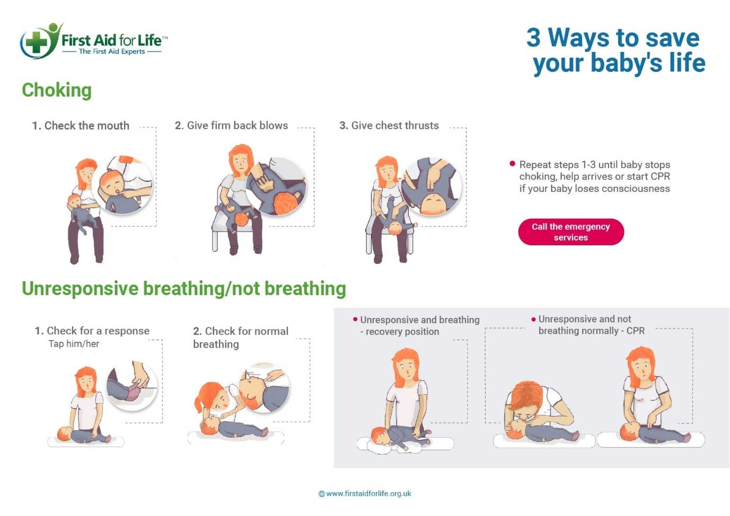

First Aid Basics for the Workplace (OHS)

|  |
| --- |
|  |
| First aid is like helping someone right away when they get hurt or sick . It's what you do until a doctor or other medical help arrives . Knowing first aid can help keep people safe at work . It can even save lives .  When someone needs first aid, the first thing to do is check if the area is safe . You don't want to get hurt while trying to help . Then, see what's wrong with the person . Are they awake? Are they breathing ? If they are not awake or breathing, you might need to call 9-1-1 .  If someone is hurt, you should also ask if you can help them . This is called getting consent . It's also important to protect yourself by using gloves or other safety gear . This keeps you safe from germs .  There are some common injuries that can happen at work . People can get cuts or scrapes from sharp tools . They can get burns from hot things or chemicals . They can also strain their muscles from lifting things the wrong way . Sometimes, people might faint or have a heart attack .  Knowing how to handle these injuries is important . For cuts, you should clean the wound and put on a bandage . For burns, you should cool the burn with water . If someone is bleeding a lot, you should press on the wound with a clean cloth . If someone faints, make sure they can breathe and keep them warm .  CPR is a very important first aid skill . CPR helps someone who has stopped breathing or whose heart has stopped . You can learn CPR in a class . In CPR, you push on the person's chest and give them breaths . This helps keep blood and oxygen flowing to their brain .  Many companies want their workers to learn first aid . They might offer classes or training . OSHA is a group that makes rules about safety at work . OSHA says that companies must have people who know first aid if there isn't a hospital or clinic nearby . Learning first aid can help you be ready to help someone in need . |

|  |
| --- |
| Reading Summary |
| * First aid is immediate help given to an injured or sick person until medical professionals arrive. * Key steps include ensuring safety, assessing the person's condition, obtaining consent, and using protective gear. * Common workplace injuries include cuts, burns, and muscle strains, and knowing CPR is a vital skill. |

Vocabulary

|  |  |  |
| --- | --- | --- |
| Term | Definition | Example Sentence |
| first aid (noun) | Help given to someone who is hurt or sick until a doctor arrives. | Knowing basic first aid can help you assist someone who is injured. |
| consent (noun) | Permission to do something. | You should always ask for consent before helping someone who is hurt. |
| CPR (noun) | A way to help someone who has stopped breathing by pushing on their chest and giving them breaths. | CPR can help save someone's life if they are not breathing. |
| OSHA (noun) | A group that makes rules about safety at work. | OSHA makes sure companies keep workers safe. |
| germs (noun) | Tiny living things that can make you sick. | Washing your hands helps get rid of germs. |

Multiple Choice Questions

|  |  |  |
| --- | --- | --- |
| Question #1 | Question #2 | Question #3 |
| According to the text, what is the FIRST thing you should do when someone needs first aid? | What does the text say you should do if someone has a cut? | According to the text, why do many companies want their workers to learn first aid? |
| A. Check what is wrong with the person.  B. Call 9-1-1 immediately.  C. Check if the area is safe.  D. Ask the person if you can help them. | A. Cool the cut with water.  B. Clean the wound and put on a bandage.  C. Give them CPR.  D. Make sure they can breathe and keep them warm. | A. To avoid paying for medical insurance.  B. To help them get promoted faster.  C. To be ready to help someone in need.  D. Because it is required by law in all states. |

Short Answer Questions

|  |  |
| --- | --- |
| Question #1 | What does the text say is the purpose of first aid? |
| __________________________________________________________________________________________________________________________________________________________________________________________________________________________________________________________________________________________________________________________________________________________________________________ | |
| Question #2 | According to the text, what should you do if someone has a burn? |
| __________________________________________________________________________________________________________________________________________________________________________________________________________________________________________________________________________________________________________________________________________________________________________________ | |
| Question #3 | What does the text say CPR helps with? |
| __________________________________________________________________________________________________________________________________________________________________________________________________________________________________________________________________________________________________________________________________________________________________________________ | |

Open Ended Questions

|  |  |
| --- | --- |
| Question #1 | Have you ever been in a situation where someone needed help? How do you think knowing first aid might have changed what happened? |
| __________________________________________________________________________________________________________________________________________________________________________________________________________________________________________________________________________________________________________________________________________________________________________________ | |
| Question #2 | The text talks about how first aid can help keep people safe at work. What are some ways you can apply first aid principles to keep yourself and others safe in your daily life, like at home or school? |
| __________________________________________________________________________________________________________________________________________________________________________________________________________________________________________________________________________________________________________________________________________________________________________________ | |
| Question #3 | The text mentions the importance of getting consent before helping someone. Why do you think it's important to ask for permission before giving first aid, and how might you do that in a respectful way? |
| __________________________________________________________________________________________________________________________________________________________________________________________________________________________________________________________________________________________________________________________________________________________________________________ | |