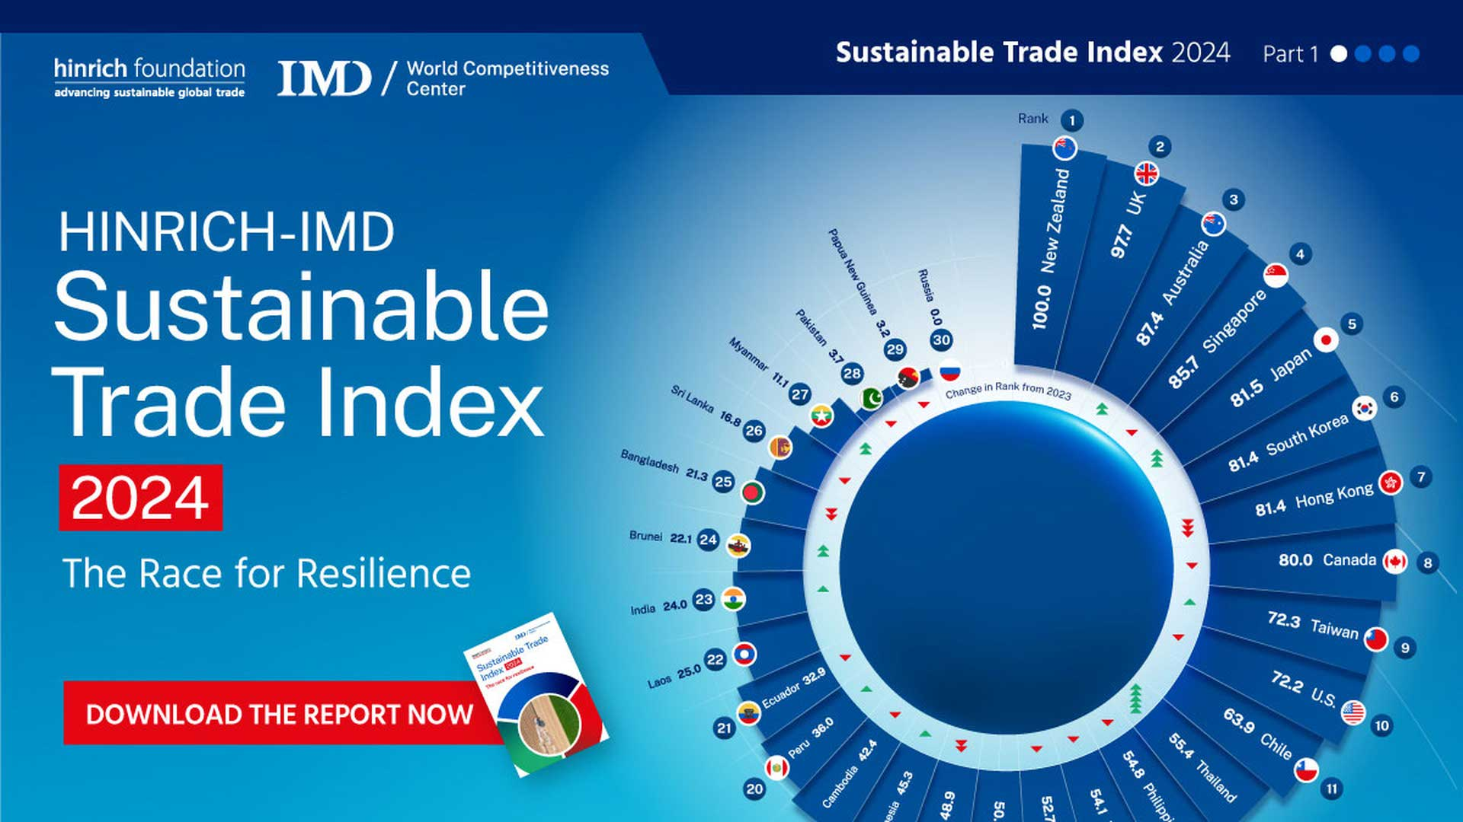

Sustainable Trade: Going Green in Global Business

|  |
| --- |
|  |
| Global trade is how countries buy and sell things to each other . It's a big part of the world's economy . But it can also cause problems for the environment . That's why people are talking about "sustainable trade" . This means finding ways to trade that are good for both the economy and the planet .  One big problem with global trade is that it creates a lot of carbon emissions . Carbon emissions are gases that trap heat in the atmosphere and cause climate change . When we ship goods all over the world, we use a lot of fuel, which releases these gases . About 30% of all carbon emissions come from global trade . So, it's important to find ways to reduce these emissions .  Many people are now interested in environmental, social, and corporate governance (ESG) . This means they want companies to be responsible about the environment, treat people fairly, and be honest in how they run their businesses . This is a good sign because it shows that people care about sustainability . But we need to be clear about what "sustainable trade" really means .  Each trade is different, which makes it hard to have one set of rules for sustainability . There are also many different ideas about what sustainability means . This can make it hard to know if a company is really being sustainable or just pretending . This is called "greenwashing," and we need to avoid it .  To help with this, the International Chamber of Commerce (ICC) has created some principles for sustainable trade . These principles help businesses figure out how to make their trade more environmentally friendly and socially responsible . The principles look at different parts of a trade, like where the goods come from, who is selling them, who is buying them, and how they are being moved .  Yale University is also working on making global trade more sustainable . They have a project that is looking at how to change international trade rules to help fight climate change . They want to create a system that supports clean energy, sustainable food, and protection of the oceans . They also want to promote a "circular economy," which means reusing materials as much as possible .  Businesses can also be more sustainable by using new ideas and technology . For example, they can use more efficient supply chains to reduce carbon emissions . They can also use data to predict demand and manage their inventory better . Some countries are also using "green tariffs," which are taxes on goods that are not environmentally friendly . By working together, countries and businesses can make global trade more sustainable and protect the planet . |

|  |
| --- |
| Reading Summary |
| * Global trade, where countries buy and sell stuff, can hurt the environment, so people want 'sustainable trade' that helps both the economy and the Earth. * Global trade makes a lot of pollution that causes climate change, so groups like the International Chamber of Commerce and Yale are trying to make trade greener. * Companies can use new ideas, like better supply chains and green tariffs, to make trade more sustainable and protect the planet. |

Vocabulary

|  |  |  |
| --- | --- | --- |
| Term | Definition | Example Sentence |
| sustainable trade (noun) | Ways of buying and selling things between countries that are good for both the economy and the environment. | The store tries to practice sustainable trade by buying products from local farmers. |
| carbon emissions (noun) | Gases released into the air that trap heat and cause climate change. | Cars and factories release carbon emissions that can harm the environment. |
| ESG (noun) | Stands for Environmental, Social, and Governance; it means companies should care about the environment, treat people fairly, and be honest. | The company's ESG score was high because they were committed to protecting the environment and treating their workers well. |
| sustainability (noun) | Finding ways to do things that protect the environment and can keep going for a long time. | Using less water is important for the sustainability of our planet. |
| greenwashing (noun) | When a company pretends to be environmentally friendly but is not really making a big effort. | The company was accused of greenwashing because they advertised their products as eco-friendly, but they were still polluting the river. |

Multiple Choice Questions

|  |  |  |
| --- | --- | --- |
| Question #1 | Question #2 | Question #3 |
| According to the text, what is one big problem with global trade? | What does ESG stand for, according to the text? | What is one thing Yale University is working on to make global trade more sustainable, according to the text? |
| A. It helps the environment too much.  B. It makes countries not want to trade with each other.  C. It creates a lot of carbon emissions that cause climate change.  D. It makes goods cheaper for people to buy. | A. Environmental, Social, and Corporate Governance.  B. Economic, Social, and Governmental rules.  C. Environmental, Social, and Global trade.  D. Economic, Sustainable, and Global growth. | A. Creating more pollution from factories.  B. Making international trade rules to help fight climate change.  C. Using less fuel to ship goods.  D. Selling more goods to other countries. |

Short Answer Questions

|  |  |
| --- | --- |
| Question #1 | What does the term "sustainable trade" mean in the text? |
| __________________________________________________________________________________________________________________________________________________________________________________________________________________________________________________________________________________________________________________________________________________________________________________ | |
| Question #2 | What is "greenwashing" according to the text, and why should we avoid it? |
| __________________________________________________________________________________________________________________________________________________________________________________________________________________________________________________________________________________________________________________________________________________________________________________ | |
| Question #3 | What has the International Chamber of Commerce (ICC) created to help businesses with sustainable trade? |
| __________________________________________________________________________________________________________________________________________________________________________________________________________________________________________________________________________________________________________________________________________________________________________________ | |

Open Ended Questions

|  |  |
| --- | --- |
| Question #1 | The article talks about how global trade can harm the environment through carbon emissions. Can you think of any ways your own choices, like what you buy or how you travel, might contribute to these emissions? What's one small change you could make in your daily life to be more environmentally friendly? |
| __________________________________________________________________________________________________________________________________________________________________________________________________________________________________________________________________________________________________________________________________________________________________________________ | |
| Question #2 | The article mentions that many people are interested in companies being responsible about the environment and treating people fairly. Think about a company you know, maybe one that makes your favorite snack or clothes. Do you think they are doing a good job being sustainable and responsible? Why or why not? |
| __________________________________________________________________________________________________________________________________________________________________________________________________________________________________________________________________________________________________________________________________________________________________________________ | |
| Question #3 | The article discusses the idea of a 'circular economy,' where we reuse materials as much as possible. Can you think of something you usually throw away that could be reused or recycled? How could you encourage your family or friends to participate in a circular economy? |
| __________________________________________________________________________________________________________________________________________________________________________________________________________________________________________________________________________________________________________________________________________________________________________________ | |