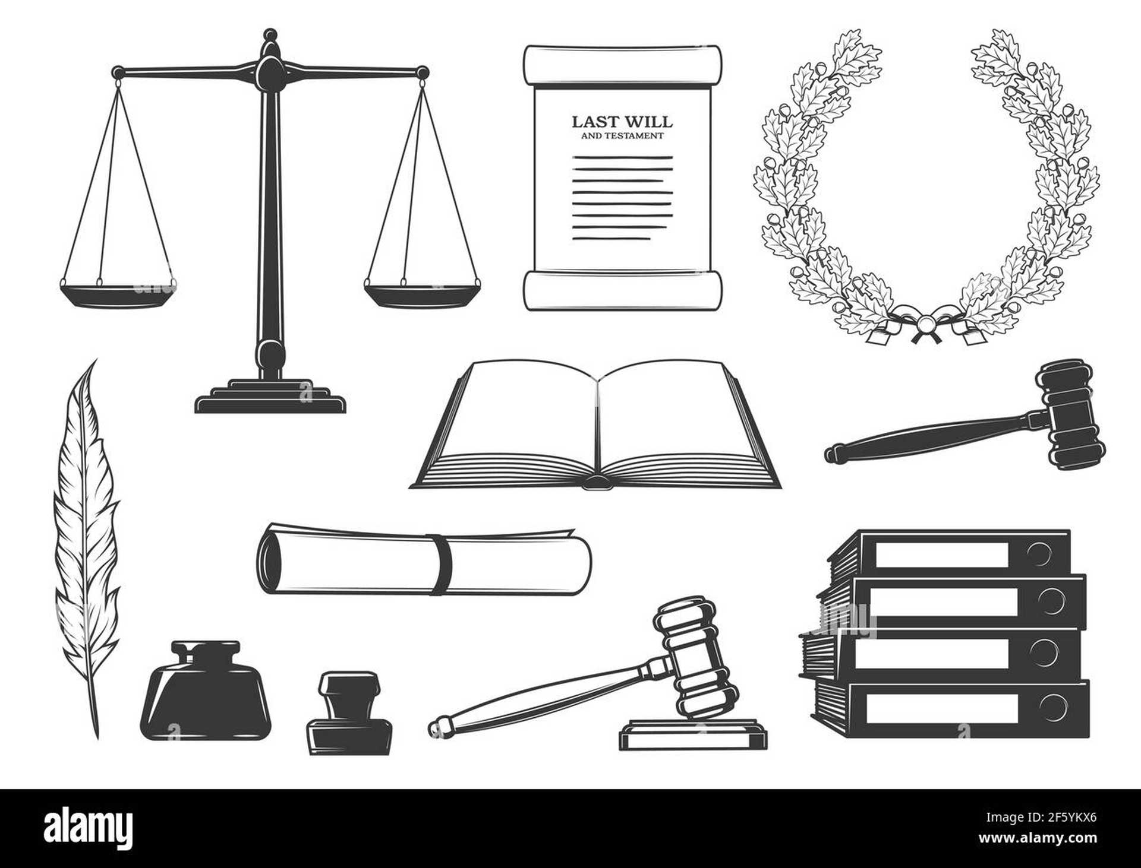

Criminal Law

|  |
| --- |
| Criminal Law |
| Criminal law is a set of rules that define and punish actions that are harmful to society. It's different from civil law, which deals with disagreements between individuals. Criminal law is important because it helps keep our communities safe and protects people's rights. It's like a set of boundaries that tell us what actions are acceptable and what actions are not.  Criminal laws are made by legislatures, which are groups of people who make laws for a country or state. In the United States, both the federal government and each state have their own criminal codes, which list specific crimes and their punishments. These laws are constantly changing to reflect new technologies and societal values.  There are different levels of crimes, with different punishments. The most serious crimes are called felonies, and they can result in a long prison sentence or even the death penalty. Examples of felonies include murder, robbery, rape, arson, and drug trafficking. Misdemeanors are less serious crimes, and they can result in a shorter jail sentence or a fine. Examples of misdemeanors include theft, vandalism, and disorderly conduct. The least serious crimes are called infractions, and they usually only result in a fine. Examples of infractions include minor traffic violations, jaywalking, and littering.  To be convicted of a crime, there must be evidence that the person committed the crime and that they intended to do it. The physical act of committing the crime is called "actus reus," and the mental state of the person is called "mens rea." For example, if someone accidentally shoots someone else, they may not be found guilty of murder because they didn't intend to kill the person.  Criminal law is a complex system that involves many different people, including police officers, prosecutors, public defenders, and judges. Each step in the process is designed to protect people's rights. Criminal law is a balancing act between protecting the public and protecting individual freedoms. |

|  |
| --- |
| Reading Summary |
| * Criminal law is a set of rules that define and punish actions that harm society, and it helps keep communities safe. * Criminal laws are made by legislatures and are constantly changing to reflect new technologies and societal values. * There are different levels of crimes, with felonies being the most serious and infractions being the least serious. |

Vocabulary

|  |  |  |
| --- | --- | --- |
| Term | Definition | Example Sentence |
| legislatures (noun) | A group of people who have the power to make laws for a country or state. | The legislatures of each state meet to discuss and vote on new laws. |
| felonies (noun) | Serious crimes that can result in a long prison sentence or even the death penalty. | Murder, robbery, and arson are examples of felonies. |
| misdemeanors (noun) | Less serious crimes that can result in a shorter jail sentence or a fine. | Theft, vandalism, and disorderly conduct are examples of misdemeanors. |
| infractions (noun) | The least serious crimes that usually only result in a fine. | Minor traffic violations, jaywalking, and littering are examples of infractions. |
| convicted (verb) | To be found guilty of a crime by a court of law. | The defendant was convicted of robbery and sentenced to five years in prison. |
| punishment (noun) | A penalty or consequence for doing something wrong or breaking a rule. | The student received a punishment of detention for talking in class. |
| actus reus (Latin phrase) | A Latin phrase meaning "guilty act" that refers to the physical act of committing a crime. | The prosecution must prove the actus reus, meaning they must show that the defendant actually committed the crime. |
| mens rea (Latin phrase) | A legal term meaning "guilty mind." It refers to the mental state a person must have to be found guilty of a crime. This means they must have intended to commit the crime or acted recklessly or negligently. | The prosecution must prove that the defendant had mens rea, meaning they knew their actions were wrong and intended to commit the crime. |
| prosecutor (noun) | A lawyer who represents the government in a criminal case and tries to prove that the defendant is guilty. | The prosecutor presented evidence to the jury in an attempt to convince them that the defendant was responsible for the crime. |
| defenders (noun) | People or things that protect something or someone from harm or attack. | The brave defenders of the castle fought off the invaders. |
| judges (noun) | People who are officially appointed to make decisions in a court of law. | The judges listened carefully to the arguments of both lawyers before making their decision. |

Multiple Choice Questions

|  |  |  |
| --- | --- | --- |
| Question #1 | Question #2 | Question #3 |
| What is the main difference between criminal law and civil law? | What are the two main components that must be proven to convict someone of a crime? | What is an example of a misdemeanor? |
| A. Criminal law deals with disagreements between individuals, while civil law punishes actions harmful to society.  B. Criminal law is about protecting people's rights, while civil law is about keeping communities safe.  C. Criminal law is made by legislatures, while civil law is made by judges.  D. Criminal law deals with disagreements between individuals, while civil law punishes actions harmful to society. | A. The person must have committed the crime and they must have intended to do it.  B. The person must have committed the crime and they must have been caught by the police.  C. The person must have committed the crime and they must have been found guilty by a jury.  D. The person must have committed the crime and they must have been sentenced by a judge. | A. Murder  B. Robbery  C. Theft  D. Arson |

Short Answer Questions

|  |  |
| --- | --- |
| Question #1 | What are the three levels of crimes, and what are their potential punishments? |
| __________________________________________________________________________________________________________________________________________________________________________________________________________________________________________________________________________________________________________________________________________________________________________________ | |
| Question #2 | How does the criminal justice system protect people's rights? |
| __________________________________________________________________________________________________________________________________________________________________________________________________________________________________________________________________________________________________________________________________________________________________________________ | |
| Question #3 | Why is criminal law constantly changing? |
| __________________________________________________________________________________________________________________________________________________________________________________________________________________________________________________________________________________________________________________________________________________________________________________ | |

Open Ended Questions

|  |  |
| --- | --- |
| Question #1 | Think about the different levels of crimes discussed in the text. How do you think these levels of crime reflect the values of our society? What do you think makes a crime more serious than another? |
| __________________________________________________________________________________________________________________________________________________________________________________________________________________________________________________________________________________________________________________________________________________________________________________ | |
| Question #2 | The text mentions that criminal law is a balancing act between protecting the public and protecting individual freedoms. Can you think of an example from your own life where these two things might be in conflict? How do you think this conflict should be resolved? |
| __________________________________________________________________________________________________________________________________________________________________________________________________________________________________________________________________________________________________________________________________________________________________________________ | |
| Question #3 | The text states that criminal laws are constantly changing to reflect new technologies and societal values. Can you think of any examples of how technology has changed the way we think about crime? How do you think technology will continue to shape criminal law in the future? |
| __________________________________________________________________________________________________________________________________________________________________________________________________________________________________________________________________________________________________________________________________________________________________________________ | |