**Write a guidebook entry for young adults from any countries.  
There are two examples below.**

**Pamukkale** is a beautiful natural place in **Denizli**, Turkey. It is famous for its white steps made of minerals from hot water. Many people visit Pamukkale because it looks amazing and special. You can walk on the white steps and swim in the warm pools. The water is relaxing and good for your body. You can also take photos and enjoy the view. There are many small hotels and pensions near Pamukkale, so you can stay there. For more information, you can visit the website: https://www.goturkiye.com/destinations/pamukkale.

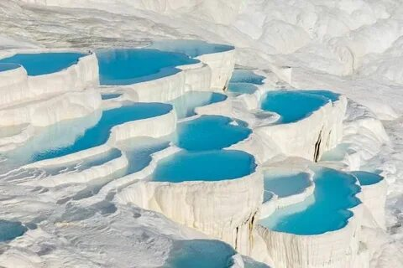

**Yedigöller National Park** is a very **beautiful** and **popular** place in the north of Turkey. It means “Seven Lakes” in Turkish. The park has seven small **lakes**, many green **forests**, and peaceful **hills**. It is an **amazing** place to walk and take photos. In autumn, the colors of the trees are **awesome**. People go there to have a picnic, camp, or just enjoy the **attractive** view. It is never **boring**, but sometimes it gets crowded on weekends. You cannot see a **volcano** or a **desert** here, but the nature is really nice. There are small hotels and wooden houses where you can stay. For more information, you can visit: <https://www.goturkiye.com/destinations/yedigoller>

