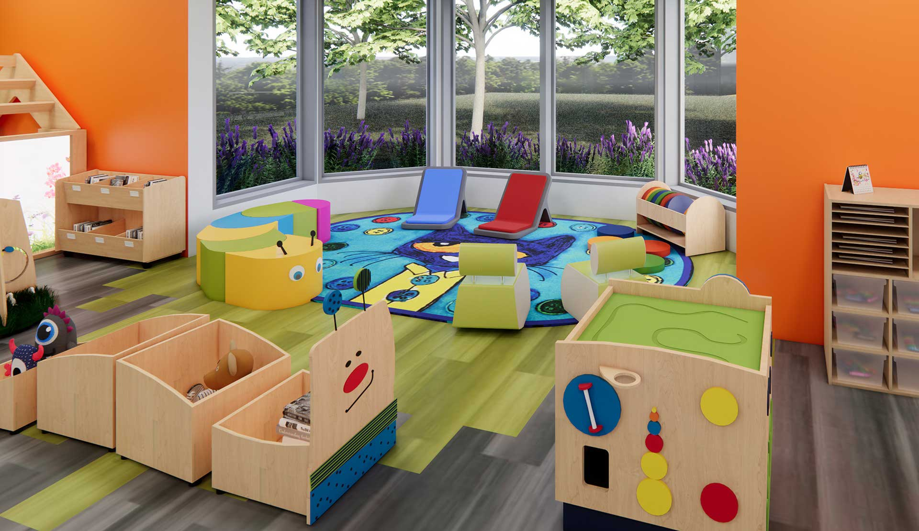

Preschool Education

|  |
| --- |
| Preschool Education |
| Preschool education is all about creating a safe and fun environment where young children can learn and grow. It's important to think about how the classroom space makes children feel. Just like adults, children are affected by their surroundings, and a well-designed classroom can make them feel welcome, secure, and ready to learn.  When designing a preschool classroom, it's important to consider the needs of all the children. There should be spaces for group activities, privacy, storage, and display. This means having areas where children can gather together for things like story time or morning meetings, as well as quiet spaces where they can play alone or in small groups. It's also important to have plenty of storage for toys and learning materials, and to display children's artwork and other creations.  A preschool classroom should be organized and engaging. This means making sure that materials are easy for children to access and use, and that the classroom is visually appealing. It's also important to create opportunities for children to explore and learn through play. This can be done by setting up learning centers with different themes, such as a block area, a dramatic play area, or a science center.  A preschool schedule should include a balance of structured activities and free play. Children need time to learn new skills and concepts, but they also need time to explore their own interests and develop their creativity. A typical preschool day might include activities like circle time, story time, art projects, and outdoor play. It's also important to make sure that children have regular opportunities to eat healthy meals and snacks, and to have quiet time to rest and recharge.  A well-designed preschool classroom and schedule can make a big difference in a child's development. By creating a supportive and enriching environment, teachers can help children learn, grow, and thrive. |

|  |
| --- |
| Reading Summary |
| * A preschool classroom should be designed to meet the needs of all children, including spaces for group activities, privacy, storage, and display. * The classroom should be organized and engaging, with materials that are easy to access and use, and visually appealing displays. * A preschool schedule should include a balance of structured activities and free play, allowing children to learn new skills and concepts while also exploring their own interests and developing their creativity. |

Vocabulary

|  |  |  |
| --- | --- | --- |
| Term | Definition | Example Sentence |
| environment (noun) | The surroundings or conditions in which a person, animal, or plant lives or operates. | The rainforest is a unique environment with many different plants and animals. |
| secure (adjective) | Feeling safe and protected from harm. | The child felt secure in the arms of their parent. |
| engage (verb) | To capture and hold someone's attention or interest. | The teacher used games to engage the students in learning. |
| access (noun) | The ability to use or obtain something. | Students need access to computers and the internet for their schoolwork. |
| enriching (adjective) | Making something better or more interesting. | Traveling to different countries can be an enriching experience. |
| display (verb) | To show or present something to others, often in a public way. | The museum will display the ancient artifacts for visitors to see. |
| thrive (verb) | To grow or develop successfully; to flourish. | The plants thrive in the warm sunshine and fertile soil. |

Multiple Choice Questions

|  |  |  |
| --- | --- | --- |
| Question #1 | Question #2 | Question #3 |
| According to the text, what is the main purpose of a well-designed preschool classroom? | What is one way to create opportunities for children to explore and learn through play in a preschool classroom? | What is the importance of including both structured activities and free play in a preschool schedule? |
| A. To make children feel safe and ready to learn  B. To provide a place for children to play and socialize  C. To help children develop their creativity and imagination  D. To teach children basic academic skills | A. Having a designated quiet space for children to relax  B. Providing a variety of learning centers with different themes  C. Encouraging children to participate in group activities  D. Making sure that all materials are easily accessible | A. To ensure that children are engaged and learning throughout the day  B. To provide a balance between learning new skills and exploring individual interests  C. To help children develop their social skills and learn to cooperate  D. To make sure that children have enough time to rest and recharge |

Short Answer Questions

|  |  |
| --- | --- |
| Question #1 | What are some examples of spaces that should be included in a preschool classroom? |
| __________________________________________________________________________________________________________________________________________________________________________________________________________________________________________________________________________________________________________________________________________________________________________________ | |
| Question #2 | How can a preschool classroom be organized and engaging? |
| __________________________________________________________________________________________________________________________________________________________________________________________________________________________________________________________________________________________________________________________________________________________________________________ | |
| Question #3 | What are some examples of activities that might be included in a typical preschool day? |
| __________________________________________________________________________________________________________________________________________________________________________________________________________________________________________________________________________________________________________________________________________________________________________________ | |

Open Ended Questions

|  |  |
| --- | --- |
| Question #1 | Think about your own classroom or a space where you spend a lot of time. How does the design of that space make you feel? How could it be improved to make you feel more welcome, secure, and ready to learn? |
| __________________________________________________________________________________________________________________________________________________________________________________________________________________________________________________________________________________________________________________________________________________________________________________ | |
| Question #2 | The text mentions the importance of balance between structured activities and free play. How do you experience this balance in your own life? Do you think you have enough time for both structured learning and free exploration? |
| __________________________________________________________________________________________________________________________________________________________________________________________________________________________________________________________________________________________________________________________________________________________________________________ | |
| Question #3 | The text emphasizes the importance of a supportive and enriching environment for children. How do you think your own environment, both at home and at school, contributes to your learning and growth? What could be done to make it even more supportive and enriching? |
| __________________________________________________________________________________________________________________________________________________________________________________________________________________________________________________________________________________________________________________________________________________________________________________ | |