Reading: How Children Grow
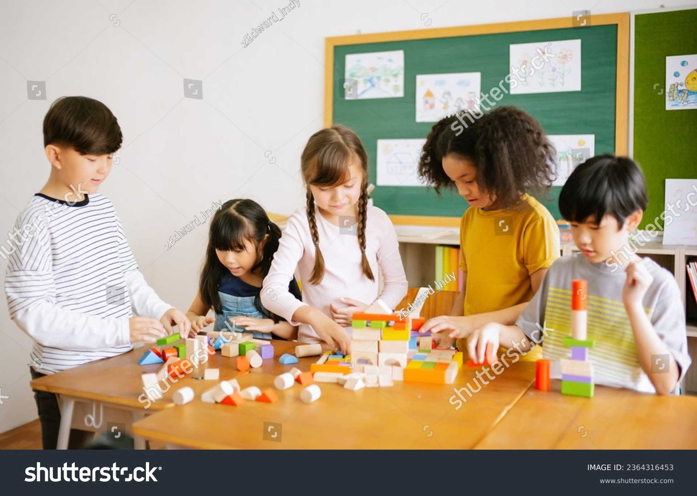
Growing up means changing in many different ways!
The Amazing Journey of Growing Up
Have you noticed that your shoes feel a little tight? Or maybe you have a wiggly tooth? These are signs that you are growing! Children grow and change every single day.
Your Growing Body
Physical growth is when your body gets bigger. When you are around seven or eight years old, you start to lose your baby teeth. New, adult teeth grow in their place. Your muscles also get stronger. You might notice you have better coordination now. This means your brain and body work together so you can catch a ball, tie your shoes, or balance on one foot more easily than when you were little.
Your Growing Mind
Mental growth is how your brain learns. You are becoming a better reader every day. You can read longer stories and understand new words. Your mind is also full of curiosity. You might ask "why" or "how" things work because you want to solve problems. Your brain is like a muscle—the more you use it to learn, the stronger it gets!
Growing with Friends
Social-emotional growth is about your feelings and how you treat others. You are learning how to use empathy. Empathy is when you understand how a friend feels. If a friend is sad, you might give them a kind word to help them feel better. You are also learning about teamwork. This means working together to play a game or finish a project. When you share, listen, and help your classmates, you are showing great social skills. Growing up is an exciting journey for your body, your mind, and your heart!

🔑 Important Words to Know
- Coordination: How well your muscles and brain work together to move.
- Curiosity: Wanting to learn or know more about something.
- Empathy: Understanding and sharing the feelings of another person.
- Teamwork: Working together with other people to reach a goal.
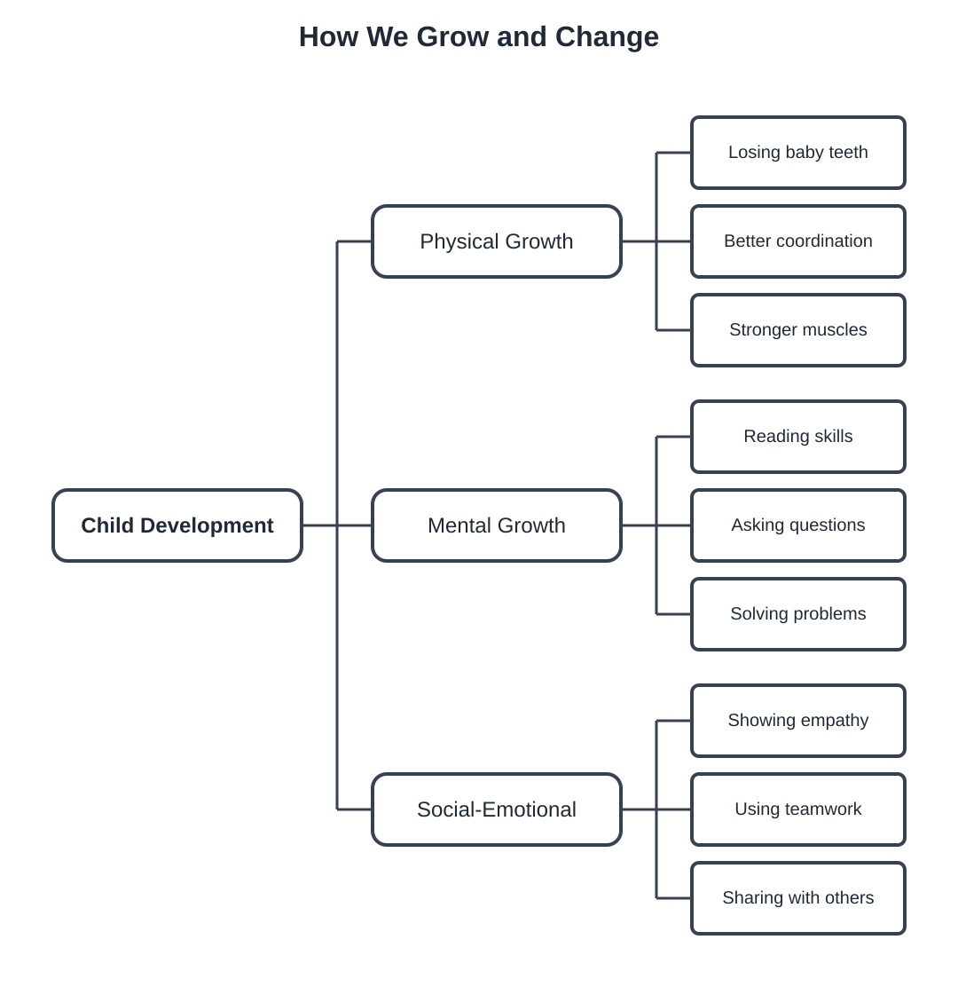
This map shows the three main ways children develop.

Vocabulary Match
Use the words from the reading to complete the activities below. These words help us talk about how we grow and change!
Part 1: Word Match
Draw a line to match the word to its simple definition.
Word | Definition
2. Development | A. Things you learn how to do well.
3. Emotions | B. Being with other people and talking.
4. Social | C. How a person grows and changes.
5. Skills | D. Strong feelings like happy or sad.
6. Share | E. To let someone else use your toys.
7. Grow | F. To get bigger and stronger.
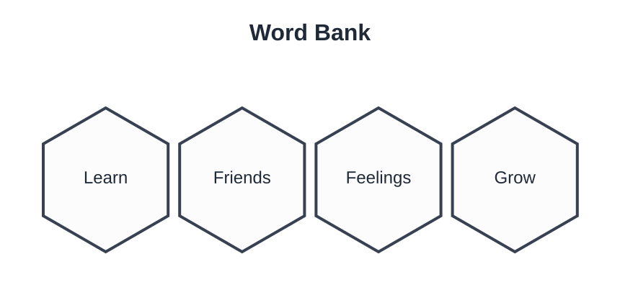
Use these words for the sentences below.
Part 2: Fill in the Blank
Write the correct word from the Word Bank to finish each sentence.
- I eat healthy food to help my body ___________ big and strong.
- At school, I ___________ how to solve math problems.

- It is important to understand your ___________, like when you are happy.
- I like to play and have fun with my ___________ at the park.

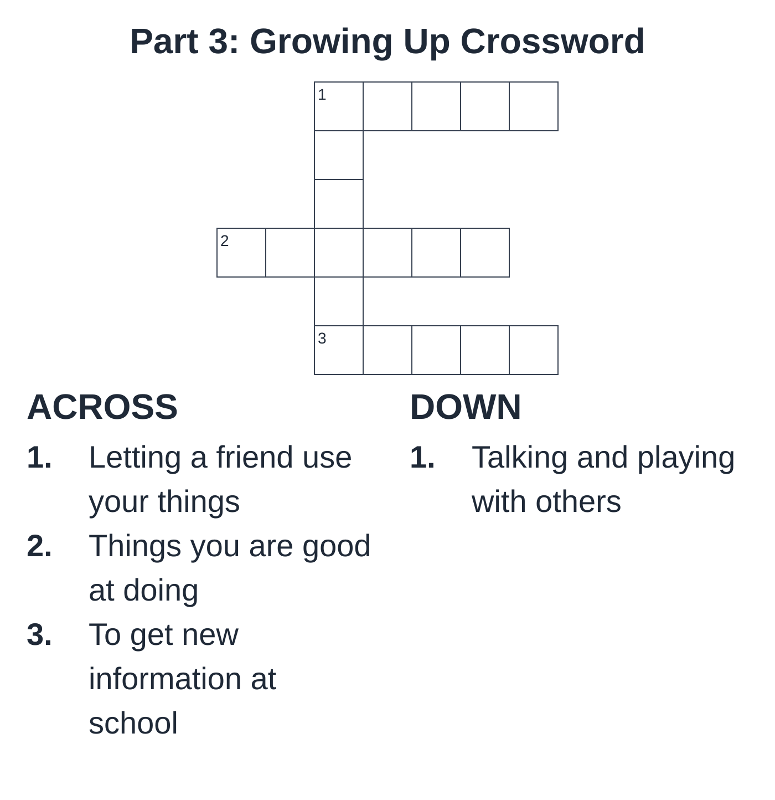
Complete the puzzle using words from our lesson.
Part 4: Word Meanings
Match the word to the picture or idea it represents.
Which word describes how you feel when you are excited or sad?
The word is...

Which word describes the process of changing as you get older?
The word is...

Understanding Feelings & Social Skills
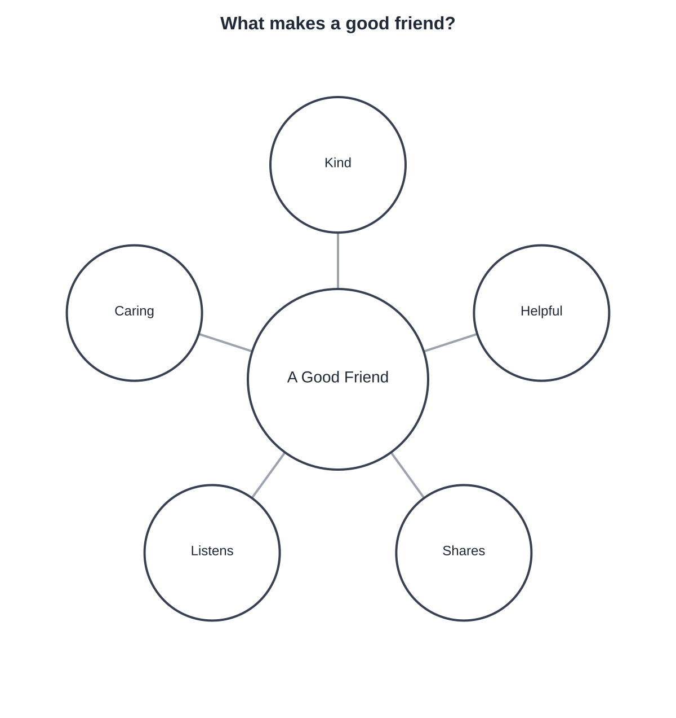
Think about these words as you complete the activity below.
Directions: Read each story. Write how the person feels and what you can do to help.
The Scenario | How do they feel? | What can you do?
A friend falls down on the playground and starts to cry.
You want to play with a red truck, but another student has it.
A new student is sitting alone at lunch time.
Your classmate wins a game and is smiling very big.

Reflection: Why is it important to think about other people's feelings?

Comprehension Check
Part 1: True or False
Read each sentence. Circle True if it is correct or False if it is wrong.
1. Children grow physically when their bodies get bigger. | True / False
2. Mental growth means learning new things at school. | True / False
3. Social-emotional skills are not important for making friends. | True / False
4. Sharing your toys is a social-emotional skill. | True / False
5. You should eat healthy food to help your body grow. | True / False

Part 2: Wh- Questions
Answer the questions using short sentences.
1. What helps you make friends and understand your feelings?
2. Where do children learn new things and solve problems?
3. Who does a good friend listen to and help?
4. Why is it important to exercise your body every day?
5. When do you use your mental skills to solve a puzzle?

Part 3: Reflection
Think about your social skills.
What is one way you can be a good friend today?
Today, I can be a good friend by...

