ÇAĞ UNIVERSITY
Hıgher Vocatıonal School, Health Institutions Management
Credit |  |  |  | Course Title |  |  |  |  |  |  |  |  |  |  |  | Credit |  |  |  | ECTS
 |  |  |  | Atatürk's Principles and History of Turkish Revolution II |  |  |  |  |  |  |  |  |  |  |  | 2-0-2 |  |  |  | 2
  TAR 202
Prerequisites |  |  |  |  |  |  |  | None
Language of Instruction |  |  |  |  |  |  |  | Turkish |  |  | Mode of Delivery |  |  |  | Online
Type and Level of Course |  |  |  |  |  |  |  | Compulsory/2.Year/ Spring Semester
Lecturers |  |  |  |  | Name(s) |  |  |  |  |  | Lecture Hours |  |  | Office Hours |  |  |  | Contacts
Course Coordinator |  |  |  |  | Dr. Veli KÖROĞLU |  |  |  |  |  | Fri. 09:40-11:05 |  |  |  |  |  |  | veli1124@cag.edu.tr
Course Objective The course aims to provide the students about the foundation and development of Modern Turkey. In this context it is objected to tell the right information about Atatürk's way of thinking, Turkish Republic History, Turkey and some factors threatening the applications of Atatürk's way of thinking, to train Turkish Youth as regards to Atatürk's way of thinking which offers an absolute unity at home as a system including all cultural components of Turkish country and finally to raise rationalist, contemporary, humanist, hardworking, and honorable youngsters.
Learning Outcomes of the Course |  |  | Students who have completed the course successfully should be able |  |  |  |  |  |  |  |  |  |  |  |  |  |  |  | Relationship
 |  |  |  |  |  |  |  |  |  |  |  |  |  |  |  |  |  |  | Prog. Output |  |  | Net Effect
 |  | 1 | to express general information about recent history of Turkey. |  |  |  |  |  |  |  |  |  |  |  |  |  |  |  | 4 |  |  | 5
 |  | 2 | to adopt an understanding about foundation thought and main principles of Turkish Republic. |  |  |  |  |  |  |  |  |  |  |  |  |  |  |  | 5 |  |  | 3
 |  | 3 | to form a general information about 20th century world main international progresses which affect present-day. |  |  |  |  |  |  |  |  |  |  |  |  |  |  |  | 4 |  |  | 5
 |  | 4 | to form an essential understanding of development of democracy in Turkey. |  |  |  |  |  |  |  |  |  |  |  |  |  |  |  | 4 |  |  | 5
 |  | 5 | to express information about international problems of Turkey and their reasons |  |  |  |  |  |  |  |  |  |  |  |  |  |  |  | 5 |  |  | 3
 |  | 6 | to compare the conditions of past and present. |  |  |  |  |  |  |  |  |  |  |  |  |  |  |  | 5 |  |  | 3
Course Description: Period of Reorganization (Turkish Revolution) Period of the Republic (Political, Social, Military and Economic, Legal, Cultural, All Amendments). The Republic of Turkey's Foreign Policy (All the agreements and pacts, Atatürk Principles and Atatürk's Underlying complementary policies. Turkish Revolution's national and universal value. From 1923 (the Treaty of Lausanne and the establishment of the Republic of Turkey), 1938 (Ataturk the economic and foreign policy, economic and foreign policy, internal politics and political parties, the system of thought of Mustafa Kemal Atatürk, the principles of democracy, the main political and reforms of Mustafa Kemal Atatürk are discussed.
Course Contents:( Weekly Lecture Plan )
Weeks | Topics |  |  |  |  |  |  |  |  |  |  |  | Preparation |  |  |  | Teaching Methods
1 | The strategy of the Turkish Revolution |  |  |  |  |  |  |  |  |  |  |  | Textbook |  |  |  |  | Presentation & Lecture  audio-visual assisted
2 | Two great revolutions in the political field (Announcement of the Republic and Removal of the Caliphate) |  |  |  |  |  |  |  |  |  |  |  | Textbook |  |  |  |  | Presentation, & Lecture  audio-visual assisted
3 | Terakkiperver Cumhuriyet Fırkası and Takrir-i Sükûn Period, Turkish Law Revolution. |  |  |  |  |  |  |  |  |  |  |  | Textbook |  |  |  |  | Presentation, & Lecture  audio-visual assisted
4 | Education and Culture Revolution. |  |  |  |  |  |  |  |  |  |  |  | Textbook |  |  |  |  | Presentation & Lecture  audio-visual assisted
5 | Revolutions in the economic sphere. |  |  |  |  |  |  |  |  |  |  |  | Textbook |  |  |  |  | Presentation & Lecture  audio-visual assisted
6 | Attempts to step into the multi-party system, Social and Health Reform. |  |  |  |  |  |  |  |  |  |  |  | Textbook |  |  |  |  | Presentation & Lecture  audio-visual assisted
7 | Foreign Policy in Atatürk Period I (1919-1923) |  |  |  |  |  |  |  |  |  |  |  | Textbook |  |  |  |  | Presentation & Lecture  audio-visual assisted
8 | Foreign Policy in Atatürk Period I (1923-1932) |  |  |  |  |  |  |  |  |  |  |  | Textbook |  |  |  |  | Presentation & Lecture  audio-visual assisted
9 | Foreign Policy in Atatürk Period II (1932-1938) |  |  |  |  |  |  |  |  |  |  |  | Textbook |  |  |  |  | Presentation & Lecture  audio-visual assisted
10 | Introduction to Atatürk Ideology |  |  |  |  |  |  |  |  |  |  |  | Textbook |  |  |  |  | Presentation & Lecture  audio-visual assisted
11 | Atatürk's Principles (Republicanism, Nationalism, Populism) |  |  |  |  |  |  |  |  |  |  |  | Textbook |  |  |  |  | Presentation & Lecture  audio-visual assisted
12 | Atatürk's Principles (Statism, Secularism, Revolutionism) |  |  |  |  |  |  |  |  |  |  |  | Textbook |  |  |  |  | Presentation & Lecture  audio-visual assisted
13 | Atatürk and Idea Life |  |  |  |  |  |  |  |  |  |  |  | Textbook |  |  |  |  | Presentation & Lecture  audio-visual assisted
14 | Atatürk, Religion State and Secularism. |  |  |  |  |  |  |  |  |  |  |  | Textbook |  |  |  |  | Presentation & Lecture  audio-visual assisted
REFERENCES
Textbook |  |  |  |  |  | - Atatürk İlkeleri ve İnkılâp Tarihi (Atatürk İnkılâpları I/2), Y.Ö.K. Yayınları, Ankara, 1010  - Atatürk İlkeleri ve İnkılâp Tarihi (Atatürkçülük), Y.Ö.K. Yayınları, Ankara, 1997  - A. İhsan Gencer ve Sabahattin Özel, Türk İnkılâp Tarihi, Der Yayınları, İstanbul 2016
Recommended Reading |  |  |  |  |  | M. Kemal ATATÜRK, Nutuk (1919-1927), Prof. Dr. Zeynep KORKMAZ, Ankara, 2007  ATATÜRKÇÜLÜK 1-2-3, MEB Yayınları, Ankara, 1998  Atatürk'ün Söylev ve Demeçleri I–II-III, Ankara, 1989  İlginç Olaylar ve Anekdotlarla Atatürk, Gnkur. Basımevi, Ankara, 1988  Atatürk'ün Tamim, Telgraf ve Beyannameleri IV, Ankara 1991  Yalçın, Durmuş vd., Türkiye Cumhuriyeti Tarihi I,II Ankara 2002
ASSESSMENT METHODS
Activities |  |  |  |  |  |  | Number |  |  | Effect |  | Notes
Midterm Exam |  |  |  |  |  |  | 1 |  |  | 40%
Effect of The Activities |  |  |  |  |  |  |  |  |  | 40%
Effect of The Final Exam |  |  |  |  |  |  |  |  |  | 60%
TOTAL |  |  |  |  |  |  |  |  |  | 100%
ECTS TABLE
Contents |  |  |  |  |  |  |  |  | Number |  |  |  | Hours |  |  |  |  |  |  |  | Total
Hours in Classroom |  |  |  |  |  |  |  |  | 14 |  |  |  | 2 |  |  |  |  |  |  |  | 28
Hours out Classroom |  |  |  |  |  |  |  |  | 13 |  |  |  | 2 |  |  |  |  |  |  |  | 26
Midterm Exam |  |  |  |  |  |  |  |  | 1 |  |  |  | 6 |  |  |  |  |  |  |  | 6
Final Exam |  |  |  |  |  |  |  |  | 1 |  |  |  | 6 |  |  |  |  |  |  |  | 6
Total  Total / 30  ECTS Credit |  |  |  |  |  |  |  |  |  |  |  |  |  |  |  |  |  |  |  |  | 66
 |  |  |  |  |  |  |  |  |  |  |  |  |  |  |  |  |  |  |  |  | 66/30=2,2
 |  |  |  |  |  |  |  |  |  |  |  |  |  |  |  |  |  |  |  |  | 2
RECENT PERFORMANCE
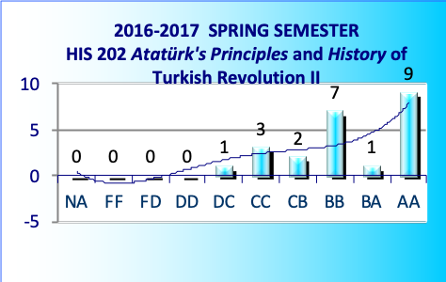 | 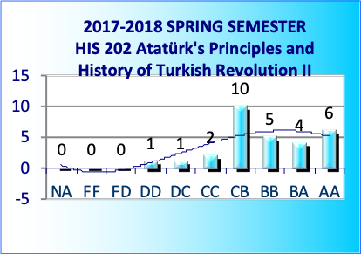
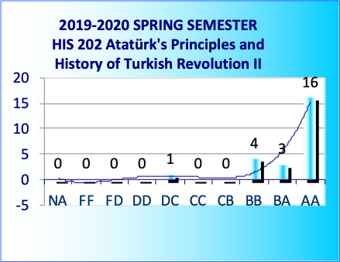 | 