CAG UNIVERSITY

VOCATIONAL SCHOOL
FOREIGN TRADE PROGRAM
Code |  |  |  | Name |  |  |  | Credit |  | ECTS
ISL 107 |  |  |  | Business Management |  |  |  | (3-0-3) 3 |  | 6
Prerequisites |  |  |  | None
Language of Instruction |  |  |  | Turkish |  |  | Mode of Delivery |  |  | Face to Face
Type and Level of Course |  |  |  | Compulsory / 1. Year/ Fall Semester
Lecturer |  |  |  | Name |  |  |  | Lecture Hours |  | Office Hours Contact
Course Coordinator |  |  |  | Asst. Prof. Dr. Yonca Bir |  |  |  | Monday  13.25-15.45 |  | Wednesday yoncabir@cag.edu.tr  11.00-12.00
Purpose |  |  |  | The course aims to provide information on the basic concepts of business, types of business, and management functions that will ensure the continuity of the business, and provide the necessary skills to evaluate the effects of effective management on business success.
Learning Outcomes of the Course |  |  |  | Students that upon successful completion of this course; |  |  |  |  |  |  | Relationship
 |  |  |  |  |  |  |  |  |  |  | Prog. Output | Prog. Output
 |  | 1 |  | To explain the basic concepts about business. |  |  |  |  |  |  | 3 | 3
 |  | 2 |  | To understand the functions of business management. |  |  |  |  |  |  | 4 | 5
 |  | 3 |  | To approach managerial ideas from a critical perspective |  |  |  |  |  |  | 6 | 5
 |  | 4 |  | To analyze managerial problems in business life. |  |  |  |  |  |  | 3 | 3
Course Description : Business, management and its basic principles, historical development, planning, organization, executive and supervision functions, strategic management issues will be emphasized, and the development and applications of management science at national and international levels will be examined.
Course Contents:(Weekly Lecture Plan)
Week | Topic |  |  |  |  |  | Preparation |  | Teaching Methods
1 | Basic Concepts of Business Administration |  |  |  |  |  | Textbook |  | Presentation&Discussion
2 | Business & Environment |  |  |  |  |  | Textbook |  | Presentation&Discussion
3 | Historical Development of the Business |  |  |  |  |  | Textbook |  | Presentation&Discussion
4 | Purposes & Responsibilities& Reasons of Business |  |  |  |  |  | Textbook |  | Presentation&Discussion
5 | Process of Business |  |  |  |  |  | Textbook |  | Presentation&Discussion
6 | Types & Classification of Business |  |  |  |  |  | Textbook |  | Presentation&Discussion
7 | Capacity, Growth and Optimum Business Size of Businesses |  |  |  |  |  | Textbook |  | Presentation&Discussion
8 | Midterm
9 | Legal Structure of Business |  |  |  |  |  | Textbook |  | Presentation&Discussion
10 | Function of Businesses Management |  |  |  |  |  | Textbook |  | Presentation&Discussion
11 | Basic Functions of Business |  |  |  |  |  | Textbook |  | Presentation&Discussion
12 | Contemporary Finance Techniques for Businesses |  |  |  |  |  | Textbook |  | Presentation&Discussion
13 | Efficiency & Effectiveness of Businesses |  |  |  |  |  | Textbook |  | Presentation&Discussion
14 | Performance Management of Businesses |  |  |  |  |  | Textbook |  | Presentation&Discussion
15 | Public Relations of Business Management |  |  |  |  |  | Textbook |  | Presentation&Discussion
16 | Final
REFERENCES
Textbook |  |  | Prof. Dr. Hasan TUTAR, 2019, Meslek Yüksekokulları İçin İşletme Yönetimi, Seçkin Yayıncılık
ASSESSMENT METHODS
Activities |  |  |  |  |  | Number | Effect |  | Notes
Midterm |  |  |  |  |  | 1 | 40%
Final Exam |  |  |  |  |  | 1 | 60%
Success Rate for the Year |  |  |  |  |  |  | 40%
Final Success Ratio |  |  |  |  |  |  | 60%
ECTS TABLE
Content |  |  |  |  | Number |  | Hours |  | Total
Hours in Classroom |  |  |  |  | 14 |  | 3 |  | 42
Hours out Classroom |  |  |  |  | 14 |  | 3 |  | 42
Midterm |  |  |  |  | 1 |  | 40 |  | 40
Final Exam |  |  |  |  | 1 |  | 45 |  | 45
Total  Total / 30  ECTS Credit  PERFORMANCE  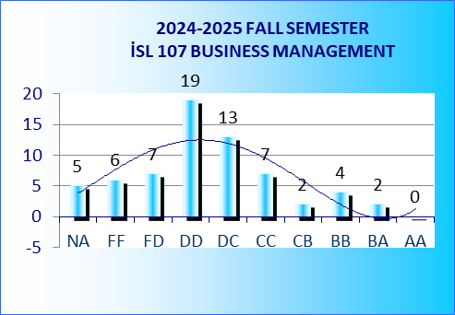 |  |  |  |  |  |  |  |  | 169
 |  |  |  |  |  |  |  |  | =169/30=5.6
 |  |  |  |  |  |  |  |  | 6

